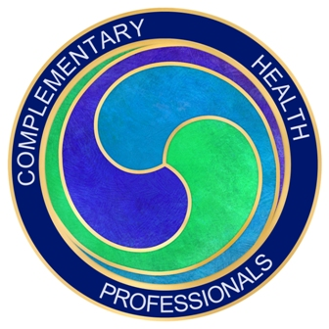
Complementary Health Professionals
Annual Conference and Awards Ceremony
7th October 2017

We are delighted to be able to invite you to our second annual conference which as last year is fully catered. This year’s speakers will be covering a wide range of subjects, supporting your professional development and giving you new ideas to pursue in the coming year. You will receive 6 CPD points for attendance and the event is free to our premier members and current students. Everyone needs to book a ticket so we can cater for the right number of people. The tickets are £55 to anyone else who would like to attend.
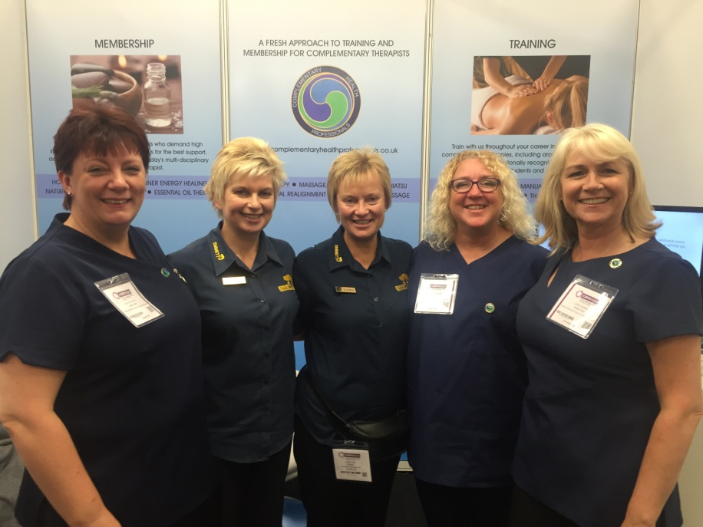
Carole Preen, Julia Oyeleye and Julie Quinn, Directors of Complementary Health Professionals with
Sue Gassick and Lesley Salt from EMMETT Technique UK at CAM Expo 2016.
9.30 Registration and refreshments
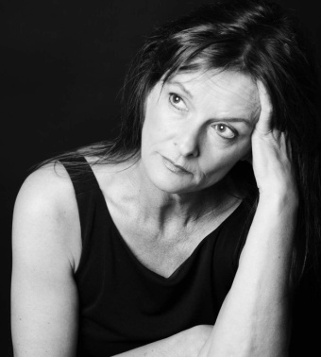
10.00 CHP Welcome and Do-In exercise for energy and invigoration!
10.10 Jane Lawson - Director of The Natural Approach - “Aromatherapy for Babies and Children"
Author of "The Natural Approach to Essential Oils", Jane is a vintage aromatherapist who has been practising and teaching aromatherapy since the early 1990's. If you would like Jane to sign a copy of her book at the conference, she will be only too happy to do so.

One of Jane's many specialities is advising on the use of essential oils for babies and children. Although you may have covered this in your training as an Aromatherapist, this will be an excellent refresher and give you new ideas and perspectives for your practice. If you are not an aromatherapist, the talk will enlighten you as to the dangers of using essential oils on babies and children without proper knowledge, which will help you advise your clients about.

10.55 Coffee Break

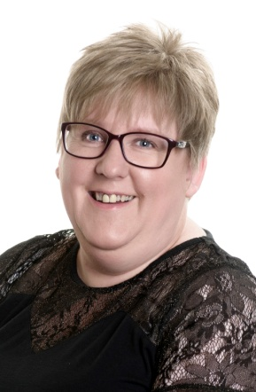
11.15 Deborah Grayson BscPharm, Dip NT CNM, mBANT - "Navigating the Medication Minefield - how to work safely with clients taking prescribed medication"

Deborah has over 20 years experience as a community pharmacist and teaches Nutritional Pharmacology and First Aid in association with Integrative Health Education. She has a growing Nutritional Therapy practice where she specialises in clients with complicated health issues and multiple medication regimes. Deborah has also taught for the College of Naturopathic Medicine and sits on the Fitness to Practice Committee of the General Pharmaceutical Council.

In this session Deborah will endeavour to give an insight into the potential problems associated with working with clients on medication and how practitioners can work safely to avoid causing any harm.
12.15 CHP Team - “How to give presentations and workshops”
Did you know that one of the best ways to attract new clients is by giving talks and presentations? It establishes you as an expert in your field and quickly generates interest and bookings for your therapies. We will give you tips and ideas of how to overcome your fears and engage your audience using NLP Techniques. This presentation also coincides with the launch of CHP's new course "Teacher Training Certificate in Complementary Therapies", which will support you in running your own courses as part of your business.
12.45 CHP Annual Awards Ceremony
Awards will be given for the three categories: Student Practitioner of the Year, Practitioner of the Year and Complementary Therapy Business of the Year.
13.00 Lunch Break - this event is fully catered
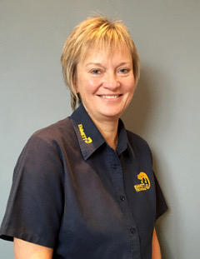
14.00 Lesley Salt - Senior Instructor and a Director of EMMETT Therapies UK.
The EMMETT Technique is a safe and simple muscle release therapy. It uses light finger pressure at specific locations on the body to initiate the gentle release of muscle tension - reducing pain and discomfort and improving movement restrictions. It is non-invasive and involves no drugs, massage oils, manipulations or high velocity thrusts. Useful for problem areas such as necks, shoulders, backs. The results are usually immediate. It can be applied as a stand-alone therapy or combined with any other bodywork technique. It is attracting a lot of interest from complementary therapists, medical professionals, and sports and exercise instructors who are interested in extending their skills. You will find out more about the therapy, how it works and if it would be useful in your practice.

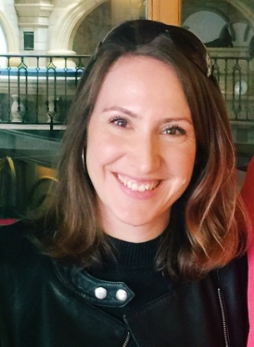
15.00 Jana Mitackova – Spiral Stabilization (SPS) UK Director, Teacher Trainer - ''Cause, treatment and prevention of back pain using muscle chains''
Jana launched Spiral Stabilization in the UK in 2014 and since then has successfully organised and taught therapist courses in London. Jana closely co-operates with the method's founder Dr Smisek (Prague, Czech Republic) who developed SPS almost 40 years ago. It has been popular in most European countries and especially in Germany for over two decades and is a combination of an exercise method and manual therapy techniques using muscle chains to eliminate the cause and not the symptoms of clients' conditions. Find out how to effectively and permanently treat back pain, chronic pain, headaches, migraines, disc herniation, flat feet, hallux valgus, scoliosis, lordosis, kyphosis, infertility, back pain in pregnancy, improve posture, running and sports performance and many more. This form of exercise is an excellent adjunct to the EMMETT Technique and Neuroskeletal Re-Alignment Therapy as well as other therapies that work with back pain and other postural correction techniques.

16.00 Plenary and Chakra Balance Meditation

16.30 Collect CPD certificates and end of conference

