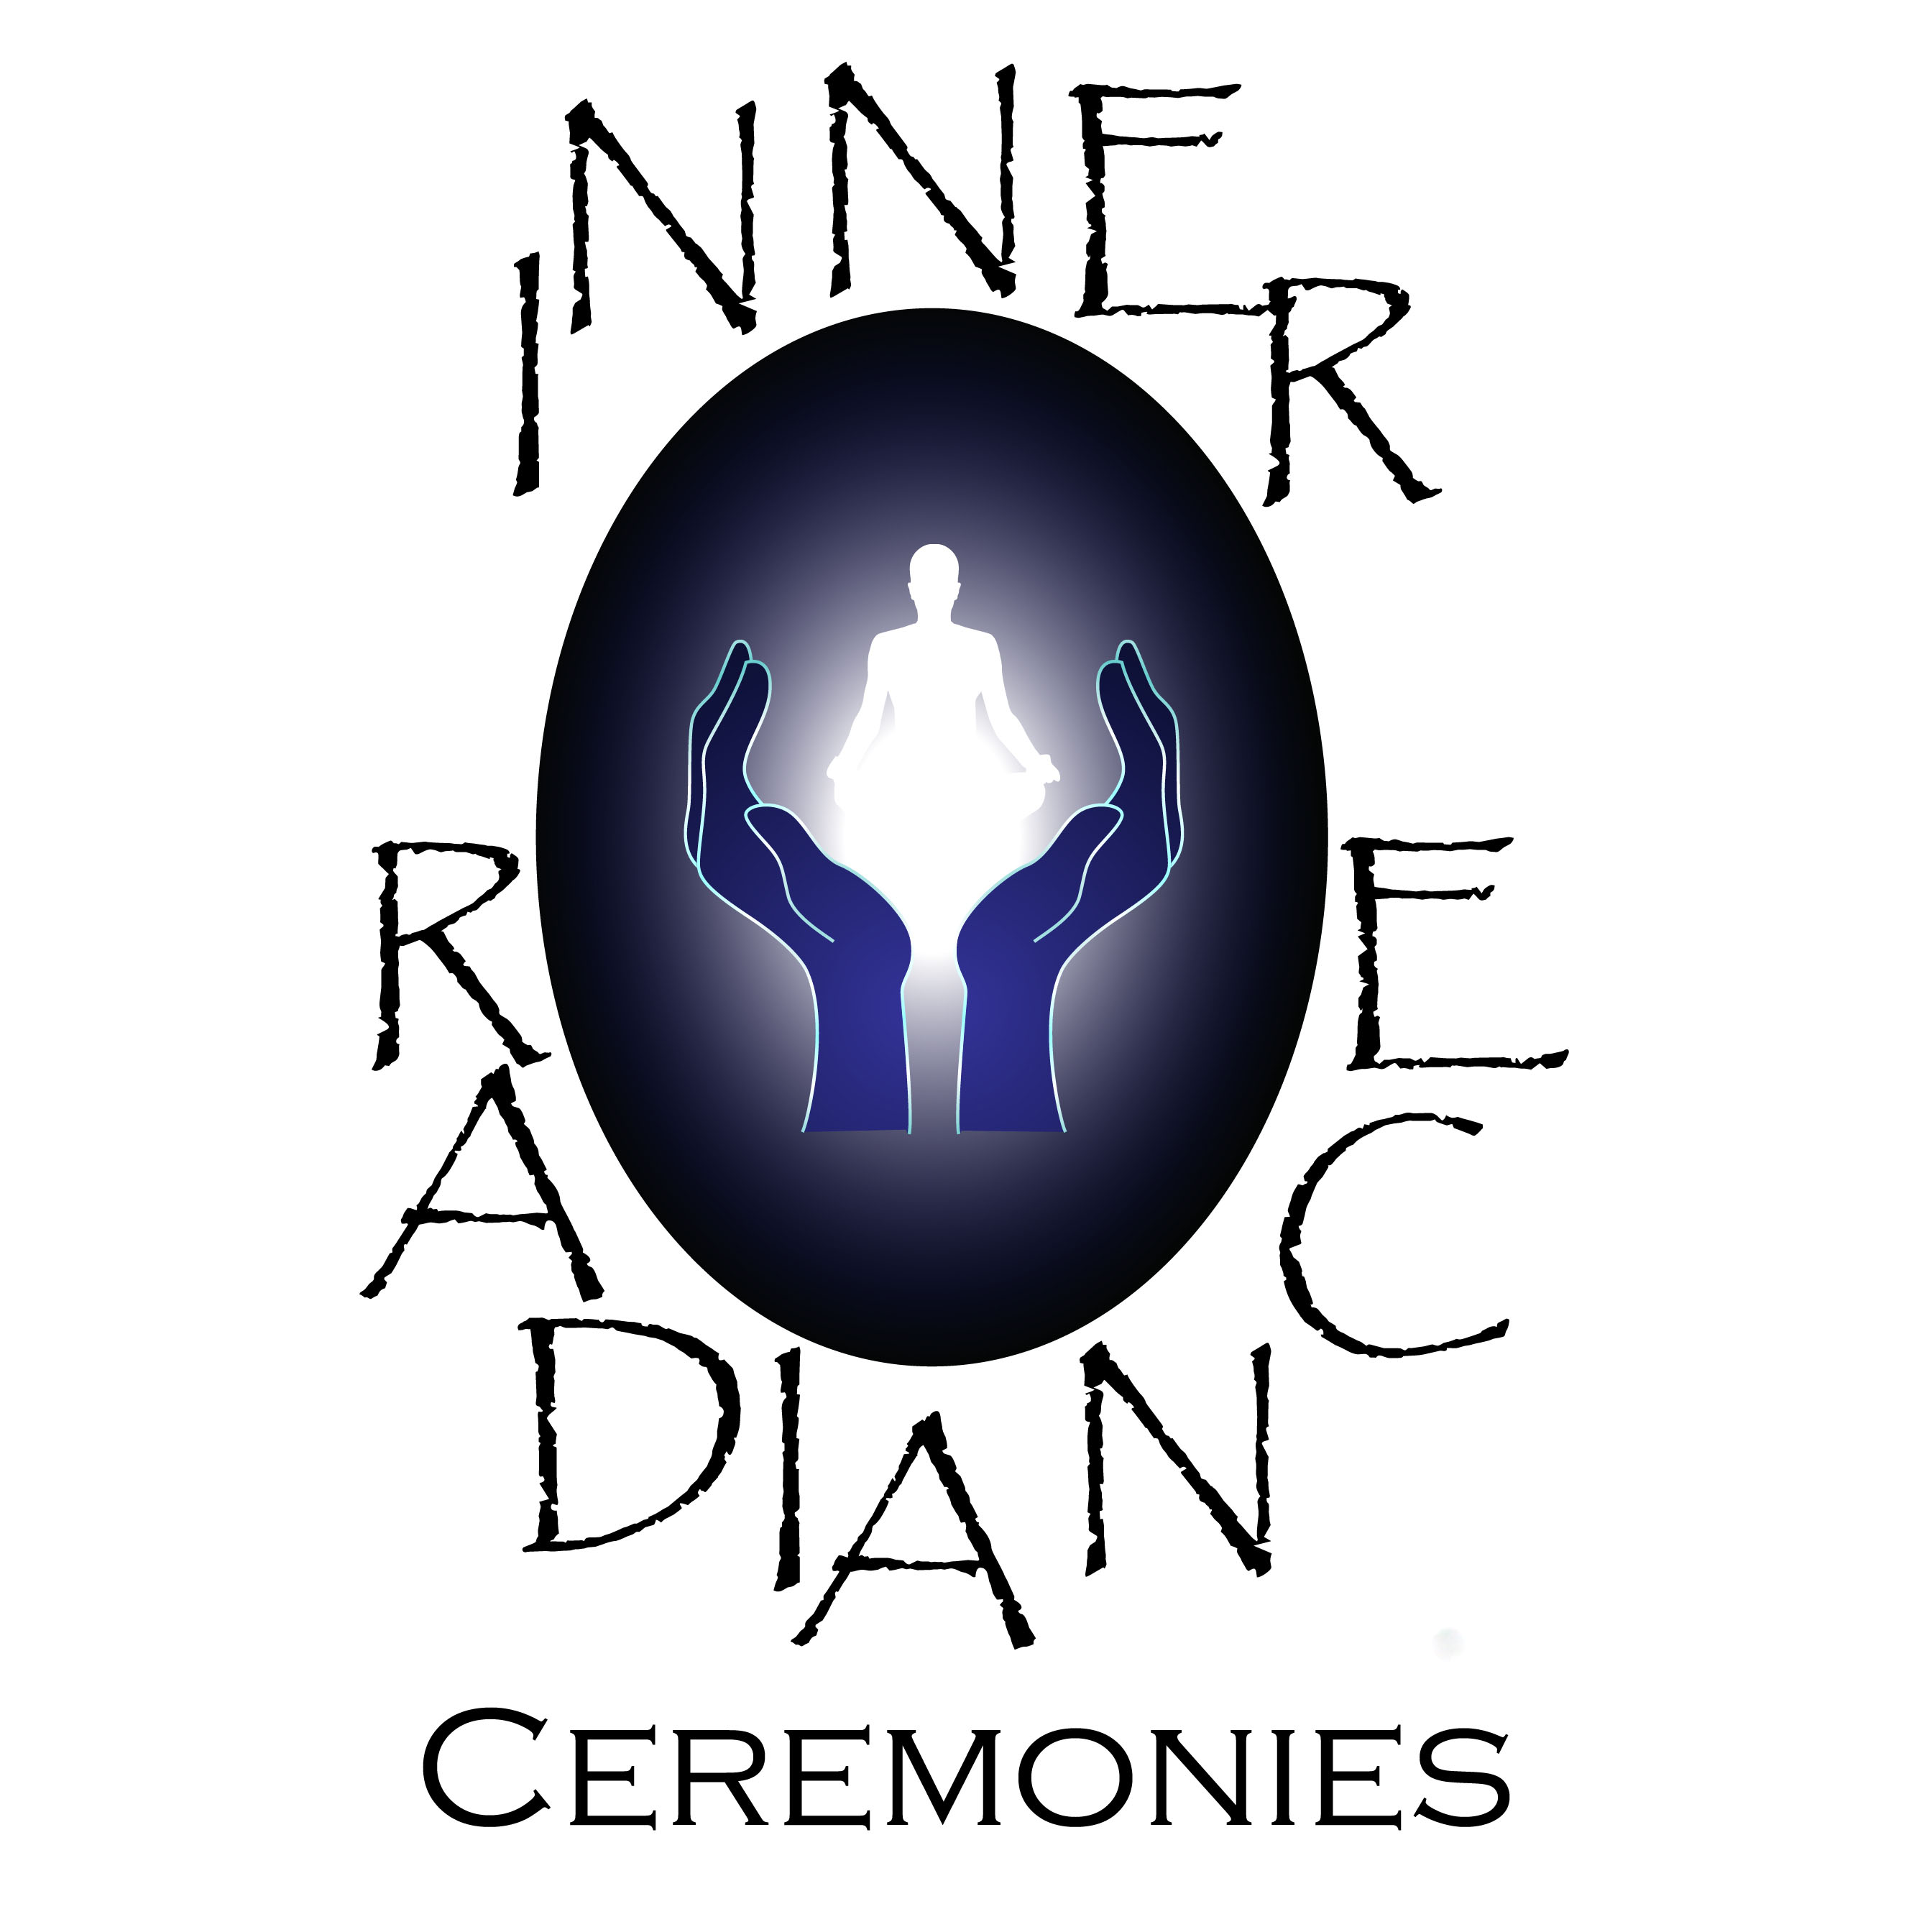

POSSIBLE WEDDING STRUCTURE

- ENTRANCE OF THE BRIDE
- OPENING POEM OR READING
- STATEMENT OF PURPOSE, e.g.
What is marriage? Why are we here?
- SECOND READING OR POEM
- CONVOCATION
Introduction to the sacred nature of the occasion
- MARRIAGE BLESSING
- ADDRESS
Talking about the couple and their love story
What is special about their relationship
The beauty and challenges of marriage
- OPTIONAL RITUALS
Lighting a unity candle
Sand Ritual
Jewish Seven Blessings
Rose Ceremony
Or others
- EXPRESSION OF INTENT
Asking the couple to confirm their intention to be married and fully committed to each other
- VOWS
Written by the couple – either different vows for each or the same for both
- SANCTIFICATION OF MARRIAGE
- BLESSING OF AND EXCHANGE OF RINGS
- OPTIONAL HANDFASTING
- PRONOUNCEMENT OF MARRIAGE

Music or singing can be included at any point in the ceremony that feels right to you.

