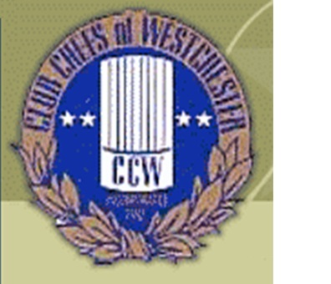

Club Chefs of Westchester Chris Gasse Foundation Golf Outing
Waccabuc Country Club
October 18, 2016

Tee Sponsorship Cost

$150

Club or Business Name _______________________________

Make Checks Payable to Club Chefs of Westchester
P.O. Box 732
Bronxville, NY 10708

