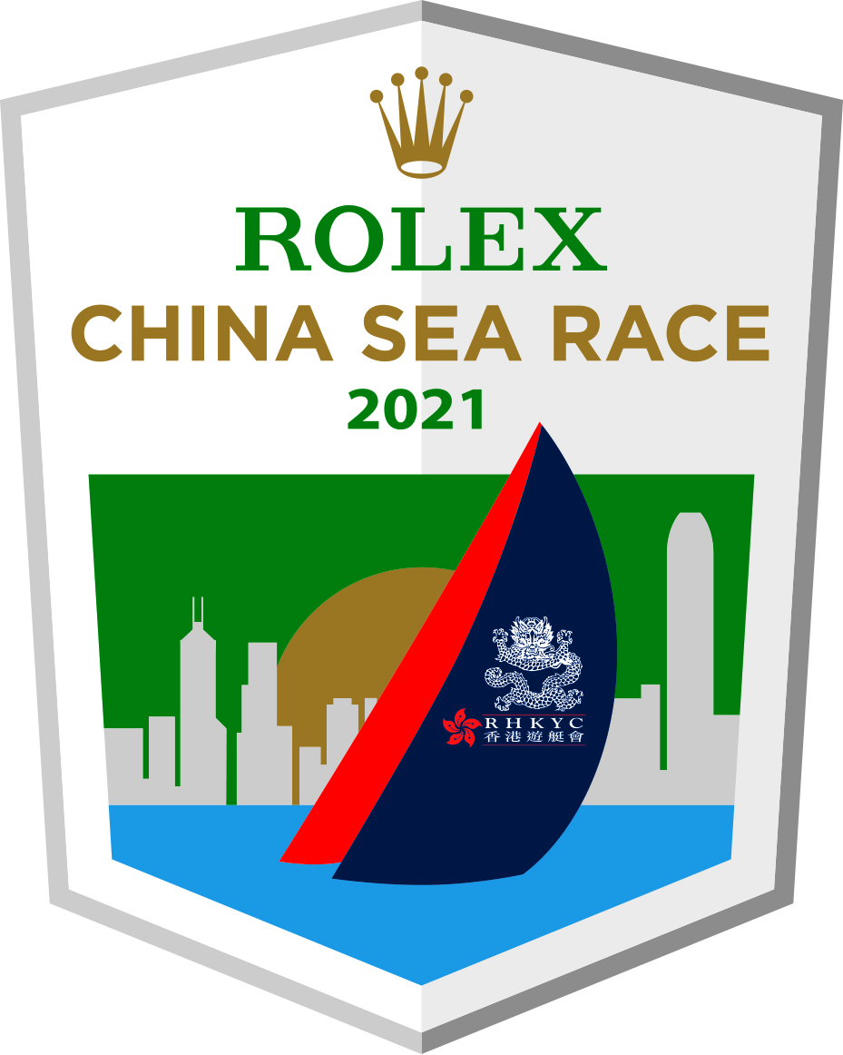

for immediate release
31 March 2020

365-day Countdown to Rolex China Sea Race 2021

Royal Hong Kong Yacht Club has released the Notice of Race and opened entry for Rolex China Sea Race 2021. The Race will start one year from today on 31 March 2021 in Hong Kong’s iconic harbour and take competitors 565nm across the South China Sea to Subic Bay in the Philippines.

2021 marks the 59th anniversary of this biennial Offshore Category 1 Race organised by the multi-faceted and cosmopolitan Royal Hong Kong Yacht Club, one of the oldest and most prestigious clubs in Hong Kong. Rolex has been a partner of the Club since 2007 and Title Sponsor of its flagship Race since 2008.

As a blue water classic, the Race has a bit of everything; from a spectacular start in Hong Kong harbour, through the lumpy, challenging conditions on the first night to the deep blue water as you near the northern Philippines. On paper, this event might look like a drag race with a predominant easterly breeze and trade winds of 70 to 90 degrees, but the reality is often different with the infamous ‘Luzon hole’ often causing the fleet to compress and effectively restart as they near the coast of the Philippines. The net result is that many boats have a chance of lifting the trophy under IRC – it all depends on how they play their approach to the Philippines.

The 2020 edition of the Rolex China Sea Race was deferred by a year to 2021 due to Covid-19 virus epidemic and in 2022 the Race will return to its original rhythm of 'even' years for the biennial Race (i.e. the next three editions will be held in 2021, 2022 and 2024).

The Notice of Race can be found on the official Rolex China Sea Race website at the following link https://www.rolexchinasearace.com/competitors

About Royal Hong Kong Yacht Club (RHKYC)
The Royal Hong Kong Yacht Club is one of the oldest and largest sports clubs in Hong Kong, with a rich, colourful history that spans 170 years of community and competitive sailing and rowing. The RHKYC provides training programmes for practitioners of all abilities and ages – both members and non-members – to nurture their development, produce elite athletes capable of competing at the highest levels, and contribute to the growth and popularity of these great pastimes. The Club also organises a full calendar of high-profile local and international race events, helping place Hong Kong firmly on the global sporting map.
Media Enquiries  Koko Mueller  Head of PR & Communications  Royal Hong Kong Yacht Club  Tel.: +852 2239 0342 / +852 9488 7497  Fax: +852 2572 5399  email: koko.mueller@rhkyc.org.hk  Janice Lam  PR & Communications Manager  Tel.: +852 2239 0340 / +852 9718 0817  Fax: +852 2572 5399  email: janice.lam@rhkyc.org.hk  Royal Hong Kong Yacht Club  Kellett Island, Causeway Bay  Hong Kong  RHKYC website: www.rhkyc.org.hk | Race Enquiries  Ailsa Angus  Sailing Manager  Royal Hong Kong Yacht Club  Tel.: +852 2239 03915  Fax: +852 2239 0364  email: ailsa.angus@rhkyc.org.hk  Sponsorship Opportunities:  Antony Phillips  Head of Sponsorship and Corporate Partnerships  Royal Hong Kong Yacht Club  email: antony.phillips@rhkyc.org.hk

