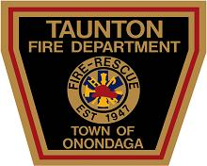
TAUNTON FIRE DEPARTMENT
RENO NIGHT / RAFFLE / FUND RAISING EVENING

Tickets: $100.00 each Only 200 tickets available

Guest tickets & Admission Tickets: $20.00 each to allow dual ticket purchasers and ticket
holder’s to bring a guest to the dinner and Reno night.

Date: Friday, November 1st, 2019 at 6:30pm

Place: Taunton Fire Department
4300 Onondaga Blvd
Syracuse, NY 13219

Evening Highlights: Buffet served at 7:30 PM until 9:00 PM
Liquid Refreshments available all evening
Casino games
50/50 raffles
Main raffle

Raffle: Process of elimination takes place throughout the course of evening. The final ten ticket
holders who’s numbers still remain will be consulted as to the distribution of the
$10,000.00 prize money.

General Information: Payment must be made in full by October 1st, 2018 to be eligible for the
two $100.00 drawings.

No ticket number will be issued until full amount is paid !!

The Taunton Fire Department reserves the right to cancel this benefit drawing at any
time and refund all money that has been collected.

“You can be sure of a good time with Taunton”

If interested in a ticket, Please contact President Tom Sauer at 315-491-1193 