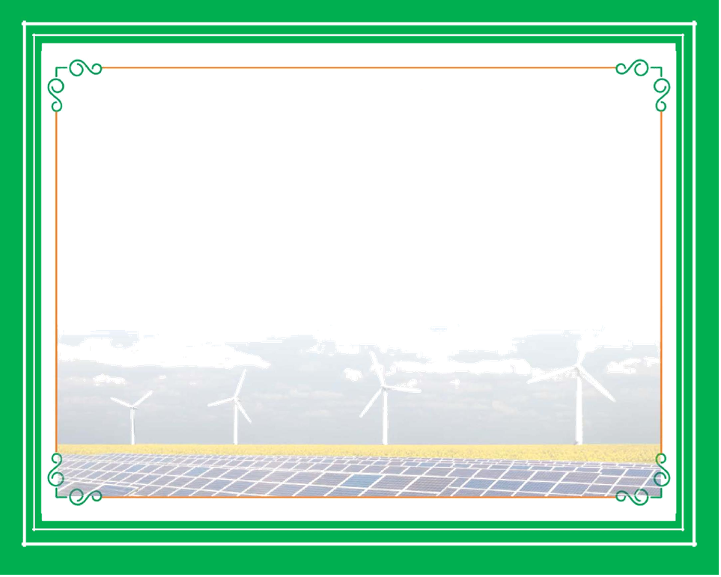

Abidjan, April 12, 2017

**Presented to**

**Director General Secretary General**

**International Solar Alliance Climate Parliament**

In fulfilment of the objectives reflected in the joint declaration signed by International Solar Alliance (ISA) and Climate Parliament on 15th November, 2016 at Marrakesh and on the occasion of the Abidjan International Parliamentary Hearing on Renewable Energy 2017 organised by the Climate Parliament we, (name of company) - - - - - - - - - -incorporated/ registered in - - - - - - - - - - (name of country) under the - - - - - - - - - - (name of the Act) as a - - - - - - - (type of legal entity), hereby present our commitment that we shall strive to install at least - - - - - (250) solar pumping systems for irrigation and/or drinking water systems in each of the following ISA member countries in Africa during the period 2017-2019 - - - - - (list the African Countries).

This is subject to requisite permission/s, appropriate demand and finances mobilised by the Government of the respective country.

We shall also establish a service centre for comprehensive maintenance, servicing and training in each country in association with our local business associate.

We also undertake that the standards and specifications for solar water pumping systems shall conform to relevant International Electro-technical Commission (IEC) norms.

Authorised signatory - - - - - - - - - -

Name - - - - - - - - - -

Designation - - - - - - - - - -

Organisation Name - - - - - - - - - -

Telephone - - - - - - - - - -

E-Mail - - - - - - - - - -

**International Parliamentary Hearing on Renewable Energy for East Africa and West Africa Abidjan, Côte d'Ivore, 12-13 April, 2017**

**Commitment for Installation of Solar Pumps**