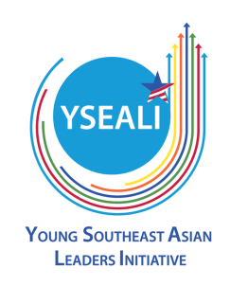
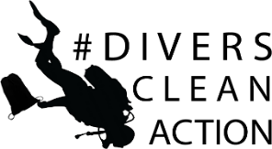
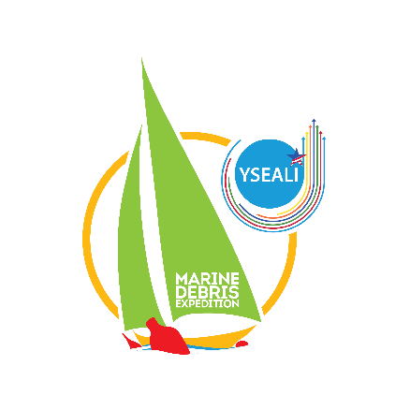
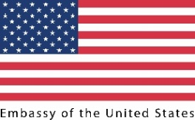

THE 2018 YSEALI REGIONAL WORKSHOP:

MARINE DEBRIS EXPEDITION

Preventing and Combatting Marine Debris in the Seas of Southeast Asia

August 4-9, 2018

Jakarta, Indonesia

APPLICATION FORM
(Every question has to be filled)
FULL NAME (exactly as it appears on your passport):
Last Name(s):
First Name(s):
Middle Name(s): optional
- Gender:
Please identify your gender. This will enable the organizers to make proper accommodation and prevent gender violation.
- Date of Birth(mm/dd/yyyy):
You should be in the range of 18-25 years old (were born from August 9, 1992 to March 1, 2000)
- Country of Birth:
- Country of Citizenship:
- Country of Residence:
- Passport Information
You must have a valid passport at least with expiry date of February 9, 2019 or later

Passport Number:

Expiry Date:
- Contact Information

Address:

Telephone:

Cell phone:

E-mail:

Emergency Contact Name and Relationship:

Emergency Contact Phone:

Emergency Contact E-mail:
- Medical, Physical, Dietary or other Personal Considerations
Please state if you have any existing medical conditions or are currently taking any prescription medication. Please inform if you easily get seasickness while traveling on boat. This will enable the organizers to provide proper needs.
- Educational background: (begin with the most recent; add more rows if needed)
Institution Name (No abbreviations) | Institution Location (City, Country) | Dates Attended  (MM/YY-MM/YY) | Major Field of Study | Degree Received and Date Received
- Work Experience (including previous positions and titles; begin with the most recent; add more rows if needed)
From – To  MM/YY – MM/YY | Position (Please specify if position is part-time) | Institution | Location (City, Country)
- Volunteer, Community Service and Extra-Curricular Activities: (begin with the most recent; only include activities you have participated in the last 3 years; add more rows if needed)
Event/Institution Name (Location) | Type of Activity and Your Role | Date of Participation  (MM/YY – MM/YY)

- Experience with the U.S. Embassy or U.S. Consulate General (including but not limited to: U.S. Government Exchange Programs; U.S. Mission activities; YSEALI activities; etc.):
Location (Institution, City) | Type of Activity and Your Role | Date of Participation  (MM/YY – MM/YY)

- Active Memberships (in Associations, Clubs, etc.).
- Evidence of English Fluency, if any (e.g. paper-based TOEFL or iBT TOEFL scores, IELTS, please attach copy of certificate)
- Interest in Traveling
Participants will be involved in much traveling from mainland to surrounding island. Please answer with yes or no. This will not affect your selection to be top finalists.
Do you like traveling?
Are you okay traveling on boat?
Are you okay being exposed to sun?
Are you able to swim?
Have you done snorkeling?
Would you be interested in snorkeling with us?
- Short essays: single spaced.
Please answer each one of the following questions based on its word limitation:
- Your background and/ or interests that make you competitive for this workshop, and how do you think yourself as a leader. (No more than 250 words)
- In your opinion, what is the biggest challenge that your country is facing in terms of the waste management and how is the best solution regarding to the challenge? (No more than 200 words)
- What do you think you can do to encourage policy makers to make changes to protect the environment in your home country? (No more than 125 words)
- Are you interested in learning about United States and ASEAN? Why? (No more than 75 words)
- What do you think you can do to transfer the knowledge and experience from the workshop to your friends, colleagues, and institutions? (No more than 100 words)
- How do you expect the lessons learned from the workshop to affect you personally and professionally? (No more than 100 words)
- If you get funding to do a community project related to waste management issues, what will you do? (No more than 200 words)

