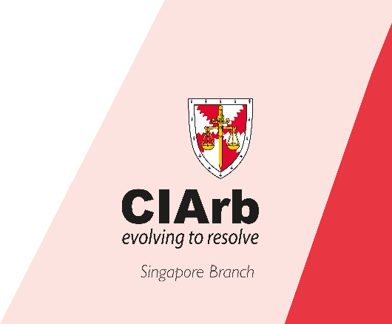
Arbitral Women Diversity Toolkit Training

FTI Consulting
12 March 2020, Singapore

THE CHARTERED INSTITUTE OF ARBITRATORS (SINGAPORE)
CO-ORGANISED WITH SINGAPORE INSTITUTE OF ARBITRATORS
is pleased to present

"Arbitral Women Diversity Toolkit Training"

Date: Thursday, 12 March 2020
Time: 9.00am – 5.00pm (Registration starts at 8.45am)
Venue: FTI Consulting
8 Shenton Way, #32-03 AXA Tower
Singapore 068811

ABOUT THE EVENT
The Toolkit is a full-day* (see below for more information) training course for all those who want to make a difference to Diversity. Groups are ideally from 20 to 30 at most. A day of mini-lectures, video clips, participatory exercises and guided workshops helps participants to make the business case for diversity, and to recognize the unconscious biases that make Diversity difficult. The goal is for each person to leave the workshop with a personal diversity plan - a goal that is achievable in that person's circumstances by a series of actions leading to behavioural change. A follow-up survey will assess the longterm influence of the Toolkit training for each participant.

*7 training hours excluding lunch; from 9.00am to 5.00pm.
SPEAKER

Louise Barrington
Louise Barrington is an independent arbitrator and mediator based in Hong Kong and Toronto. She was one of the first Chartered Arbitrators in Asia and has taught and assessed for the Institute for 20 years. As one of the two founders of ArbitralWomen, she has been studying the role of women and promoting women in international dispute resolution for 25 years. In 2006 she moderated the first panel to deal with Diversity in a seminal conference entitled "The Changing Face of International Arbitration" and since then has regularly presented Diversity issues on four continents. With a grant from AAA-ICDR she led the creation of the Diversity Toolkit, and since its inauguration in late 2018 has presented it in the U.S., Canada and Mexico, as well as training others to deliver it in their own jurisdictions.

REGISTRATION FORM
THE CHARTERED INSTITUTE OF ARBITRATORS (SINGAPORE)
CO-ORGANISED WITH SINGAPORE INSTITUTE OF ARBITRATORS
" Arbitral Women Diversity Toolkit Training"

Date: Thursday, 12 March 2020
Time: 9.00am – 5.00pm (Registration starts at 8.45am)
Venue: FTI Consulting
8 Shenton Way, #32-03 AXA Tower
Singapore 068811

PART A: PARTICIPANT INFORMATION
Title (Mr/Dr/Mrs/etc): _______________________
Family name: ______________________________ First/given name: ______________________
Tel/HP: ___________________________________ Email: _______________________________
Company: _________________________________ Designation: __________________________

PART B: REGISTRATION FEES
Registration Fees Category (Please tick)
S$70 - I am a member of CIArb / SIArb; Membership No.: _________________________
S$100 - None of the above but I would like to attend as a member of the public

PART C: PAYMENT METHOD
Payment Category (Please tick)
Cash Payment at CIArb Singapore Office before the event or at Event Venue
Cheque made payable to “The Chartered Institute of Arbitrators (Singapore) Limited”
Bank Transfer details as below:

Beneficiary Name | The Chartered Institute of Arbitrators (Singapore) Limited
Beneficiary Address | 1003 Bukit Merah Central, #02-10, Singapore 159836
Account No | 001-905849-0
Beneficiary Bank | DBS Bank Ltd
Bank Address | 6 Shenton Way DBS Building Singapore 068809
Bank Code | 7171
Branch Code | 001
Swift Code | DBSSSGSG

*Please provide payment slip / proof of payment with registration form

PART D: SUBMISSION OF REGISTRATION FORM
Kindly attach your completed registration form or send the above information in the email text body, in email to secretariat@ciarb.org.sg.

The closing date for registration is 2 March 2020. (Spaces are limited, and registrations are on a first-come-first-served basis). The organisers reserve the right not to accept registrations and to cancel or alter the date and details of the event.

The Chartered Institute of Arbitrators (CIArb) is the world's leading professional membership body for arbitration and alternative dispute resolution (ADR). CIArb promotes the use of ADR internationally through 16,000 professionally qualified members in over 133 countries.

The Chartered Institute of Arbitrators (Singapore)
Tel: (65) 6968 1598 | Email: secretariat@ciarb.org.sg | Website: www.ciarb.org.sg

