Registering as a Player, Coach, Trainer, Volunteer or Referee

Go to https://www.playrugbyleague.com/ and Enter the postcode or club name where you want to register

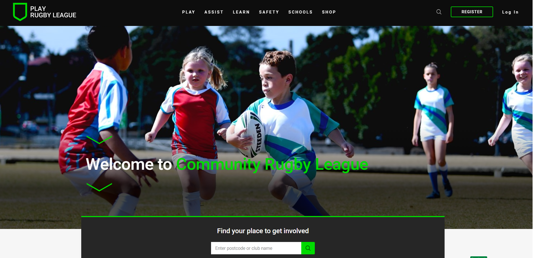

Click on filter and select your participant type

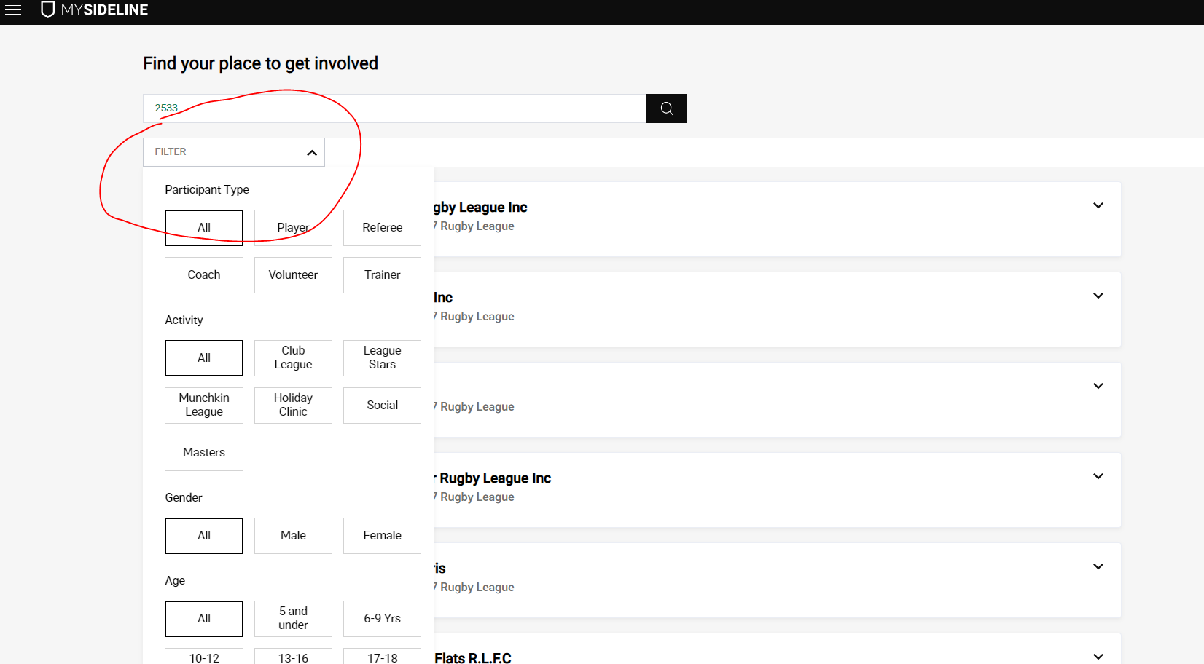

Once you have selected you participant type eg player, then select the club where you want to play and click on register
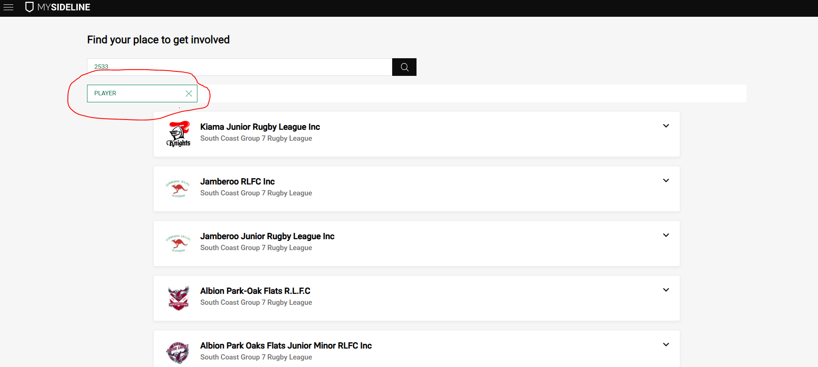

Select the profile of the person that you are registering, check all the registration details are correct and make any payments that are needed
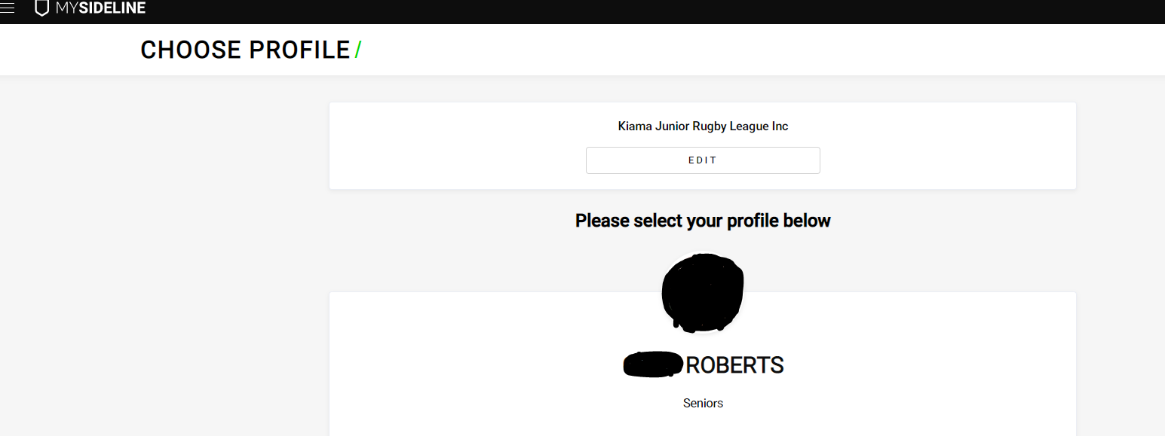
Check that all your details are correct and complete the registration
