Instructions to log in or sign up for an NRL Account

Go to https://www.nrl.com/account and either log into your account or if you don’t have an NRL account sign up

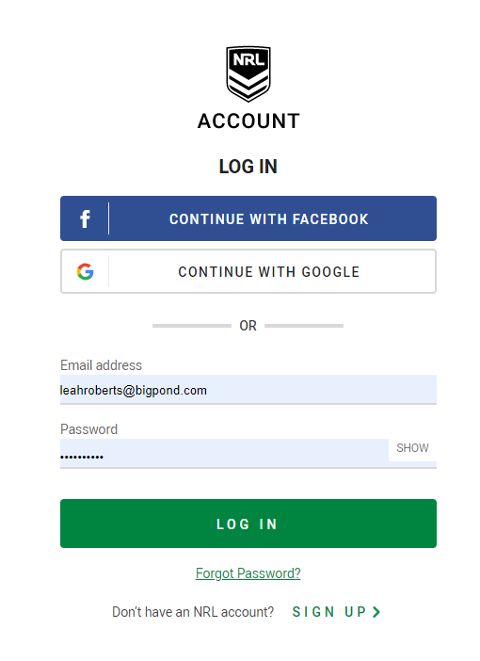

If you need to sign up for an account, please continue
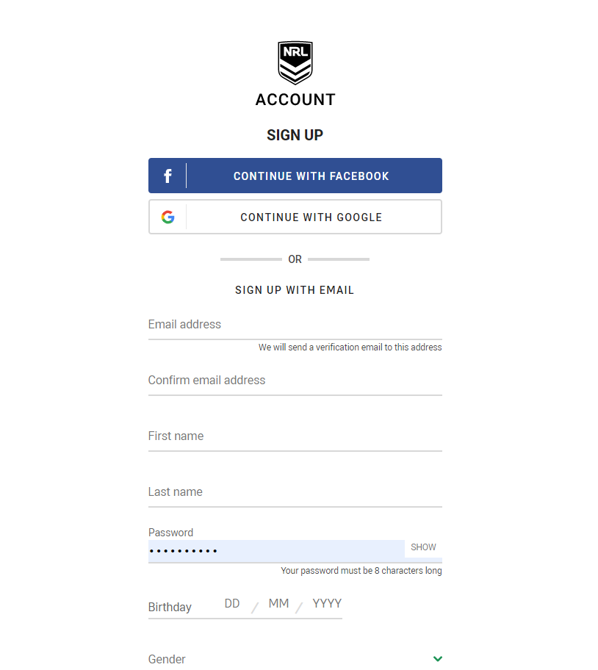

You will need to verify your new account by sending a code to your email address

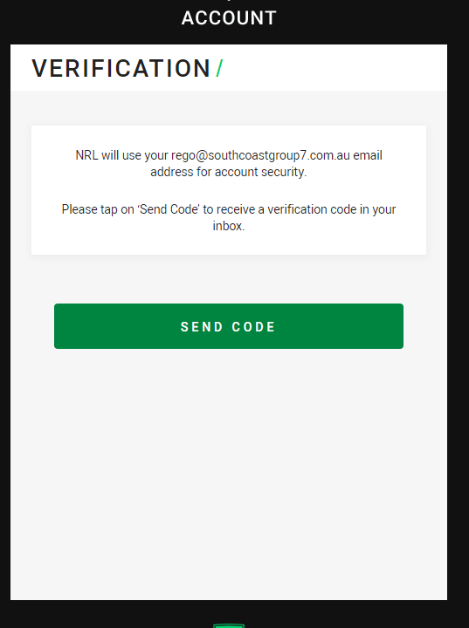

Once you have received your email enter the 4-digit number into your account and press continue. You will now have an NRL account

