## final logo WGC 100 (002) cid:D1B0F730-DD6B-42D8-97D8-D985D4139DDE@home

<http://www.wgccentenary.org/> email: [sport@wgccentenary.org](mailto:sport@wgccentenary.org)

## celebrating a century of sport

## welwyn Garden City centenary – Sport For All

## Summer 2018 Newsletter

**Planning Is Well Underway**

We have now met well over half of the town’s Sports Clubs, youth organisations and schools and are delighted with everyone’s enthusiasm to take part in the Centenary and also with the imaginative ideas suggested to us. If we have not yet been able to meet with you please be patient. Our intention is to speak to everyone this year. On the other hand, if you have a burning desire to meet us, please e-mail the above address .

**How is 2020 Shaping Up?**

Our intention is for a Year of Sport with events throughout the year, but with a concentration in the summer months, particularly a ‘Week of Sport’ from Saturday 27th June to Sunday 4th July. Whilst several things have yet to be confirmed it is looking likely that the town will again be able to host a big cycling event, the WGC Petit Tour, on Sunday 28th June. As usual this will be in the town centre with Parkway as the main cycling track and many ancillary activities and stalls in and around Howardsgate, as shown in the photo below.

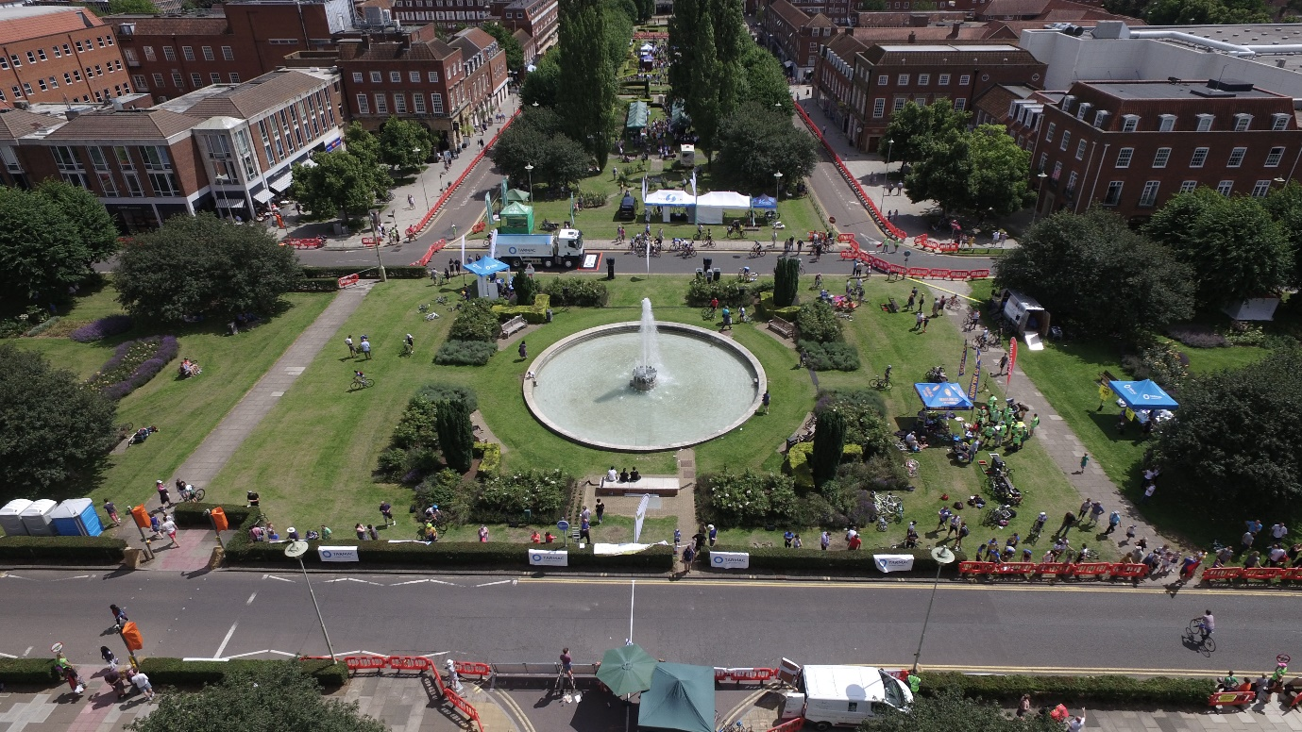

Plans are also afoot for Dragonboat racing at Stanborough Lakes on Sunday 5th July. Our aim here is for teams from local Clubs, Businesses, Youth Organisations and so on to take part.

Between these dates each school will have their own Sports Week and we hope that there will be many activities and competitions with a Centenary theme, perhaps involving key numbers like 2020 and100?.

**Creating Memories**

Like many celebrations the Centenary is an opportunity to have fun and get some kind of memento so you can look back and say “I was there”. Our intention is to provide medals, trophies, t-shirts, plaques and the like not only to provide a sense of achievement for those taking part, but also to haul out of the drawer in years to come and reminisce, perhaps during a future town celebratory event (or a visit by The Antiques Roadshow).

**Funding**

Funds for all of this are not coming from the public purse. Instead, a great deal of work is going into finding willing sponsors who are keen to support what we want to achieve. We will follow up on this with each Club during the next year as more detailed planning gets underway.

**So, Who Is Doing What?**

Suggested events and activities include:

Badminton – a Junior Tournament

Bowls – more below

Bridge – a Safari event

Cricket – possibly a centenary match against Letchworth and a joint event between all the Clubs

Cycling – as well as the Petit Tour a “Come and Try It” session

Golf – An inter-Club tournament, Open Days and youth competitions

Lacrosse – a junior tournament

Netball – Senior and Junior tournaments linked to a Festival of Netball

Orienteering – a ‘come and try it’ event

Running and Triathlon – several events ranging form a Half Marathon, through 10k and 5k runs and a Family 2K run as well as races around the track at Gosling

Tennis – inter-club tournament, an exhibition match and Open Days

Volleyball – a tournament

Youth Football – several events including the Summer Football Tournament at Panshanger Football Club with a Centenary fair Play award.

We have yet to meet with or receive firm ideas for the following sports:

Archery Athletics Boxing Gymnastics Hockey Martial Arts

Rugby Sailing Senior Football Squash Swimming

So, if your Sport or Club is not involved yet, please get in touch with us.

**Youth Organisations**

We are delighted that the Scouts and Guides have shown a keen interest in joining in, not only in sports events but across many other Centenary activities. We have also had a very positive response from the Air Cadets and hope soon to include the Sea, Army, and Marine Cadets. One possibility which is being looked at is some kind of multi-sport competition between them all at Gosling.

**Highlighting Bowls**

We’ve had a very enthusiastic response from the 6 local Bowls Clubs: Shire Park, De Havilland, Hatfield, Welwyn Garden City, Welwyn and Parkside. They are keen to take part by arranging special Centenary events at their own Clubs, especially Open Days, and also a Centenary Tournament between the Clubs who will compete for the Welwyn Garden City Centenary Bowls Trophy. This will be a first for all the Clubs and the hope is that it will be something that can continue in future years.

The season is well underway for all Clubs as the photo below from Parkside shows.

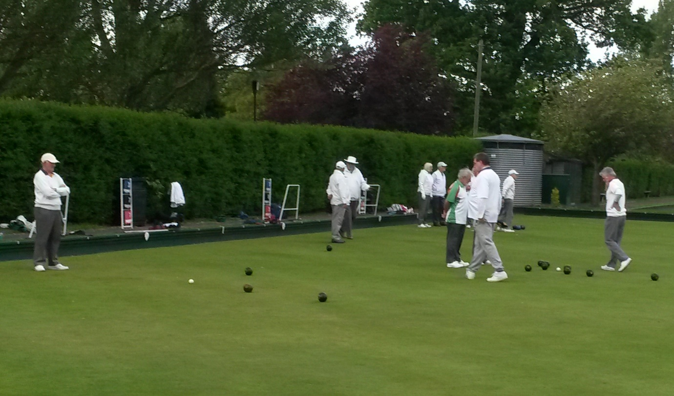

**Better**

By now we are becoming accustomed to the strapline *Better* used by Greenwich Leisure (GLL) which appears not just at Gosling Sports Park but now at Stanborough Lakes, Panshanger Golf Club, King George V and Moneyhole Playing Fields, and elsewhere since the merger with Finesse. This has not only brought the management of all the town’s major sports and leisure venues under one organisation but has given us an opportunity to work with them across a whole range of sports activities. Craig Woodward, their Partnership Manager, is a member of our Sports Group and he has told us that “*GLL are extremely keen to play a major part in all of the centenary celebrations and, especially, sport. We see this as an opportunity to not only help to achieve the aims of Sport For All by making the best use of all of our sites, but also allowing us to make our facilities available to everyone in the town.”*

This is really positive and will enable Clubs, Schools and other organisations to arrange many events.

**How To Get More People Involved In Sport?**

For those of us involved in sport and leisure activities this is the perennial question as we seek to attract new participants and members. During our discussions with Clubs it has been heartening to hear about individual plans and how keen everyone is to use the Centenary as an opportunity to showcase their sport/Club. We on the Sports Group intend to follow this up wherever possible via publicity and highlighting what is taking place.

### So, how is 2020 looking?

Some dates are firm, others are pencilled in:

* February – Love WGC 10k
* March – Welwyn Half Marathon
* April/May – Bowls Clubs’ Open days
* April to September – Bowls tournament
* May - Hertfordshire Triathlon
* Spring – Junior Badminton tournament
* June – Tennis events
* June – a Pop-Lacrosse tournament for schools
* June – Panshanger Football tournament
* June – Welwyn 10k and a 2k Family Run
* June Centurion Triathlon
* June - Day of Yoga – 21st (come & try)
* June – Petit Tour (Sunday 28th)
* June/July – Week of Sport (27 June to 5 July)
* July – Gosling “Come and Try It” day (4 July)
* July - Dragonboat Racing (5th July)
* July – Volleyball tournament on the 2nd
* June/July – Schools Sports week (29 June to 3 July)
* June/July – Welwyn Hatfield Primary School games (3 July?)
* Summer – WGC vs Letchworth Cricket match
* Summer – Family Pitch and Putt and Foot Golf – Panshanger
* Summer – Uniformed Groups Sports tournament
* September – Junior and Senior Netball tournament (5th and 6th)
* October – Cycle Cross 8K and “come and try it”
* December – Cycle Cross

**Please get in touch if you would like to know more by using the links on the first page**.