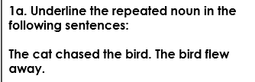
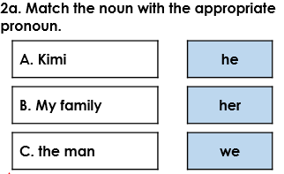

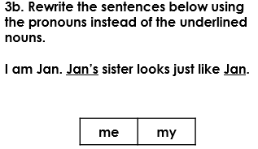
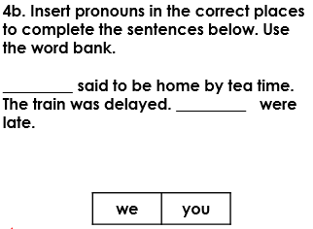
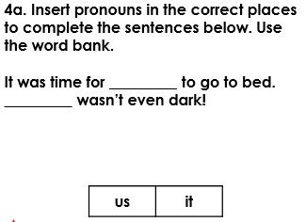
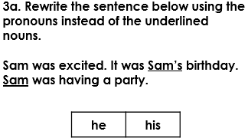

Underline the repeated noun phrase in the following sentences:
The angry, black dogs ran and then the angry, black dogs jumped over the fence.

The old lady from across the road was gardening but then the old lady from across the road vanished!

It was a great invention although James didn’t know if the great invention would work. James hadn’t drawn any plans for the great invention yet.

