Existence


Team Narwhal

Contributing Members: Mitchell Martin, Allante Means, and Hunter Marquis.

Description

A few hundred years in the future humanity has branched off into the depths of the galaxy, finding new ways to expand the standard lifestyles of the human way. With a newfound intelligent alien life form, humanity has monopolized the alien’s entertainment that resembles a demolition derby with space ships on a uninhabited planet with an earth-like atmosphere. Wages are placed on Alien and Human ships for large amounts of currency. The Arms Dealer lurks in the shadows of the planet looking to make a buck by rigging the fights. Payments can be made to the Arms Dealer to help influence your chances of victory. Bet wisely, you’ll never know how dirty the other betters are playing.

Designer’s Intent

- Destroy: Destroying a ship removes the ship from play, which simulates a real battle with ships where the only way to win is to destroy the enemy ship.
- Bluffing: Turn the tides of battle by raising your bet, rearranging your cards, looking at items but not purchasing them, purchasing items and saving them for clutch wins, all to try to bait your enemy.
- Translate: In between battles manipulate your fleet as you see fit, translate the order of your fleet to capitalize, or get back into the battle.
- Disperse: Players must use their resources wisely by strategically spending their money. If a player misuses their money, it could lead to their defeat.
- Trade: A neutral mercenary ship is supplying munitions for the games, allowing bettors to bribe him to rig the games. This allows the Players to quickly and strategically alter the outcome of battles.
- Intended Audience: Sci-fi fans between ages 13 - 40 who are a interested in a strategic, gambling combat game.
Materials list

- 2 Fleet Decks - 25 Cards per player *See card section for Cut-Outs
- Arms Dealer Deck - 45 Cards *See card section for Cut-Outs
- Asteroid Deck - 20 Cards *See card section for Cut-Outs
- Currency - (25) 1,000; (15) 5,000; (10)10,000 Cut-Out Coin Cards *See card section for Cut-Outs


Asteroid Cards
5,000

Power increase

Effect
Item Cards
Ship Cards

Value
Repair 1 Scout from your Scrapyard to add back to your Fleet Deck.
+100
Drone
100
Place Items Here
5,000
10,000
1,000
Coins (by Value)
Ship

Power
The Board
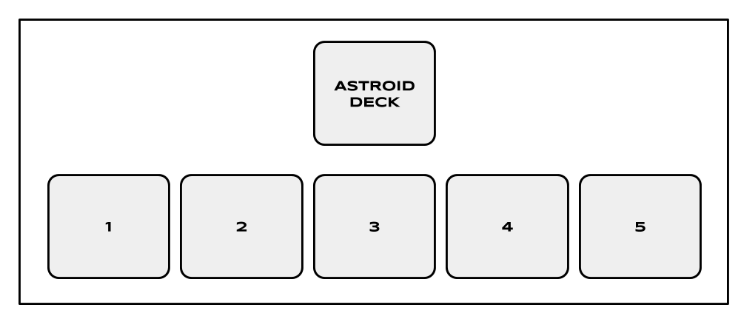
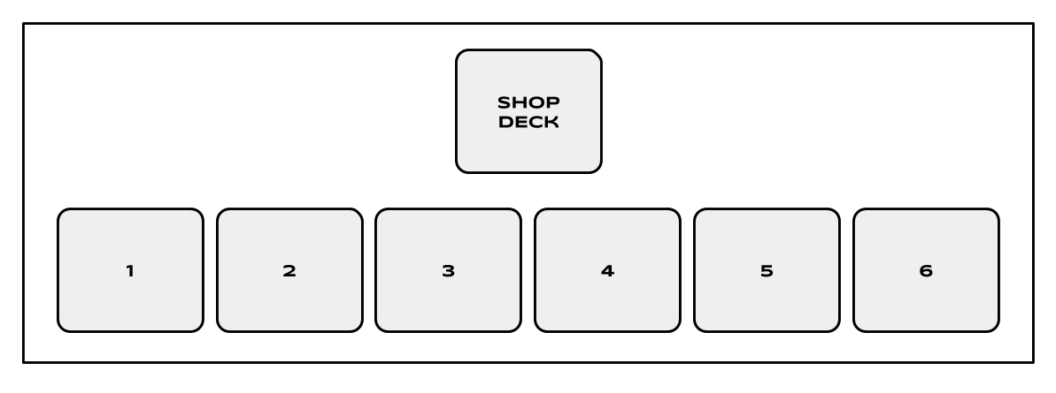
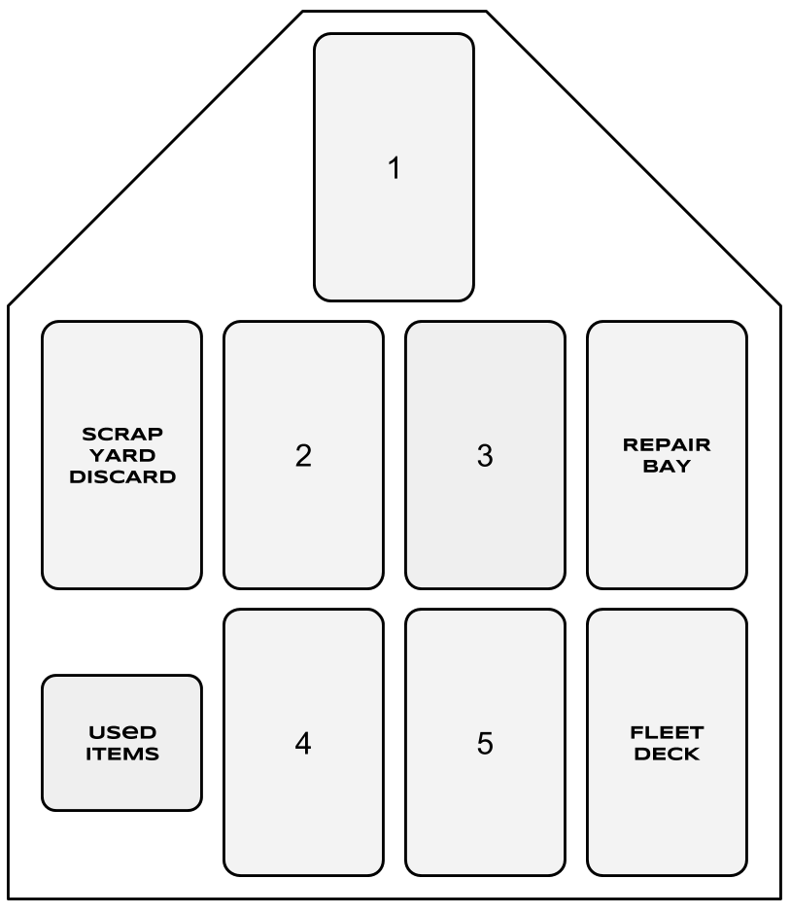
Rules
Setup

- Each Player will choose one of the two Fleet Decks, either humans or aliens, and shuffle their deck before placing the respective deck face down in front of them.
- Shuffle the Arms Dealer deck and place it face down on the side of the playing field within reach of both players.
- Remove the top 6 cards from the Arms Dealer deck and place them face down in a line from one player to the other. These will be the starting items in the Shop.
- Shuffle the Asteroid deck and place the deck face down on the side of the playing field opposite the Arms Dealer deck.
- Remove the top 5 cards from the Asteroid deck and place them face down in a line opposite the Shop.
- Each Player takes (1) 10,00 coin, (1) 5,000 coin, and (3) 1,000 coins for their starting money and the remaining money is placed near the Arms Dealer deck outside the play field.

Turn Phase

Fleet Phase
- Each player will draw the top 5 cards of their Fleet deck. The Players will then lay the 5 cards face down on the playing field in any order they choose on the numbered spaces. The numbered spaces will determine the order in which the ships engage in battle.

Arms Dealer Phase
- The first player with all of their cards face down on the field in the order they choose gets to buy from the Arms Dealer first and may not reorder their cards.
- Players may spend 1,000 coins per card to flip over and see what the card does/says. Then, the Player will decide if they want to keep the card to use in a future battle, or replace the card face down. If the Player chooses to keep the card, the Player must spend 2,000 additional coins. The card is then added to the Player’s hand to be used in battle.
- Once the first player is finished purchasing, the second player may then purchase for their ship.

(See Arms Dealer in General Rules for more details)

Betting Phase
- The first player who purchased items will place the first bet at 3,000 coins. The second player’s initial bet is 2,000 coins. This will ensure the winner gets at least 5,000 coins each battle.
- After the first time betting, the winner of the previous skirmish will be placing the first bet.

Battle Phase
- Once both Players are finished purchasing items, the battle will begin.
- Each fight between two ships is called a skirmish. There are 5 skirmishes per battle.
- The first skirmish of the battle begins by both players flipping over the card in the location labeled “1”. Players may then choose to equip an item they have purchased to their face up ship. After items have been placed or if both players decided not to equip items, the ship with the highest power is the winner of the skirmish.
- If two ships have equal power, both ships are destroyed and count as a win for both players. The most recent Player to go first will go first again in the next skirmish.
- The items used will placed face up in a stack next to the Arms Dealer Deck. The destroyed ship is then placed face up in the Scrapyard discard pile to the left of the winning Player’s Formation Playing Field while the winning ship is returned to the Repair Bay and placed face down to the right of the Fleet Deck.
- The losing ship is placed in the Scrapyard while the winning ship is placed in the Repair Bay.

Strategy Phase
- After the first skirmish, the strategy phase will begin.
- The winner of the previous skirmish will have the first turn. If tied in the previous skirmish, the player who went first last will go first again.
- One, and only one, of three actions must be taken:
  - Ready up: perform no changes and the second player will then be able reorder fleet or do the same.
  - Raise the bet: second player must match the bet or forfeit the next skirmish.
  - Reorder fleet: Switch the order of two of your remaining face down ships, giving the opportunity for the second player to do the same or keep their ships in the same order.
- The next skirmish will take place once both players have taken an action and the victor is determined in the same way as the initial skirmish.

Collection Phase
- The first player to successfully win 3 skirmishes is the winner of the battle and collects the pot of money made by bets. If both Players reach 3 skirmish wins at the same time, skirmishes will continue to take place Sudden Death style until a skirmish has only one victor.
- The losing Player will draw 2 of the asteroid cards and receive coins equal to the amount displayed on the cards.
- Once the coins have been dispersed, the remaining Asteroid and Arms Dealer cards will be discarded and replaced with the amounts described in the Setup.
- The next battle then begins by returning to the Fleet Phase.

General Rules

Arms Dealer
- When purchasing from the shop, a Player may view and purchase as many items as their supply of money allows.
- No cards can be purchased directly from the deck. Only cards on the field may be purchased
- New cards are not drawn until the Collection Phase
- If the shop runs out of cards during the Arms Dealer Phase, no cards may be purchased until a Collection Phase is reached.

Asteroids
- The defeated Player is the only one who may harvest an asteroid for resources.
- Only two asteroids may be drawn per Collection Phase.

The Ships
- When a Player’s Fleet deck has run out of cards, the cards in the Repair Bay are shuffled and become the new Fleet Deck.

Betting
- Bets may not be withdrawn. Once a bet or raise is placed, it will stay in the pot until the battle is complete and a victor obtains the coins.

Winning the Game
- If one Player has no ships remaining to use, the Player with ships remaining is the winner.
- If both players destroy each other’s last ship and neither player can play a ship, the Player with the most money wins.
- If one Player is unable to place the initial bet, the other Player wins.

Mechanics (cards are shown face up to see the placement of specific cards)

Destroy
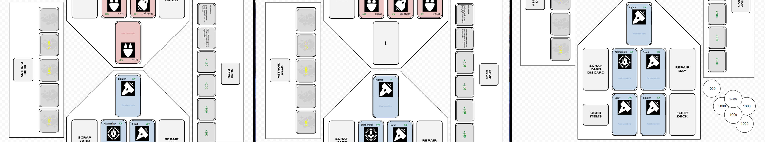

- When a ship loses a skirmish due to its’ power being less than that of the enemy’s, the ship is destroyed, sent to the Scrapyard and is unable to be used again unless a card states otherwise.

Bluffing
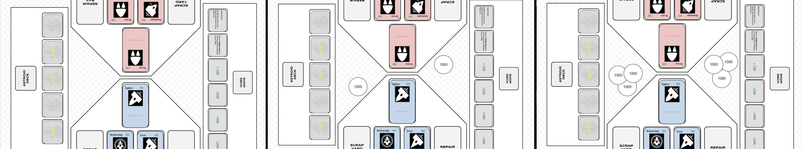
- With the Betting phase players are allowed to raise or lower their bets to sway the opponent's movement, to forcibly persuade the opponent to consider the depth of the bet and potentially exceed their initial bet with player 1 hoping to bait Player 2 into a larger bet.

Translate
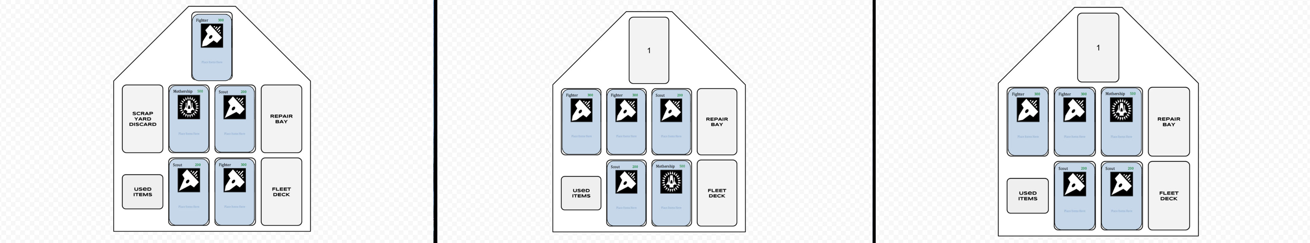
- Players have the option to change the order of their Fleet at any moment during the Strategy Phase, giving the player the ability to facilitate the battle the way they see fit.

Disperse
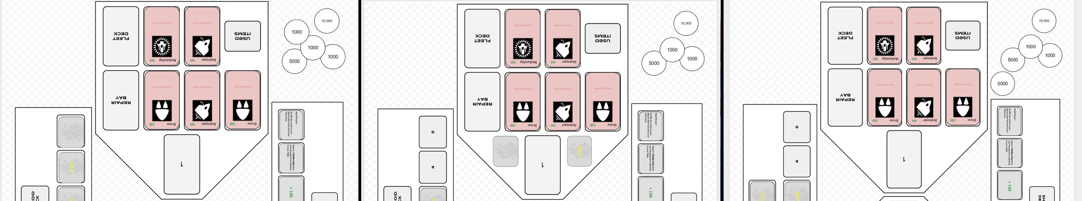
- Currency can be earned winning battles by placing bets in between skirmishes, and harvesting asteroids. The coins are dispersed at the end of battles.

Trade
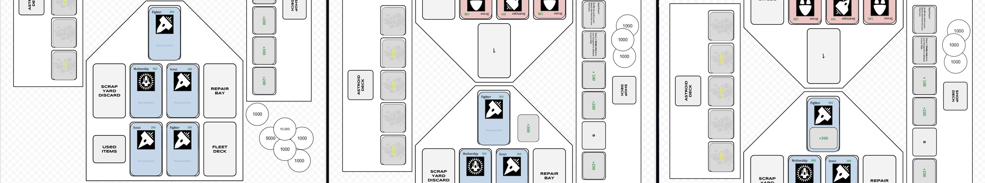
- Trade your accrued currency with the Arms Dealer for items to give your team an advantage in battle.

Developer’s Log

Taking the Attack and Defend mechanics out of a combat game proved to be quite difficult at first, especially considering the Destroy mechanic was to remain in the game. To keep the Destroy mechanic, there needed to be some sort of combat, but with fewer features. One way we thought to do this was to create a rock, paper, scissors mechanic so certain ships will beat other ships; but with 5 ship types, not all ships would line up properly. Instead of having the Firepower and Shield, we changed it to a single “Power” stat for each of the ships. So the combat has less player interaction and choice.
When trying to add in the new mechanic of Bluffing, we immediately thought of poker-like games with placing bets and performing actions unknown to the other player to get inside their head. While keeping combat in the game, the bluffing turned into placing bets on the combat itself. This changed our story as well from the players being two factions fighting one another, to the players being a third party overseeing the combat of the two factions. Betting on individual battles did not seem all that entertaining so we decided to extend the battles into round-based combat. This built suspense and even more opportunities for the players to bluff. To implement the Bluffing mechanic, we had to modify our combat phase pretty extensively. We split the phase of combat into two parts: the battles/skirmishes themselves and a strategy phase giving players the opportunity to rethink their strategy and see how the other player is playing the game. In our first version of the game all cards were visible to all players. There was no knowledge hidden from the enemy player. Instead of just adding the betting feature, we also decided to place the items face down, and give players the opportunity to arrange the order of their cards in any way they choose. Some players may choose to play all of their strong cards at the beginning of the order for a power play. While others may play weaker cards first because of some items they have in their hand to get the upper hand. There are many ways for players to use the Bluff mechanic.
The options of the second mechanic seemed difficult because of their simplicity. Obfuscate seemed to go right alongside the Bluffing mechanic so it was difficult to implement it separately. Translate was somewhat already present in the game because of our flipping/revealing of the cards so we had to come up with a new way to use it. Since we had a board for the game setup and numbered spaces on the board, the best way to newly use translate was changing the order of ships. With combat being round-based, we found that giving players the opportunity to change the order of the cards was a way to give a losing player a chance to come back, or any player to change their strategy; all the while still having a chance to bluff and win the skirmish/battle.
Our first of the game was very fast-paced and meant for gamers who like quick-strategic fun. The main part of the game, ships doing battle was mostly luck-based with the players not knowing what ship they would be doing battle with. This time around we tried to implement a lot more strategic gameplay. The items cards were placed facedown so the player must strategically decide what/if they want to view. Then, players may decide if they want to purchase the card or not, which could potentially be a bluffing opportunity to make the other player think the card viewed was useless. Players determine the order their ships do battle instead of it being luck-based. To keep a balance of luck and strategy, the 5 cards used in the fleet are drawn from the deck with the player unable to choose which cards their hand will contain. Otherwise, the players would always choose the strongest cards. We wanted to implement new strategic opportunities for players without changing the feel of the game.
In the end, once we narrowed down the features that had to be removed (Firepower and Shield), it was just a matter of adding in the new mechanics without straying too far from our original vision. We isolated our original features that didn’t have to do with Attack or Defend and kept them constant prior to touching on the new mechanics. After finding ways to add in Bluffing and Translate, we then tweaked the original features to fit in with the new mechanics. This helped to make this version of the game feel like an add-on instead of a whole new game.

References
Narwal Pic:

Emblem [Digital image]. (n.d.). Retrieved October 8, 2016, from
https://s-media-cache-ak0.pinimg.com/236x/ed/46/17/ed46177463b8561e173cb7f91b71b244.jpg

Icons on cards:

Card Images [Digital image]. (n.d.). Retrieved October 9, 2016, from http://game-icons.net

Drone
100
Place Items Here

Drone
100
Place Items Here

Drone
100
Place Items Here

Drone
100
Place Items Here

Drone
100
Place Items Here

Drone
100
Place Items Here

Drone
100
Place Items Here

Drone
100
Place Items Here

Drone

100
Place Items Here
Drone

100
Place Items Here
Drone

100
Place Items Here
Drone

100
Place Items Here
Drone

100
Place Items Here
Drone

100
Place Items Here
Drone

100
Place Items Here
Drone
100
Place Items Here


Scout

200
Place Items Here
Scout

200
Place Items Here
Scout

200
Place Items Here
Scout

200
Place Items Here
Scout

200
Place Items Here
Scout

200
Place Items Here
Drone

100
Place Items Here
Drone

100
Place Items Here
Scout

200
Place Items Here
Scout

200
Place Items Here
Scout

200
Place Items Here
Scout

200
Place Items Here
Scout

200
Place Items Here
Scout

200
Place Items Here
Scout

200
Place Items Here
Scout

200
Place Items Here

Fighter

300
Place Items Here
Fighter

300
Place Items Here
Fighter

300
Place Items Here
Fighter

300
Place Items Here
Fighter

300
Place Items Here
Fighter

300
Place Items Here
Fighter

300
Place Items Here
Fighter

300
Place Items Here

Fighter

300
Place Items Here
Fighter

300
Place Items Here
Destroyer

400
Place Items Here
Destroyer

400
Place Items Here
Destroyer

400
Place Items Here
Destroyer

400
Place Items Here
Destroyer

400
Place Items Here
Destroyer

400
Place Items Here

Repair 1 Drone from your Scrapyard to add back to your Fleet Deck.

Repair 1 Drone from your Scrapyard to add back to your Fleet Deck.

Repair 1 Drone from your Scrapyard to add back to your Fleet Deck.

Repair 1 Scout from your Scrapyard to add back to your Fleet Deck.

Repair 1 Scout from your Scrapyard to add back to your Fleet Deck.

Repair 1 Scout from your Scrapyard to add back to your Fleet Deck.

Repair 1 Fighter from your Scrapyard to add back to your Fleet Deck.

Repair 1 Fighter from your Scrapyard to add back to your Fleet Deck.

Repair 1 Destroyer from your Scrapyard to add back to your Fleet Deck.
Reinforcements!
Flip over the next card of your Fleet Deck to assist you in combat for this skirmish only. Add the power of the new card to your current card. If defeated, both cards are destroyed.
Reinforcements!
Flip over the next card of your Fleet Deck to assist you in combat for this skirmish only. Add the power of the new card to your current card. If defeated, both cards are destroyed.
Reinforcements!
Flip over the next card of your Fleet Deck to assist you in combat for this skirmish only. Add the power of the new card to your current card. If defeated, both cards are destroyed.
Reinforcements!
Flip over the next card of your Fleet Deck to assist you in combat for this skirmish only. Add the power of the new card to your current card. If defeated, both cards are destroyed.

Repair 1 Mothership from your Scrapyard to add back to your Fleet.
Reinforcements!
Flip over the next card of your Fleet Deck to assist you in combat for this skirmish only. Add the power of the new card to your current card. If defeated, both cards are destroyed.

Repair 1 Destroyer from your Scrapyard to add back to your Fleet Deck.
Redraw!
Return your current Ship card on the field to the Fleet Deck and shuffle. Return the deck face down to playing field and flip the top card over. This will be your new card for combat this skirmish.
Redraw!
Return your current Ship card on the field to the Fleet Deck and shuffle. Return the deck face down to playing field and flip the top card over. This will be your new card for combat this skirmish.
Redraw!
Return your current Ship card on the field to the Fleet Deck and shuffle. Return the deck face down to playing field and flip the top card over. This will be your new card for combat this skirmish.
Redraw!
Return your current Ship card on the field to the Fleet Deck and shuffle. Return the deck face down to playing field and flip the top card over. This will be your new card for combat this skirmish.
+ 100

+ 100

+ 100

+ 100

+ 100

+ 100

+ 100

+ 100

Rapid Repair!

Shuffle the cards in your Repair deck back into your Fleet Deck.

Rapid Repair!

Shuffle the cards in your Repair deck back into your Fleet Deck.

Rapid Repair!

Shuffle the cards in your Repair deck back into your Fleet Deck.
Redraw!
Return your current Ship card on the field to the Fleet Deck and shuffle. Return the deck face down to playing field and flip the top card over. This will be your new card for combat this skirmish.
+400
+400
+300
+300
+300
+300
+200

+200

+200

+200

+200

+200

+ 500

5,000
5,000
1,000
1,000
1,000
1,000
1,000
1,000
1,000
1,000

Mothership

500
Place Items Here
Mothership

500
Place Items Here
3,000
3,000
3,000
3,000

5,000
5,000
5,000
5,000
5,000
5,000
5,000
5,000
5,000
5,000
10,000
10,000
10,000
10,000
10,000
10,000
10,000
1,000
1,000
1,000
1,000
1,000
1,000
1,000
1,000
1,000
1,000
1,000
1,000
1,000
1,000
1,000
1,000
1,000
1,000
1,000
1,000
1,000
1,000
1,000
1,000
1,000
5,000
5,000
5,000
5,000
5,000
10,000
10,000
10,000

