
Cosmic Armada
Dynamic Cosmos

Steven Sims

Jerime Garivay

Mitchell Martin-Moran

Veronica Jackson

Christopher Miller

Jesse Cady

DESIGN DOCUMENT
11/16/15

Table of Contents
Table of Contents
Design History
Version 1.10 (Pre-Alpha)
Using the ability cards in your hand during attack sessions to a positive effect.
Version 2.00
Game Overview
Where does the game take place?
What is the story?
What is the main focus?
How many characters/units/pieces does the player control?
Game Theory
Feature Set
General Features
Game Components
Rules & Mechanics
Game Setup
Turn Sequence
General Rules
Resources
Ships
Movement
Combat
Abilities
Map
Spaces
Planets
Asteroids
Cards
Events
Abilities
Detailed Rules for Specific Pieces
Flowcharts
End Game Conditions
Rules Questions & Strategies

Design History
We were trying to incorporate a fleet building aspect to the Cosmic Armada design. There were some complications due to the designing and mechanics let alone the balance work of the scope. The team decided to scrap the idea and go with, 10 ships at maximum for each player. Our team has also revamped the resource system into two formats, the Resource Y (Energy) and Resource Z (Electronics). We believe this will make it more user friendly for the players. The team expects to perfect the game within 3-4 version updates.

Version 1.10 (Pre-Alpha)

Game Board
- Contains 9 regions
  - Two player start regions
  - Six planet Regions
  - One Capital Planet region.

Ships
- 10 ships placed at the start
  - Including Command Ship
- Build more ships w/ blueprints from resources throughout the game
- Two different styled teams
- Each moves a different way
- Built from scraps and resources
- Duplicating smaller ships

Combat
- When you defeat a ship, gathering scrap
- Each has an offensive and defensive ability
  - each combat will use one ability per ship either offensive or defensive
- Different ship types have positives and negatives. Such as stealth/scout ships are fast but lack offensive and defensive abilities. Defenses lack Offense and speed, and offense lacks defense and speed.
- Using ship’s class abilities and ability cards

Resources
- Resource A (Energy)
- Resource B (electronics)

Fighting over Planets/resources

7 Planets per game (12 Planets total)
- Asteroids/moons in addition
  - Taking up smaller spaces to create additional strategic moves
  - Smaller number of resources
- Small planets randomly selected at the start of each game
- Taking up the flower shaped spaces
- Row/column decided by 20 sided, moving additional spaces by additional dice
- Reroll if too close to one another (5 or 6 spaces)
- Placed in the sectors

Planet dynamics
- Gather resources
- Color in space for planet
- Resources exhausted after three turns
  - Disappears afterwards
- Within one space around planet, ability to move freely to defend

Events
- Events will be either good or bad and will be determined at random points in time.
- Events will occur through each of the planets.

Additional Elements
- Warp drive ability, once every ten turns - jumping more spaces than normal
- Event cards/abilities

Using the ability cards in your hand during attack sessions to a positive effect.

Version 2.00
- Play Board:
  - The board is split into nine total regions with neutral territories and non navigational areas in between.
    - Brek Bashers and Bruisers Player Sector (Running Name)
    - Soldi Cacciatore Player Sector (Running Name)
    - Planet Sector One (Running Name)
    - Planet Sector Two (Running Name)
    - Planet Sector Three (Running Name)
    - Planet Sector Four (Running Name)
    - Planet Sector Five (Running Name)
    - Nova Alexandria (Running Name)
    - Blabahiri Capital Planet Sector (Running Name)
- Ship movement:
  - At the start of the game, players will place their fleet in their own strategic way, within the designated player area.
  - After the start of the game, players will move their ships based upon ship speed.
  - For every point in ship speed, players can move their ship one space.
  - Each ship has different Armada Abilities that can affect other ships within their Armada or themselves.
    - Example is a defensive ship that allows other ships in certain areas around it to gain a shield to avoid being taken out by another player
  - Players will also move their ships into different planet’s orbits to collect resources.
    - Every turn that a player is in the planet’s orbit, the player will receive materials, with a cap in materials you can have at once, that can be used for special ability cards.
  - Players can “attack” another player’s ships and will take them out if there is no shield or ability card to save the ship.
    - There are certain ability cards that allow a ship to gain a shield for a short period of time, such as one turn, to avoid being destroyed.
  - If another player takes out one of your ships, it will no longer be on the board, or at your disposal.
  - You must also protect your Command Ship from enemy attack as well.
    - Your Command Ship can move and does have abilities attached to it, but if your ship is destroyed you lose the game.
  - Attacking a player is the act of moving to a space beside, above, or underneath an enemy ship and declaring an attack.
    - If the ship has no shield or ability card that the player activates, then the ship is destroyed.
  - Moving as a squad:
    - This is the act of moving a defender or commander class grouping together.
      - These two ship types have a special ability called an Armada Ability.
      - The Armada ability allows the ship to add neighboring ships to it in order to form a squad.
      - A player can move a squad once per turn if they want to the same amount of spaces that the Defender or Command class ship can normally move.
        - Downside is you can no longer move any other ships that turn.
- Resources:
  - Resources are gathered from controlling a Planet.
  - There are two different types of resources available in the game:
    - Resource A (Dark Green Gems)
    - Resource B (Root Beer Gems)
  - These resources have a set maximum limit of resources per player.
    - Resource A has a max limit of 10 pieces
    - Resource B has a max limit of 10 pieces.
- Ability Cards:
  - Players will draw 5 cards at the beginning of the game for their base set of ability cards.
  - Players can draw new ability cards after completing an event or destroying an enemy ship.
  - Players can use ability cards at anytime, as long as they have enough resources to activate the ability card.
  - Ability cards are cards used to help you or hurt the other player in attack sequences.
    - An example of this would be a player is being attacked and he has a card that allows him to put up a shield to negate the attack. This will use resources that the player has acquired.
- Planets:
  - At the beginning of the game after ships are placed, players will draw planets for each planet sector on the board and set the planet cutouts in its designated spot.
    - Planet Sectors are as follows:
      - Planet Sector One
      - Planet Sector Two
      - Planet Sector Three
      - Planet Sector Four
      - Planet Sector Five
      - Capital Planet Sector
  - Each Planet has a different set of resources available and sometimes have events attached to them.
  - A player can collect resources from the Planet as long as they are in the Planet’s atmosphere and there is not an enemy ship in the same planet’s atmosphere.
  - If there is another enemy ship at the same planet, neither faction can collect resources from that planet until one of the factions are gone.
- Event Cards:
  - Events are instances that some planets have.
  - Events are drawn by the player and can range from a positive outcome to a negative one.
    - An example would be a player draws a card that causes them to lose all of their resources they have stocked up or an event that causes the player’s resources to be completely full.
  - Event frequencies are decided by the particular planet they are occurring on.
    - An example would be one planet may have a player draw an event card every three turns that the player is in control of the planet.
    - A player can leave the planet prior to the event, but there are a lot of positive things that can come from participation in an event.

Version 2.1

We removed the ship abilities and decided to up the speed of the ships by two because we wanted to make the game more focused on the Ability Cards. Also, the ships didn’t seem to be moving far and it was taking a while for any of the ships to actually interact. We also upped the ability card deck count to 40.

Game Overview

Where does the game take place?
Cosmic Armada takes place in the deep reaches of space, where Bounty Hunters and Scavengers bide for resources that can make them rich and famous. Factions now run the Galaxy and strive to grasp more areas for a wider control.

What is the story?
Two major factions, Brek’s Bashers and Bruisers and Soldi Cacciator, are bidding for control over a heavily influential solar system in the Andromeda Galaxy. Taking control of one of these factions, players will wage war on the opposition to gain a foothold in this central system. Collect resources and use special abilities to gain dominance and take over the system.

What is the main focus?
The main focus in the game is to hunt down and defeat the opposing enemy armada. The player must conquer many planets to gain additional resources to apply devastating attacks and quick thinking defensive counter measures in order to achieve the goal of the game.

How many characters/units/pieces does the player control?
Cosmic Armada is a 2 player strategic tabletop game. The player(s) are controlling a fleet of 10 unique ships under their command. The grid is hexagonal so the player is able to move 360 Degrees in any direction. They will also take control of planets to gain resources that they will use throughout the game. Additionally players will build a deck of 40 ability cards that allow them to gain special movements, attacks, or defensive traits that use the resources that players have collected.

Game Theory
Symmetry – The game has both symmetric and asymmetric pieces. The map is symmetric because the players are both equal distance from the planets and having the same required starting areas. The asymmetric aspect of this is that the players may select their starting spaces within the zones. Both players have the same cards to choose from to make their decks, which is symmetric, but each player chooses which cards are in their deck, which would make it asymmetric.

Play Style – This game is non-cooperative. We want to provide a competitive PvP (Player Vs. Player) aspect inside the game. We wanted to have the same feel as Magic the Gathering by the card play mechanics between both players within a game board environment.

Summation – Cosmic Armada has a zero-sum aspect when each player is engaged in combat. The ship that the player lost in battle cannot return to the playing field. Cosmic Armada also has a non-zero-sum element when each player orbits around a planet to gain additional resources; this doesn’t affect the other player unless they’re both contesting the same planet.

Perfect/Imperfect Information – The perfect information on Cosmic Armada is the battlefield. Additionally, each player can view the stats on the ships within the playing field. Each player can see where all the ships are at throughout the game. This is the only element that remains constant. The only imperfect information is the ability cards that the players have in their hand, as well as the event cards from planetary conquest.

Feature Set

General Features
- Players try to conquer the planets to obtain resources to use throughout the game.
- Conflict takes place numerous times if players choose to initiate combat between one another.
- There must be two players for the game to take place. We don’t have a way to include more than that so for now it is only two-player.

Game Components

- 1 Game Board with hexes with nine different zones as well as two permanent and 4 possible non navigational areas
  - Brek’s Breakers and Bruisers Starting Zone
  - Soldi Cacciator Starting Zone
  - Six Planet Zones
  - One Capital Planet Zone
  - 567 spaces in total 27 X 21 rows
- 20 Resource A root beer glass counters
  - These will be used for the resource costs of every Ability Card, Ship Class Ability, and some Event Cards.
  - These will be collected throughout the game by occupying different planets on the game board.
- 20 Resource B dark green glass counters
  - These will be used for the resource costs of every Ability Card, Ship Class Ability, and some Event Cards.
  - These will be collected throughout the game by occupying different planets on the game board.
- 10 Brek’s Breakers and Bruisers ship cut out pieces
  - These will be used to visually represent the different ships on the game board.
- 10 Brek’s Breakers and Bruisers ship reference cards
  - These will contain information about the different ships, such as backstory, speed stats, and Class Abilities.
- 10 Soldi Cacciator ship cut out pieces
  - These will be used to visually represent the different ships on the game board.
- 10 Soldi Cacciator ship reference cards
  - These will contain information about the different ships, such as backstory, speed stats, and Class Abilities.
- 11 Planet Cards
  - These will contain information on the different planets that will be placed on the board for the duration of the game.
    - Information such as how many resources per turn and player gets, how often does an event card need to be drawn, and backstory on the Planet will be displayed on this card.
- 6 Planet Identifiers
- These will be used to lay on the board to identify the planet assignments
- 3 Capital Planet Cards
  - These will contain information on the different planets that will be placed on the board for the duration of the game.
    - Information such as how many resources per turn and player gets, how often does an event card need to be drawn, and backstory on the Planet will be displayed on this card.
- 1 Capital Planet Identifier
  - This will be used to mark the location of the planet deck on the game board.
- Rule Book
  - This will contain all the rules of the game and how to play.
- Two Sets of 20 Ability Cards per Player (Players will build decks of 40 cards per player out of these sets)
  - Each player will have a pre-built deck of cards to select from to make their 40-card deck.
    - Players will build these decks before the game and will use these decks to give their Armada special abilities throughout the game.
- 20 Event Cards
  - These are cards that have information on different events that players will go through throughout the game.
    - Every card has a different event on them that can range from good to bad. These will either help the player or hurt them.
- 7 Six-Sided Dice
  - These will be used to keep track of the event counters on the planets.
- 4 Asteroid Belt Cutout Pieces
  - These will be placed within the blue designated areas to create new non-navigational areas.
- 2 Asteroid Belt Cut-Out-Pieces
- Wet-Erase Markers (for board labeling)

Rules & Mechanics

Game Setup
1. Place the board in between both players with the green starting zones closest to the players
2. Shuffle the event cards and place them face down on either open side of the board equal distance from both players.
3. Both players create a deck of their designated Ability cards and shuffle these decks to be placed face down in front of them. 5 cards are then drawn to make the starting hand.
- Deck can contain:
  - 40 cards maximum.
  - No more than 3 copies of the same General Ability Card in a deck.
  - No more than 2 copies of the same Ship Class Ability Card in a deck.
4. Shuffle up the Planet Cards and Draw six of them from the top of the deck. Each of these will represent the designated Planet Sectors in the order they were drawn. Place these on the side opposite the event cards so both players can see them throughout the game.
5. The Capital Planet deck is then shuffled and a card is drawn to be assigned to the Capital Sector.
6. Each player then places their ten ships wherever they please within the Green Starting Area on their own side of the map.
7. A coin is then flipped to determine who goes first.
4. Place the Planet Identifiers on the Planet Sectors on the board. They can be placed on any of the spaces.

Turn Sequence
1. Prior to the movement of any ships, all resources are either added or lost as directed (see Resources).
2. The player may move up to three ships in one turn and use any abilities able to be used (see Abilities).
3. Combat can be initiated with any ship capable of combat (see Ships: Combat).
4. Once all combat, abilities and events have been resolved play shifts to the other player.

General Rules

Resources

Resource A - A very precious and sturdy metal, it is the only metal that is capable of entering and exiting faster than light travel.

Resource B – A highly combustible substance that has been refined to become engine fuel, as well as being used in many weapon systems.

- Resources can be obtained from Events, Abilities, or Planets. Sometimes these things can make you lose resources as well.
- Abilities need resources to be activated.
- Players can not have more than 10 of each resource.

Ships
Each player has 10 ships:

1 Command Ship 3 Defensive Class Ships
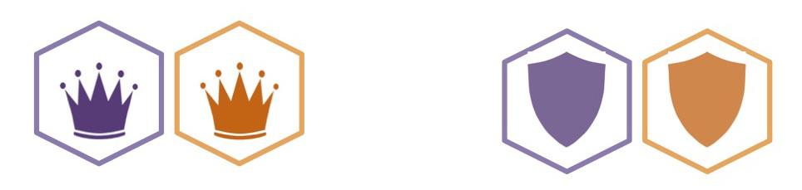

3 Attacker Ships 3 Scout Ships
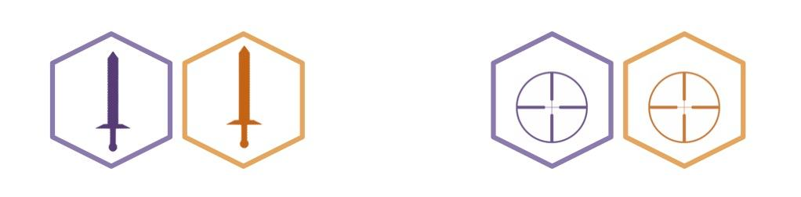

Movement
- Each ship has a Speed that determines the max amount of spaces it can move in one turn.
- Players may move up to 3 ships per turn. A player can move less than three if desired but no more than three can moved in one turn.
- Players can move any space adjacent to their current space and it would count as one.

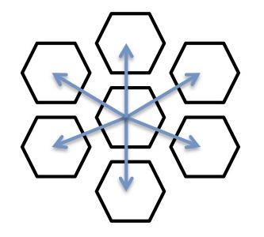

- Two ships cannot occupy the same space otherwise combat is initiated to determine which ship can stay there.
- Ships cannot land on a solid colored space such as Planets and Asteroids.

Combat
- When a ship is approaching the same space and is within one space as an existing ship, Combat is initiated if the player chooses to initiate it.
- If the defending player has no abilities to use to defend them or if they are out of abilities to use, their ship is destroyed and the winning ship takes the space of the defeated.
- Abilities maybe be used to counter whenever possible.
- The last ability to be used will be the final result of the combat.
- When a ship is defeated, the winning player draws an ability card.

Map

Spaces
- Players may travel in any open space on the board. It is allowed to return to the player’s starting zone once it has been left. This is only to limit planet proximity at the start of the game.

Planets
- The map consists of 6 Planets and 1 Capital Planet
  - The Capital planet gives more of a reward for owning it but has a higher risk due to its central location and extended atmospheric space.
- If a ship is within the atmosphere of a planet (Red Outlined spaces), they gain control of the planet obtaining the resources and events that come along with it.
- Once a Planet is captured, place a die on the Planet card to mark the turn count for the occurrence of Events and reduce the number at the beginning of each of your turns for the Planets that you control. Once the die is to reach zero, place it back at the maximum turn count and trigger an Event.
- If two ships occupy the atmosphere of the same planet and no combat is taking place, neither player has control of the planet even if one player has more ships in the atmosphere.
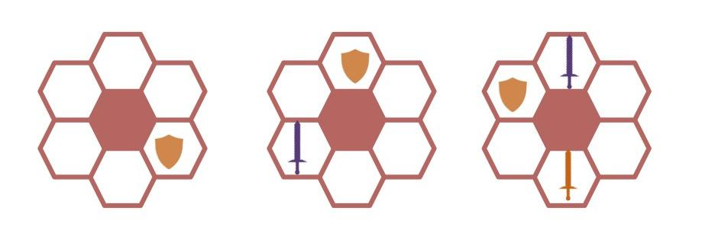

Asteroids
- The solid blue spaces are the Asteroid Belts. These spaces cannot be traveled on. They are obstacles that must be gone around unless an Ability is used that specifically states traveling over it is allowed.
- The Blue outlined spaces are areas that asteroid belts may appear if an event induces it. If stated, the solid blue cutouts are placed within the outline to make the spaces impassable.
- If a ship is in the area where an Asteroid Belt is appearing, it is immediately destroyed.

Cards

Events
- Events are unexpected occurrences that can either help or hinder the players.
- Events can be triggered either by Planets or if an ability states so.
- A planet only triggers an Event after a player gains control of it. If control changes, a new event is not triggered but the turn count continues. If both players are in the Atmosphere of the same Planet, the turn count freezes for the occurrence of Events.
- If an Ability activates an Event, it is placed on the most recently obtained planet by that player.

Abilities
- Each Ability has a different requirement for resources, which are needed to activate.
- Ability cards can be used at any time as long as the user has the resources to do so.
- New cards are only drawn if an event states so or if a ship is destroyed and the winner of the battle draws a card.
- When an ability is used, place it in a discard pile next to the Ability Deck.
- If a player runs out of ability cards, they can no longer use any. The deck is not reshuffled.

Detailed Rules for Specific Pieces
Capital Planets:

Jegrotis  - Resources per turn  - 4 Resource A  - 4 Resource B  - Events?  - Every 6 turns of occupation, draw an Event | Blabahiri  - Resources per turn  - 4 Resource A  - 4 Resource B  - Events?  - Every 5 turns of occupation, draw an Event
Skillon
- Resources per turn
  - 4 Resource A
  - 4 Resource B
- Events?
  - Every 4 turns of occupation, draw an Event

Planets:

Xovis  - Resources per turn  - 2 Resource A  - 1 Resource B  - Events?  - Every 2 turns of occupation, draw an Event | Storth  - Resources per turn  - 1 Resource A  - 1 Resource B  - Events?  - Every 4 turns of occupation, draw an Event
Casweon  - Resources per turn  - 1 Resource A  - 2 Resource B  - Events?  - Every 3 turns of occupation, draw an Event | Zosmion  - Resources per turn  - 2 Resource A  - 1 Resource B  - Events?  - Never
Oshone  - Resources per turn  - 1 Resource A  - 1 Resource B  - Events?  - Every 4 turns of occupation, draw an Event | Desmoid  - Resources per turn  - 1 Resource A  - 2 Resource B  - Events?  - Every 2 turns of occupation, draw an Event
Raonia  - Resources per turn  - 2 Resource A  - 1 Resource B  - Events?  - Never | Agantu  - Resources per turn  - 1 Resource A  - 1 Resource B  - Events?  - Every 2 turns of occupation, draw an Event
Vechion  - Resources per turn  - 1 Resource A  - 2 Resource B  - Events?  - Every 5 turns of occupation, draw an Event | Edrerth  - Resources per turn  - 2 Resource A  - 2 Resource B  - Events?  - Every 4 turns of occupation, draw an Event
Toethea
- Resources per turn
  - 2 Resource A
  - 2 Resource B
- Events?
  - Never

Ships:

Soldi Cacciator:

The Roach  - Command Class Ship  - Ship Speed  - Normal Speed: 4  - Afterburner Speed: 3 | Cricket  - Scout Class Ship  - Ship Speed  - Normal Speed: 7  - Afterburner Speed: 4
Hummingbird  - Scout Class Ship  - Ship Speed  - Normal Speed: 6  - Afterburner Speed: 3 | Roadrunner  - Scout Class Ship  - Ship Speed  - Normal Speed: 8  - Afterburner Speed: 4
Rhino  - Defensive Class Ship  - Ship Speed  - Normal Speed: 5  - Afterburner Speed: 4 | Armadillo  - Defensive Class Ship  - Ship Speed  - Normal Speed: 5  - Afterburner Speed: 4
Turtle  - Defensive Class Ship  - Ship Speed  - Normal Speed: 4  - Afterburner Speed: 3 | Shark  - Attacker Class Ship  - Ship Speed  - Normal Speed: 6  - Afterburner Speed: 5
Bull  - Attacker Class Ship  - Ship Speed  - Normal Speed: 5  - Afterburner Speed: 4 | Wolverine  - Attacker Class Ship  - Ship Speed  - Normal Speed: 6  - Afterburner Speed: 6

Brek’s Bashers and Bruisers:

Heimdall  - Command Class Ship  - Ship Speed  - Normal Speed: 4  - Afterburner Speed: 3 | Hermes  - Scout Class Ship  - Ship Speed  - Normal Speed: 7  - Afterburner Speed: 4
Victoria  - Scout Class Ship  - Ship Speed  - Normal Speed: 6  - Afterburner Speed: 3 | Njord  - Scout Class Ship  - Ship Speed  - Normal Speed: 8  - Afterburner Speed: 4
Bandua  - Defensive Class Ship  - Ship Speed  - Normal Speed: 5  - Afterburner Speed: 4 | Wepwawet  - Defensive Class Ship  - Ship Speed  - Normal Speed: 5  - Afterburner Speed: 4
Tohil  - Defensive Class Ship  - Ship Speed  - Normal Speed: 4  - Afterburner Speed: 3 | Ares  - Attacker Class Ship  - Ship Speed  - Normal Speed: 6  - Afterburner Speed: 5
Thor  - Attacker Class Ship  - Ship Speed  - Normal Speed: 5  - Afterburner Speed: 4 | Hephaestus  - Attacker Class Ship  - Ship Speed  - Normal Speed: 6  - Afterburner Speed: 6

Ability Cards:

EMP  - Attack Class Ability  - Costs 5 Resource A and 6 Resource B  - Shuts down all enemy ships within a radius of ten spaces. Can only be used during your ship being attacked. You ship is destroyed in the process.  - Ships effected will not be able to move for two turns. | Shield Generator  - Generic Ability  - Costs 3 Resource A  - Creates a shield around your ship for one turn to negate an attack.
Suicide Dive  - Generic Ability  - Costs 7 Resource A and 7 Resource B  - Destroy any one of your ships to destroy and one of an enemy’s ships, excluding the Command Ship. | Warp  - Scout Class Ability  - Costs 2 resource B  - Move up to 10 spaces in one direction. Does not replace your regular ship movements.
Double Laser  - Attack Class Ability  - 4 Resource A  - Doubles your attack, so if someone uses a shield, you destroy that shield and still destroy the ship. | Second Hit  - Attack Class Ability  - 3 Resource A  - Negates a shield ability
Command Destruction  - Generic Ability  - 10 Resource A and 10 Resource B  - Can only be used within one space of a Command Ship  - Instantly destroys a Command Ship by doing 3 attacks simultaneously | Time Warp  - Generic Ability  - Costs 5 Resource B  - Recover a used ability
Wormhole  - Scout Class Ability  - Costs 5 Resource A  - Jump to any space outside of a planet’s atmosphere. | Event Horizon  - Generic Ability  - Costs 4 Resource A  - Trigger an Event
Overshield  - Generic Ability  - Costs 2 Resource B  - Block an incoming attack by gaining an extra shield | Hyper Drive  - Scout Class Ability  - Costs 3 Resource A  - Move 5 spaces
Overcharge  - Generic Ability  - 3 Resource A  - Generic ability  - With this ability any ship can sacrifice their movement in order to break a shield as well as destroy the ship, it is however ineffective against command ships’ double shielding. | Flying Fortress  - Command Class Ability  - Costs 4 Resource A and 4 Resource B  - Sacrifice all movement for 1 turn to generate a shield around all adjacent ships that can not be penetrated.
Dum Dum Decoy Drop  - Defensive Class Ability  - 4 Resource A  - By releasing a decoy with the same tracking signature as your ship you can avoid incoming fire once this turn. | Virus Upload  - Attacker Class Ability  - 3 Resource B  - Send a virus to an opposing ship’s navigational system. This renders them unable to move 1 turn, ineffective against command ships.
Defensive Swap  - Defensive Class Ability  - 2 Resource A and 2 Resource B  - Create a warp that allows your Defensive ship to automatically swap places with any ship that you control on the board. | Master Navigator  - Scout Class Ability  - 3 Resource A and 4 Resource B  - Allows you to pass through an asteroid field this turn.
Counter Measure  - Defensive Class Ability  - 2 Resource A and 3 Resource B  - Deploys a Flare that avoids any incoming damage this turn. | Overcharge  - Offensive/Defensive  - 3 Resource A and 4 Resource B  - can double the damage or shield this turn.

Event Cards:

Rex the Builder:  - If player wants to use, requires 4 Resource A  - If player wants to use, requires 4 Resource B  - Allows the player to rebuild one of their ships that have been destroyed by another player or event. | Meteor Shower  - A meteor shower hits affects the Atmosphere around the Planet you are on. Any ship within the atmosphere is obliterated.  - All ships are destroyed in the Atmosphere of the planet this event card was drawn on.
Solar Flare  - A solar flare hits the planet’s atmosphere and shuts down all systems on all ships within the atmosphere.  - All Ships within the Atmosphere cannot move for two more turns. | Tactical Lazer  - One ship within the atmosphere of this planet gains a tactical lazer for one use.  - This allows the ship to attack a ship within three spaces around the ship and instantly destroy that ship. No abilities can protect it. Excludes the Command ship.
Resource Vien  - You find a vein of resources that is vaster than you have ever seen before!  - Instantly max out all resources to the player who draws this event. | Scarcity  - Locations to obtain resources are far and few between  - For the next two turns, you obtain no resources.
Special Delivery  - Draw an ability card. | Planetary Convergence  - Two planets from another solar system collided and create two additional asteroid belts within this solar system.  - Place two Asteroid Belts in the blue designated areas on whichever side this event is drawn. If Asteroids are already in this sector, add them to the other side of the game board.
It’s a trap!  - You are ambushed by pirates when collecting the resources, you lose 3 of each resource. | What’s that noise?  - While making your way to the resource you hear a loud roar, a behemoth of a creature comes into the clearing. You must wait 1 turn before harvesting resources.
Reversed engineered tech  - While exploring the planet you come upon some useful devices. A scientist may be able to recreate these. Draw 2 ability cards. | The motherload  - You stumble across a stash of goods hidden in a small cave. Collect 4 Resource A and 4 Resource B.
Comet collision  - While recovering the resources on the planet, hear a loud explosion. When looking to the sky you see that a comet appears to have collided with something creating a new asteroid belt. Place a new asteroid belt near location. | Bront The Destroyer  - Costs 6 Resource A and 6 Resource B  - Destroy any enemy ship, aside from the Command Ship.
Planetary Collision
- Two planets from another solar system collided and create two additional asteroid belts within this solar system.
  - Place two Asteroid Belts in the blue designated areas on whichever side this event is drawn. If Asteroids are already in this sector, add them to the other side of the game board.

Flowcharts

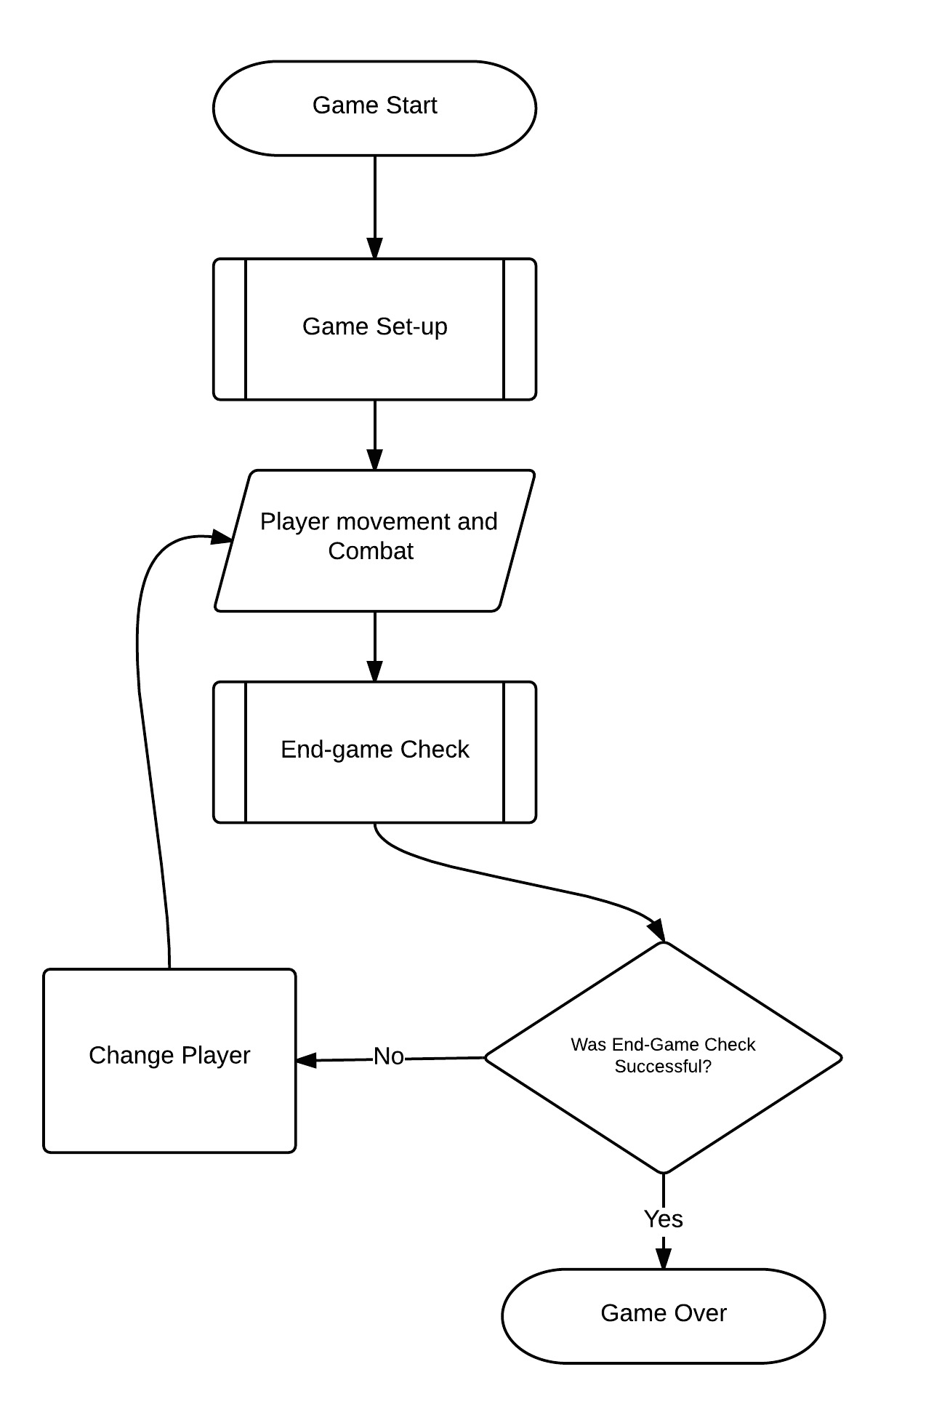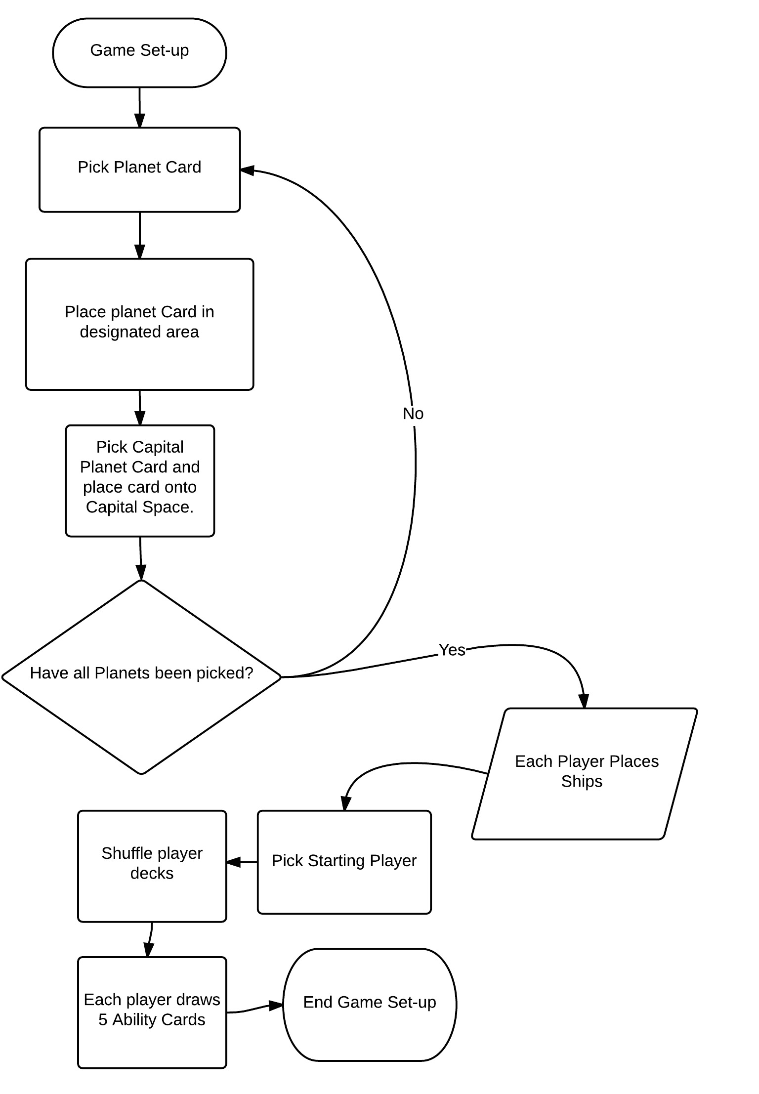
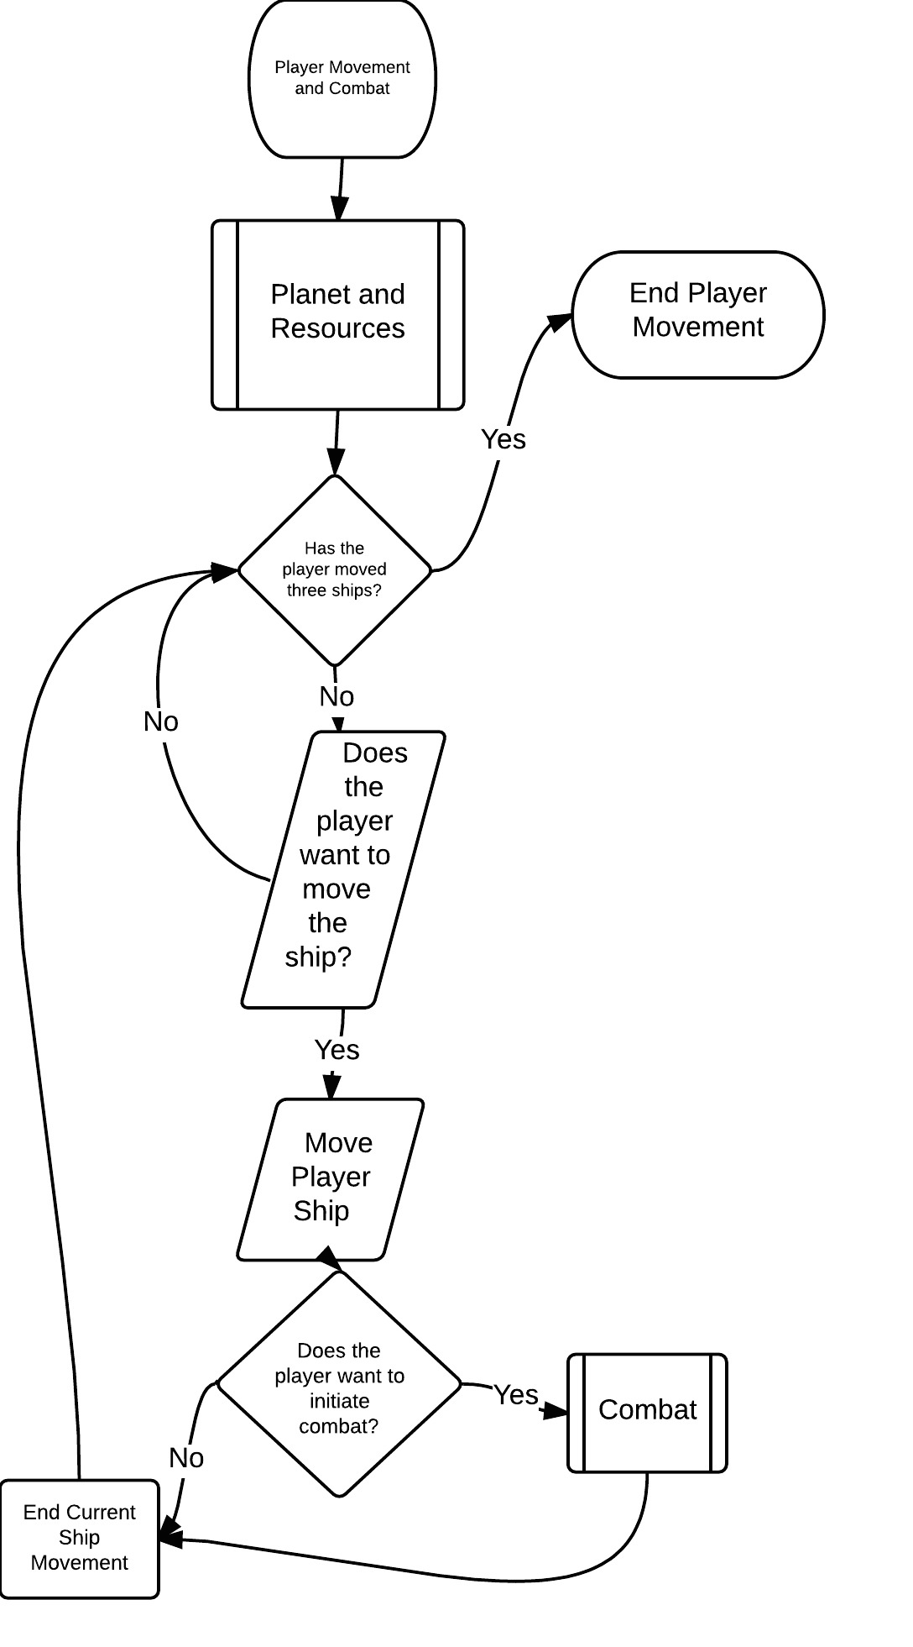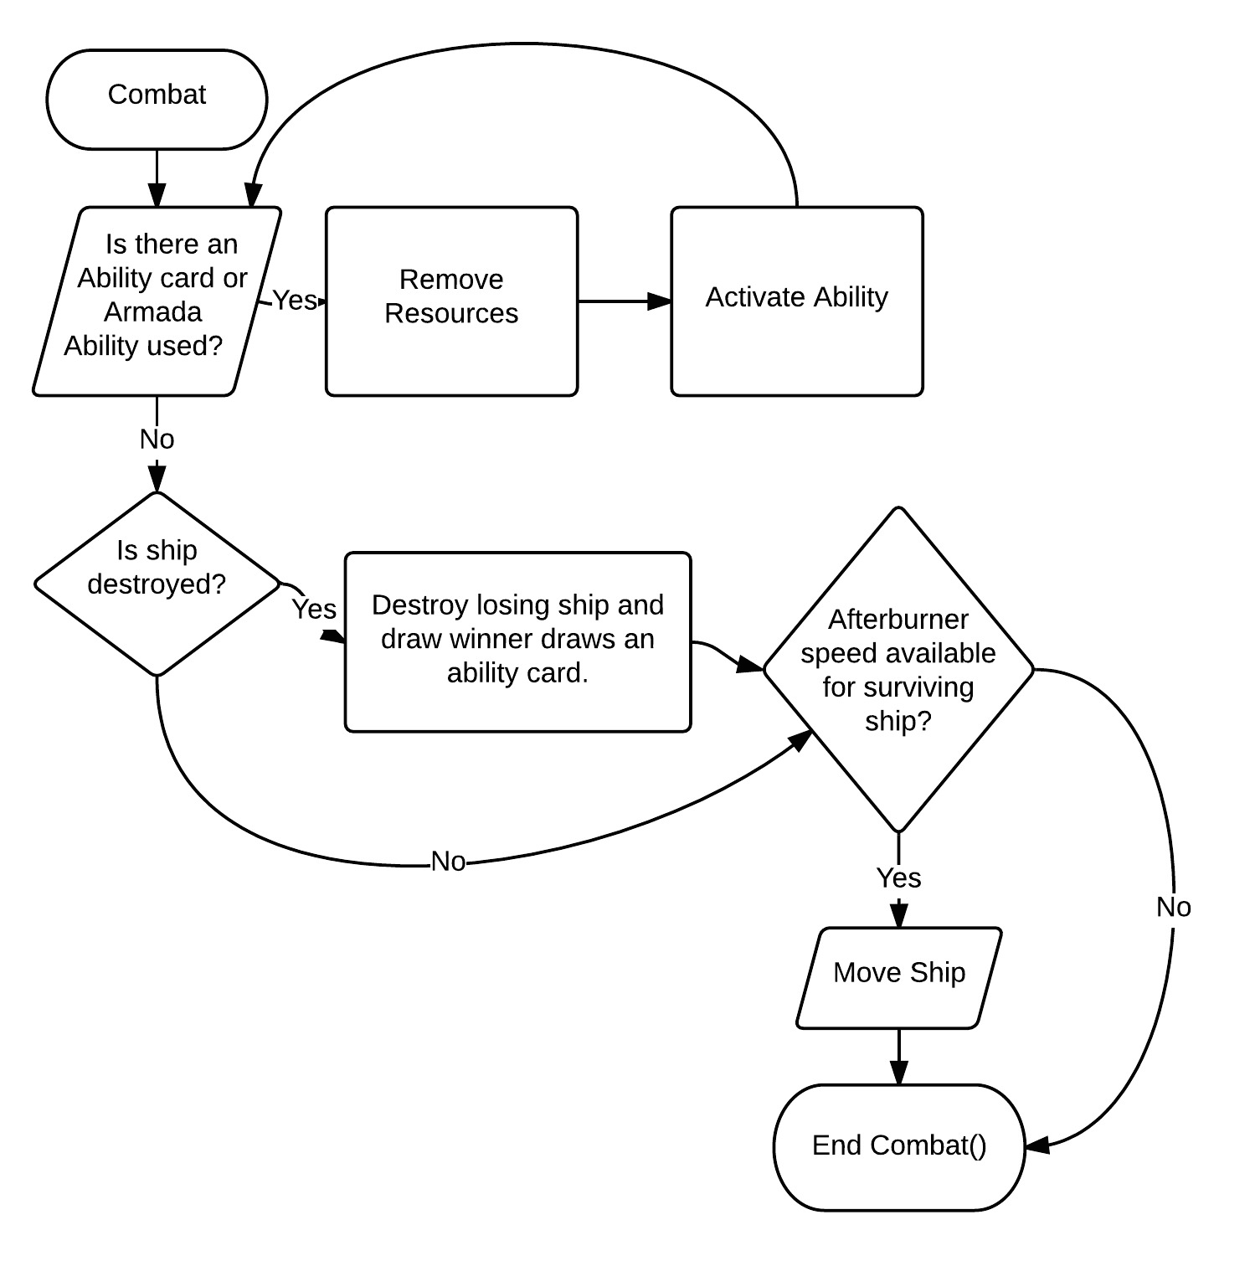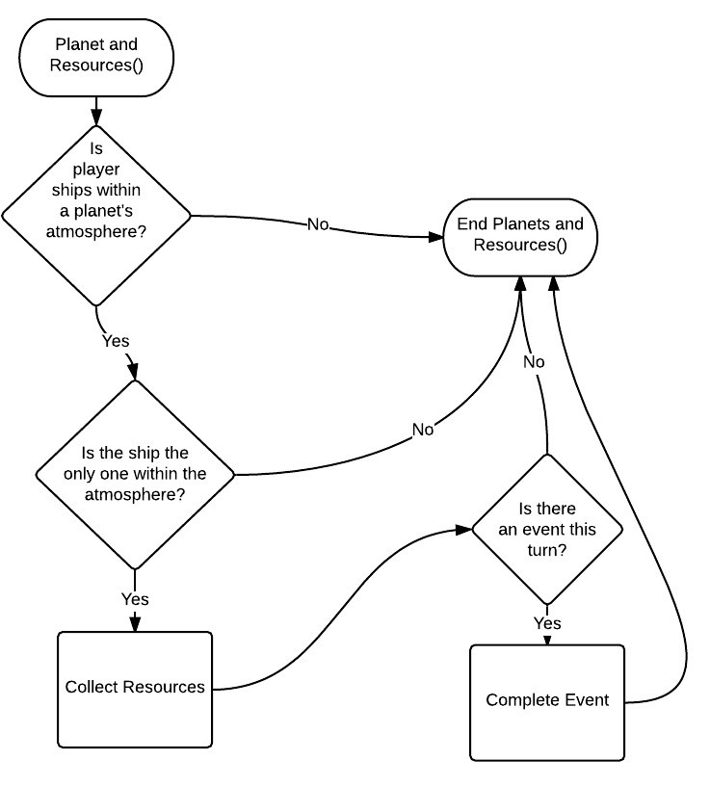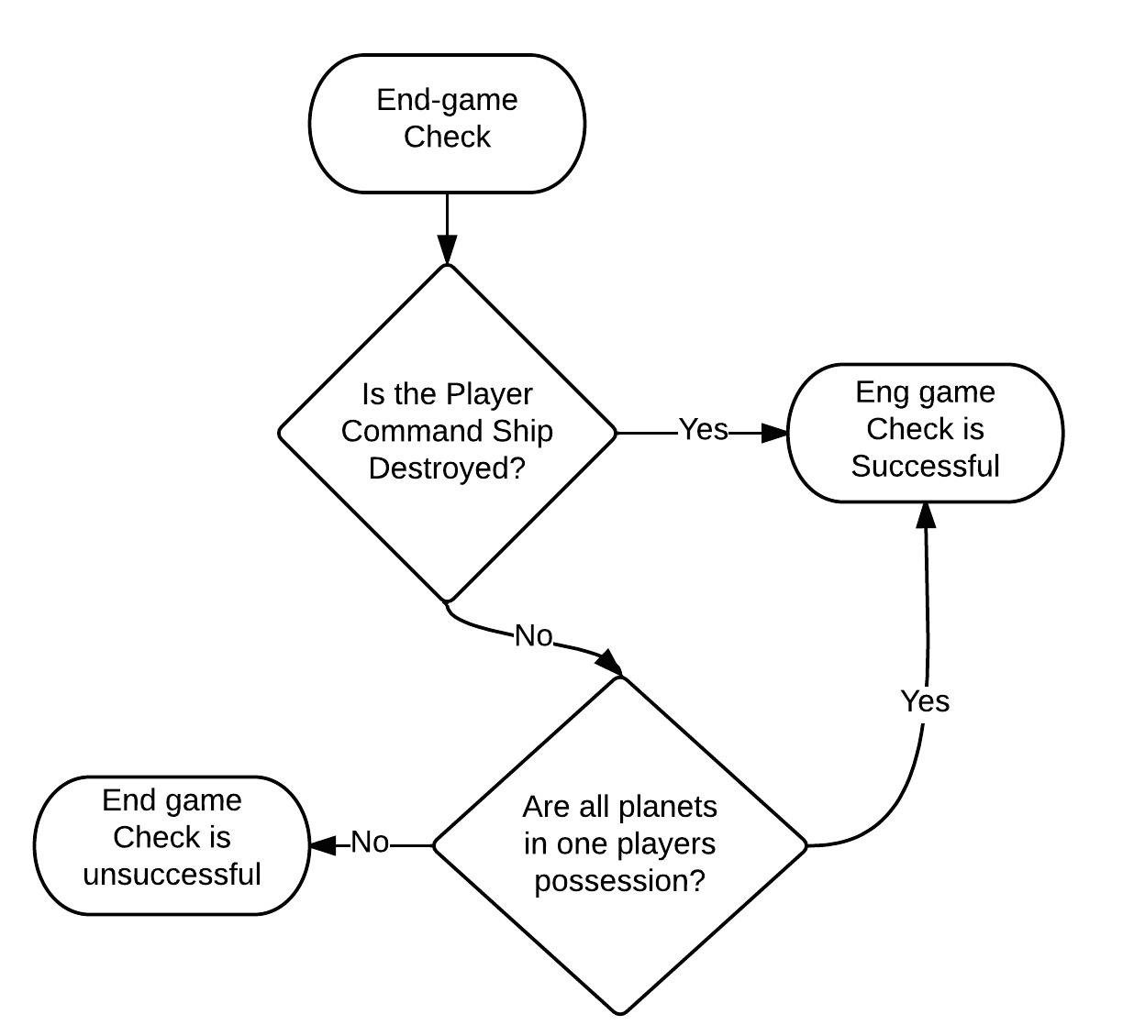

End Game Conditions
- If a player destroys the other’s command ship, then they are victorious!
- Alternatively, if a player gains control of all 6 Planet Areas and the Capital Planet, then they have complete control over the Solar System and win the game.

Rules Questions & Strategies
FAQ:
Q: Where can I place my ships if I can rebuild one of my ships in the game?
A: You can place it in the starting zone for your respective faction. All ships will start in the starting zones at all points in the game.

Q: Do I place my Asteroid Belts at the beginning of the game?
A: In a standard game, you will not place anything new on the board, aside from your ships and planet cutouts. If you want to modify your game experience you can, but in a normal game of Cosmic Armada, you will start with only the permanent non maneuverable spaces in place.

Strategy to play the game
- Deploying part of your fleet to different planets to gain extra resources in a short amount of time.
- Grouping your ships together so that it will be difficult for your opponent to engage in combat.
- Asteroid belts can help block out or in enemy ships.
- Surrounding an enemy ship is a great way to take one down. This is most effective way to take down a Defensive Class Ship or a Command Class Ship as these class types are harder to take down.
- Using an Attack Class Ship that has a high afterburner speed, you can attack one ship and fly to the next to take down a maximum of two ships with only one of your own!

