Existence
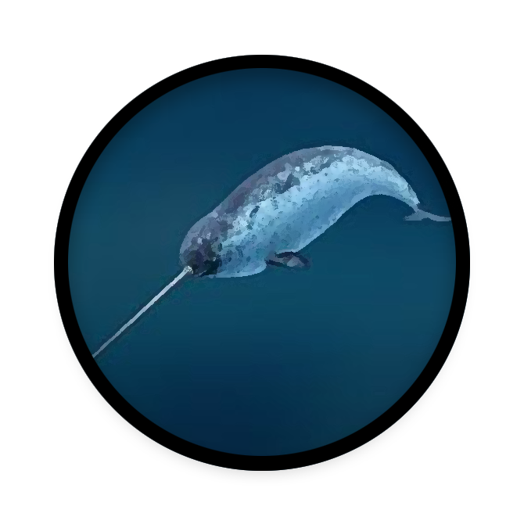

Team Narwhal

Contributing Members: Mitchell Martin, Allante Means, and Hunter Marquis.

Description

A few hundred years in the future humanity has turned its focus to the cosmos in search of intelligent life. During their expedition into a far away galaxy humanity stumbled upon an uninhabited planet with an earth-like atmosphere, with resources required for stability readily available. During the expedition of the planet an alien civilization with hopes to claim this uninhabited planet as their own wages war on humanity for control of the planet.

Designer’s Intent

- Destroy: Destroying a ship removes the ship from play, which simulates a real battle with ships where the only way to win is to destroy the enemy ship.

- Attack: In combat, the only way to destroy an enemy ship is to attack it.

- Defend: In combat, once you’re attacked, you’re best bet is going to be to defend. Doing so will only better your chance of survival.

- Disperse: Players must use their resources wisely by strategically spending their money. If a player misuses their money, it could lead to their defeat.

- Trade: A neutral mercenary ship is supplying munitions for the conflict.

- Intended Audience: Sci-fi fans between ages 10 - 50 who are a interested in a fast paced card game.

Materials list

- 2 Fleet Decks - 25 Cards per player *See card section for Cut-Outs
- Arms Dealer Deck - 45 Cards *See card section for Cut-Outs
- Asteroid Deck - 20 Cards *See card section for Cut-Outs
- Currency - (25) 1,000; (15) 5,000; (10)10,000 Cut-Out Coin Cards *See card section for Cut-Outs




Asteroid Cards
5,000
+ 20

+ 10
5,000
Cost

Effect
Cost

Effect

Repair 1 Scout from your Scrapyard to add back to your Fleet. This card will be placed on the playing field to be used for combat this turn. Can be used if a ship(s) already is on the field.
6,000
Item Cards
Ship Cards
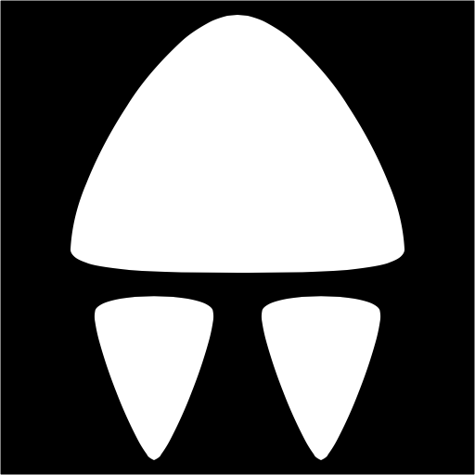

5,000
10,000
1,000
Coins (by Value)
Value
Firepower

Shield

Speed

Ship

Value
Drone
2,000
Place Items Here
20

20

60
The Board
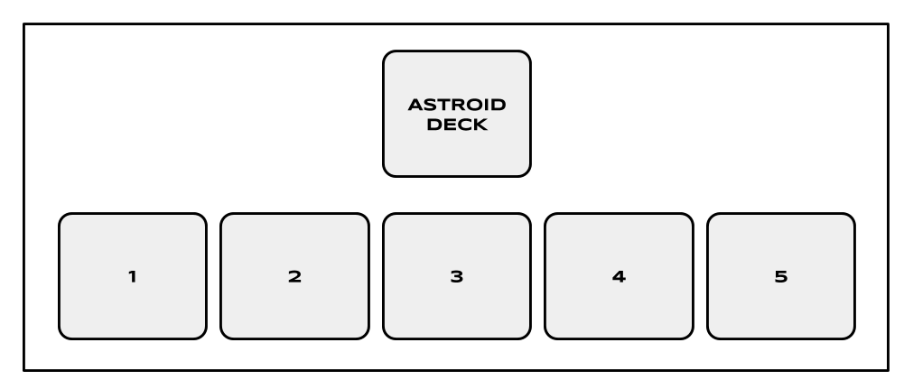
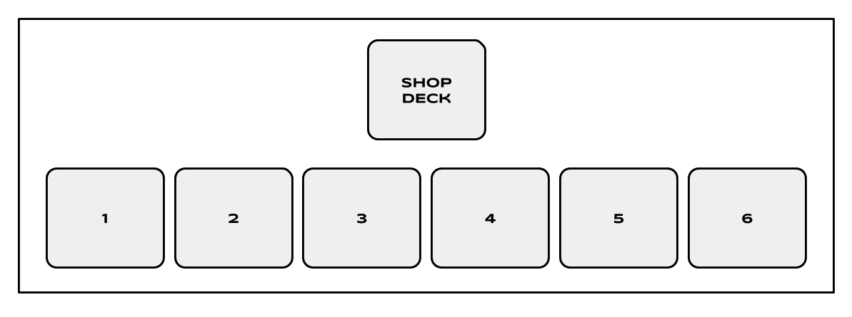
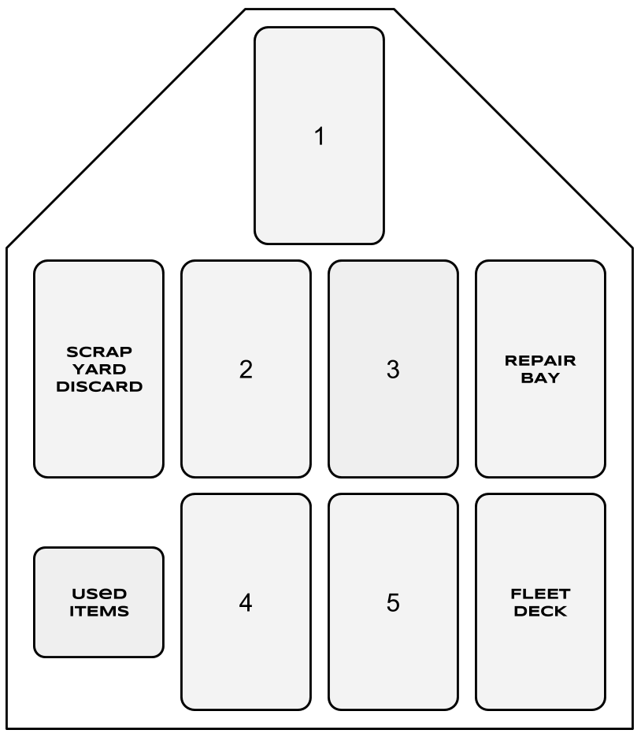

Rules
Setup (Initial)

- Each Player will choose one of the two Fleet Decks, either Earth or Skaxar, and shuffle their deck before placing the respective deck face down in front of them.

- Shuffle the Arms Dealer deck and place it face down on the side of the playing field within reach of both players.

- Remove the top 6 cards from the Arms Dealer deck and place them face up in a line from one player to the other. These will be the starting items in the Shop.

- Shuffle the Asteroid deck and place the deck face down on the side of the playing field opposite the Arms Dealer deck.

- Remove the top 5 cards from the Asteroid deck and place them face down in a line opposite the Shop.

- Each Player takes (1) 5,000 coin and (3) 1,000 coins for their starting money and the remaining money is placed near the Arms Dealer deck outside the play field.

Turn Phase

1. Flip Phase

- Each player will flip over the top card of their Fleet deck and place it face up in front of them: these will be the ships engaging in battle this turn.

2. Arms Dealer Phase

- The player whose ship has the highest speed gets to buy from the Arms Dealer first.
- When buying from the Arms Dealer, the player will spend money to purchase items that will be equipped immediately to their ship as long as the ship remains on the field.
- Once the first player is finished purchasing, the second player may then purchase for their ship.

(See Arms Dealer in General Rules for more details)

3. Combat Phase

- Players will then calculate the Firepower and Shield after the items from the Arms Dealer have been added.
- The resolution of the combat phase is then determined by each ship’s Firepower and Shield Rating:

- Winning the combat: Firepower Higher than Shield Rating
  - If Ship A has a higher Firepower than Ship B’s Shield Rating, Ship B is destroyed; the Player who won the battle receives money equal to the value of the destroyed ship.
  - If both ships’ Firepower is higher than the other’s Shield, both ships are destroyed and both Players receive money equal to the value of the enemy ship.
- The items used will be placed face up in a stack to the left of the Fleet Deck. The destroyed ship is then placed face up in the Scrapyard discard pile to the left of the winning Player’s Formation Playing Field while the winning ship is returned to the Repair Bay and placed face down above the Fleet Deck. After which, the Recovery Phase will then take place.
- Stalemate
  - If no ship has a higher Firepower than the enemy’s Shield Rating, a stalemate is reached. This can be obtained if Firepower and Shield Rating stats are equal or if the Firepower is lower than the enemy’s Shield Rating.
  - When a stalemate is reached, both ships and their items remain on the playing field and play returns the Flip Phase. The cards that had the Stalemate will have their Firepower and Shield Rating stats added to the new cards and the Fleet with Firepower higher than the enemy’s Shield Rating would win the combat.
  - Stalemates can stack and will repeat until a winner is determined.

4. Recovery Phase

- Money is awarded to the player for defeating the ship, the amount of which is to be determined by the defeated ship in question.
- The losing Player has the option of harvesting resources from an Asteroid. This is done by selecting one of the face down Asteroid cards and receiving money equal to the amount displayed on the card.
- If the Arms Dealer inventory has all been sold, 6 new cards are drawn from the top of the Shop Deck and placed face up as the new items: Once the Shop Deck is depleted, it remains depleted.
- If the Asteroids have all been taken from the field, 5 new Asteroids are drawn from the top of the Asteroid Deck and placed face down in the respective spots.
- The next turn then begins by returning to the flip phase.

General Rules

Arms Dealer

- When purchasing from the shop, a Player may purchase as many items as their supply of money allows.
- No cards can be purchased directly from the deck. Only face up cards may be purchased.
- New cards are not drawn until all 6 cards have been depleted and the Recovery Phase is reached.
- If the shop runs out of cards during the Arms Dealer Phase, no cards may be purchased until the next turn after a Recovery Phase has been reached.

Asteroids

- The defeated Player is the only one who may harvest an asteroid for resources.
- Only one Asteroid can be harvested per Recovery Phase.
- When a Player takes the last Asteroid, 5 new cards are immediately placed down for the next turn.

The Ships

- When a Player’s Fleet deck has run out of cards, the cards in the Repair Bay are shuffled and become the new Fleet Deck.
- If a Player is unable to play a ship, but able to purchase a card allowing them to bring a ship in, they get to buy the card from the shop before the enemy player is able to buy items.

Winning the Game

- If one Player is unable to do combat due to not having a ship to play because of not having any more ships in their Fleet Deck or not being able to purchase a card from the shop to bring a ship back, they lose the fight and the Player with ships remaining is the winner.
- If both players destroy each other’s last ship and neither player can play a ship, the Player with the most money wins.

Mechanics

Destroy

(Storyboard)
- Destroy is initiated during combat when a player's Fire Power is higher than the enemy's Shield value. The enemy’s ship is destroyed and sent to the scrapyard.

Attack

(Storyboard)
- Initiate battle with the opposing player based on your Fire Power and the enemies Shield. Fire Power must have a value higher than the Shield value.

Defend

(Storyboard)
- Shield value is used as a defense mechanism, this value is set for each ship and can be altered with purchases from the Arms Dealer. Shields are used to defend incoming attacks.

Disperse

(Storyboard)
- Currency can earned from defeating enemy ships, and asteroids. Only the player who defeats the ship receives currency for the destroyed ship's value, With currency being used to purchase items from the Arms Dealer.

Trade

(Storyboard)
- Trade your accrued currency with the Arms Dealer for items to gain an advantage, or defend against your enemy’s assault.

References
Narwal Pic:
https://s-media-cache-ak0.pinimg.com/236x/ed/46/17/ed46177463b8561e173cb7f91b71b244.jpg

Icons on cards:

Card Images [Digital image]. (n.d.). Retrieved October 9, 2016, from http://game-icons.net

Drone
2,000
Place Items Here
20

20

60
Drone
2,000
Place Items Here
20

20

60
Drone
2,000
Place Items Here
20

20

60

Drone

2,000
Place Items Here
20

20

60
Drone

2,000
Place Items Here
20

20

60
Drone
2,000
Place Items Here
20

20

60
Drone
2,000
Place Items Here
20

20

60

Drone
2,000
Place Items Here
20

20

60
Drone

2,000
Place Items Here
20

20

60
Drone

2,000
Place Items Here
20

20

60
Drone

2,000
Place Items Here
20

20

60
Drone

2,000
Place Items Here
20

20

60
Drone

2,000
Place Items Here
20

20

60
Drone

2,000
Place Items Here
20

20

60
Drone

2,000
Place Items Here
20

20

60
Drone

2,000
Place Items Here
20

20

60

Scout

4,000
Place Items Here
20

40

50
Scout

4,000
Place Items Here
20

40

50
Scout

4,000
Place Items Here
20

40

50
Scout

4,000
Place Items Here
20

40

50
Scout

4,000
Place Items Here
20

40

50
Scout

4,000
Place Items Here
20

40

50
Drone

2,000
Place Items Here
20

20

60
Drone

2,000
Place Items Here
20

20

60
Scout

4,000
Place Items Here
20

40

50
Scout

4,000
Place Items Here
20

40

50
Scout

4,000
Place Items Here
20

40

50
Scout

4,000
Place Items Here
20

40

50
Scout

4,000
Place Items Here
20

40

50
Scout

4,000
Place Items Here
20

40

50
Scout

4,000
Place Items Here
20

40

50
Scout

4,000
Place Items Here
20

40

50

Fighter

6,000
Place Items Here
60

40

40
Fighter

6,000
Place Items Here
60

40

40
Fighter

6,000
Place Items Here
60

40

40
Fighter

6,000
Place Items Here
60

40

40
Fighter

6,000
Place Items Here
60

40

40
Fighter

6,000
Place Items Here
60

40

40
Fighter

6,000
Place Items Here
60

40

40
Fighter

6,000
Place Items Here
60

40

40

Destroyer

8,000
Place Items Here
60

60

30
Destroyer

8,000
Place Items Here
60

60

30
Destroyer

8,000
Place Items Here
60

60

30
Destroyer

8,000
Place Items Here
60

60

30
Destroyer

8,000
Place Items Here
60

60

30
Destroyer

8,000
Place Items Here
60

60

30
Fighter

6,000
Place Items Here
60

40

40
Fighter

6,000
Place Items Here
60

40

40
7,000
7,000
7,000
7,000
7,000
15,000
12,000
12,000
9,000
9,000
6,000
6,000
6,000
3,000
3,000
3,000

Reinforcements!

Flip over the next card of your Fleet Deck to assist you in combat for this turn only

Reinforcements!

Flip over the next card of your Fleet Deck to assist you in combat for this turn only

Reinforcements!

Flip over the next card of your Fleet Deck to assist you in combat for this turn only

Reinforcements!

Flip over the next card of your Fleet Deck to assist you in combat for this turn only

Reinforcements!

Flip over the next card of your Fleet Deck to assist you in combat for this turn only

Repair 1 Mothership from your Scrapyard to add back to your Fleet. This card will be placed on the playing field to be used for combat this turn. Can be used if a ship(s) already is on the field.

Repair 1 Destroyer from your Scrapyard to add back to your Fleet. This card will be placed on the playing field to be used for combat this turn. Can be used if a ship(s) already is on the field.

Repair 1 Destroyer from your Scrapyard to add back to your Fleet. This card will be placed on the playing field to be used for combat this turn. Can be used if a ship(s) already is on the field.

Repair 1 Fighter from your Scrapyard to add back to your Fleet. This card will be placed on the playing field to be used for combat this turn. Can be used if a ship(s) already is on the field.

Repair 1 Fighter from your Scrapyard to add back to your Fleet. This card will be placed on the playing field to be used for combat this turn. Can be used if a ship(s) already is on the field.

Repair 1 Scout from your Scrapyard to add back to your Fleet. This card will be placed on the playing field to be used for combat this turn. Can be used if a ship(s) already is on the field.

Repair 1 Scout from your Scrapyard to add back to your Fleet. This card will be placed on the playing field to be used for combat this turn. Can be used if a ship(s) already is on the field.

Repair 1 Scout from your Scrapyard to add back to your Fleet. This card will be placed on the playing field to be used for combat this turn. Can be used if a ship(s) already is on the field.

Repair 1 Drone from your Scrapyard to add back to your Fleet. This card will be placed on the playing field to be used for combat this turn. Can be used if a ship(s) already is on the field.

Repair 1 Drone from your Scrapyard to add back to your Fleet. This card will be placed on the playing field to be used for combat this turn. Can be used if a ship(s) already is on the field.

Repair 1 Drone from your Scrapyard to add back to your Fleet. This card will be placed on the playing field to be used for combat this turn. Can be used if a ship(s) already is on the field.
5,000
5,000
5,000
5,000
5,000
5,000
5,000
5,000
6,000
4,000
4,000
4,000
2,000
2,000
2,000
2,000
+ 10
+ 30
+ 20
+ 20
+ 20
+ 10
+ 10
+ 10

Rapid Repair!

Shuffle the cards in your Repair deck back into your Fleet Deck.

Rapid Repair!

Shuffle the cards in your Repair deck back into your Fleet Deck.

Rapid Repair!

Shuffle the cards in your Repair deck back into your Fleet Deck.
Redraw!
Return your current Ship card on the field to the Fleet Deck and shuffle. Return the deck face down to playing field and flip the top card over. This will be your new card for combat this turn.
Redraw!
Return your current Ship card on the field to the Fleet Deck and shuffle. Return the deck face down to playing field and flip the top card over. This will be your new card for combat this turn.
Redraw!
Return your current Ship card on the field to the Fleet Deck and shuffle. Return the deck face down to playing field and flip the top card over. This will be your new card for combat this turn.
Redraw!
Return your current Ship card on the field to the Fleet Deck and shuffle. Return the deck face down to playing field and flip the top card over. This will be your new card for combat this turn.
Redraw!
Return your current Ship card on the field to the Fleet Deck and shuffle. Return the deck face down to playing field and flip the top card over. This will be your new card for combat this turn.
2,000
2,000
4,000
4,000
4,000
6,000
3,000
3,000
3,000
5,000
5,000
5,000
5,000
+ 10

+ 20
+ 10

+ 20
+ 20

+ 10
+ 20

+ 10
+ 10

+ 10
+ 10

+ 10
+ 10

+ 10
+ 30
+ 20
+ 20
+ 20
+ 10
+ 10
5,000
5,000
1,000
1,000
1,000
1,000
1,000
1,000
1,000
1,000

3,000
3,000
3,000
3,000
Mothership

10,000
Place Items Here
80

80

20
Mothership

10,000
Place Items Here
80

80

20

5,000
5,000
5,000
5,000
5,000
5,000
5,000
5,000
5,000
5,000
10,000
10,000
10,000
10,000
10,000
10,000
10,000
1,000
1,000
1,000
1,000
1,000
1,000
1,000
1,000
1,000
1,000
1,000
1,000
1,000
1,000
1,000
1,000
1,000
1,000
1,000
1,000
1,000
1,000
1,000
1,000
1,000
5,000
5,000
5,000
5,000
5,000
10,000
10,000
10,000

