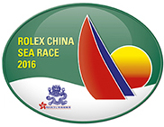

for immediate release
18 March 2016

Rolex China Sea Race 2016
Race Chairman’s View

Organised by Royal Hong Kong Yacht Club, the 2016 edition of the Rolex China Sea Race will start on Wednesday 23 March. Race Chairman, Simon Powell shared his thoughts on the 565nm Category 1 Offshore race, which has been run under the auspices of RORC since 1972 and has been included in Rolex’ prestigious catalogue of sailing events since 2008.
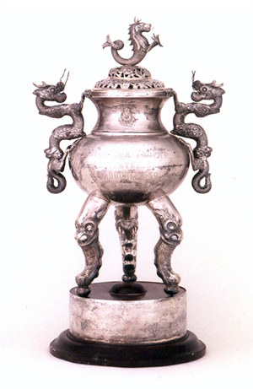
China Sea Race Trophy

“With less than a week to go to the start of the race, I am sitting at RORC in St James looking up at the painting of the Fastnet rock and thinking about the club that has hosted the Fastnet since 1925… and reflecting on Asia’s own flagship race, the Rolex China Sea Race.

The 2016 edition of Asia’s most exciting race marks another chapter as the number of international entries continues to rise and swells the entries to 34. The Chinese entries continue to grow as the Swan 80 UBOX shows up complete with some Dongfeng crew fresh from the Volvo round the world race.

General consensus is that the Rolex China Sea Race is up there as one of the most challenging Category 1 races on the planet. Despite significant commercial shipping, the South China Sea is a remote part of the world that requires crews to be prepared for self-rescue in the event that something goes wrong. As a blue water race, it has a bit of everything from a spectacular start in the iconic Hong Kong harbor, through the lumpy challenging conditions on the first night to the deep blue water as you near the northern Philippines.

On paper this event might look like a drag race with a predominant easterly breeze and Trade winds of 70 to 90 degrees but the reality is often different with the infamous Luzon hole causing the fleet to compress and effectively restart. The net result is that there are many boats that have the chance of lifting the trophy under IRC.

The Rolex China Sea Race might be less than half the age of the Fastnet Race but, in my opinion, it’s still the Asian classic and one that should be on every offshore sailor’s bucket list.”

Rolex China Sea Race will start on 23 March 2016 in front of Royal Hong Kong Yacht Club’s Kellett Island headquarters in Hong Kong and will finish in Subic Bay, Philippines, hosted by Subic Bay Yacht Club.
Race action will be tracked by Yellowbrick Tracking and will be shown live at www.rolexchinasearace.com

- End -

About Royal Hong Kong Yacht Club
Royal Hong Kong Yacht Club (RHKYC) is one of the oldest sports clubs in Hong Kong and is proud of its rich, colourful history, which stretches back over 160 years of social and competitive sailing and rowing. RHKYC organises a full calendar of local and international racing for both keel boats and dinghies, ranging from round-the-cans to Category 1 offshore races. The Club also provides sailing courses for members and non-members at various levels to nurture the development of sailing.

About Rolex

Leading brand of the Swiss watch industry, Rolex, headquartered in Geneva, enjoys an unrivalled reputation for quality and expertise the world over. Its Oyster watches, all certified as chronometers for their precision, are symbols of excellence, performance and prestige. Pioneer in the development of the wristwatch as early as 1905, the brand is at the origin of numerous major watchmaking innovations, such as the Oyster, the first waterproof wristwatch, launched in 1926, and the Perpetual rotor self-winding mechanism introduced in 1931. Rolex has registered over 400 patents in the course of its history. A truly integrated and independent manufacturing company, Rolex designs, develops and produces in-house all the essential components of its watches, from the casting of the gold alloys to the machining, crafting, assembly and finishing of the movement, case, dial and bracelet. Rolex is also actively involved in supporting the arts, sports, exploration, the spirit of enterprise, and the environment through a broad palette of sponsoring activities, as well as philanthropic programmes.
For enquiry:

Koko Mueller  PR & Communications Manager  Tel.: +852 2239 0342 / +852 9488 7497  Fax: +852 2838 5738 +852 2572 5399  email: Koko.Mueller@rhkyc.org.hk  Royal Hong Kong Yacht Club  Kellett Island, Causeway Bay  Hong Kong  RHKYC website: www.rhkyc.org.hk | Lindsay Lyons  Assistant Manager – Sailing and Promotion  Tel: +852 2239 0391  Email: Lindsay.Lyons@rhkyc.org.hk  Fax: +852 2239 0364  Royal Hong Kong Yacht Club  Kellett Island  Causeway Bay  Hong Kong

