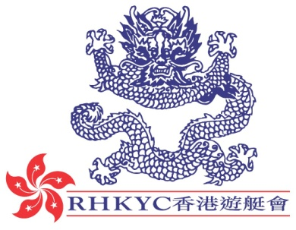 | 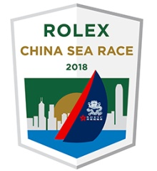

for immediate release
27 January 2017

Rolex China Sea Race Launches New Official Website

Royal Hong Kong Yacht Club today unveiled its new official website and logo for its flagship event, the biennial Rolex China Sea Race - Asia’s principal blue-water classic.
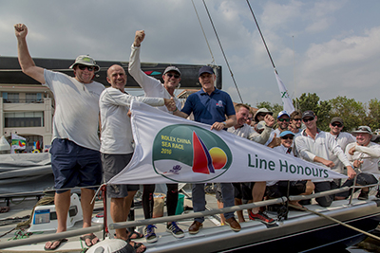
2016 Line Honours Winner
Philip Turner / Alive
photo: ROLEX / Daniel Forster

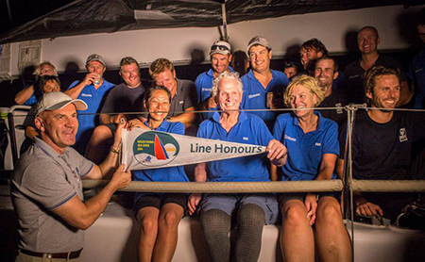
2014 Line Honours Winner
Syd Fischer / Ragamuffin 90
photos: ROLEX / Kurt Arrigo

The Rolex China Sea Race is Asia’s oldest Category 1 Offshore Race and has been awarded several accolades including Asian Regatta of the Year at the Asia Boating Awards. Competing yachts cross the start line in Hong Kong’s iconic Victoria Harbour; negotiating both traditional and modern sea traffic before embarking on the open water section of the 565nm course to Subic Bay in the Philippines. The Race finishes with gentle wind, adding to the challenging test of seamanship.
With Wang Bin’s Swan 82 UBOX making its debut entry for China in the 2016 edition of the Race, and in recognition of the importance of the ever-increasing interest in yacht racing in China, the Notice of Race is offered in both English and Chinese, as are key areas of the website.
The new website also features video highlights of past races and an honour roll of winners dating back to the first Race held 55 years ago when in 1962 Reverie took Line Honours after six days of racing. Line Honours winners include a veritable who’s who of sailing; Karl Kwok’s Beau Geste, Neil Pryde’s Hi Fi, Frank Pong’s Jelik and Syd Fischer’s Ragamuffin 90, amongst others.
There is also a photo gallery and access to the 2016 race tracker which will switch to live tracking once the 2018 Race begins.
The 2016 edition saw an entry list of 34 boats from seven countries including two from Mainland China and a double-handed entry. Phillip Turner’s RP66, Alive, claimed Line Honours and set a new race record with a time of 47h 31m 08s - 11 minutes and 59 seconds inside the previous record held by Karl Kwok’s Beau Geste for 16 years.
The Notice of Race for the 2018 Rolex China Sea Race starting on 28 March 2018 is available online at www.rolexchinasearace.com.

About Royal Hong Kong Yacht Club
Royal Hong Kong Yacht Club (RHKYC) is one of the oldest sports clubs in Hong Kong and is proud of its rich, colourful history, which stretches back over 160 years of social and competitive sailing and rowing. RHKYC organises a full calendar of local and international racing for both keel boats and dinghies, ranging from round-the-cans to Category 1 offshore races. The Club also provides sailing courses for members and non-members at various levels to nurture the development of sailing. For more information on the Royal Hong Kong Yacht Club please visit www.rhkyc.org.hk.

For enquiry:
Koko Mueller  PR & Communications Manager  Tel.: +852 2239 0342 / +852 9488 7497  Fax: +852 2838 5738 +852 2572 5399  email: koko.mueller@rhkyc.org.hk  Royal Hong Kong Yacht Club  Kellett Island, Causeway Bay  Hong Kong  RHKYC website: www.rhkyc.org.hk | Naomi Walgren  Assistant Manager - Sailing and Promotion  Tel.: +852 2239 0391  Fax: +852 2239 0364  email: naomi.walgren@rhkyc.org.hk  Royal Hong Kong Yacht Club  Kellett Island, Causeway Bay  Hong Kong

