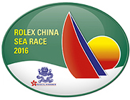

for immediate release
22 March 2016

ROLEX China Sea Race 2016
Starts Wednesday 23 March

The 2016 Rolex China Sea Race will start on Wednesday 23 March in Hong Kong’s iconic Victoria Harbour and will finish 565nm later in Subic Bay in the Philippines. This year marks the 28th edition of this biennial Offshore Category 1 race, run under the auspices of RORC since 1972. Organising authority Royal Hong Kong Yacht Club (RHKYC) is hosting 33 local and overseas boats at its Kellett Island base prior to the start, including entries from Australia, China, Japan, Philippines, Russia and Singapore.
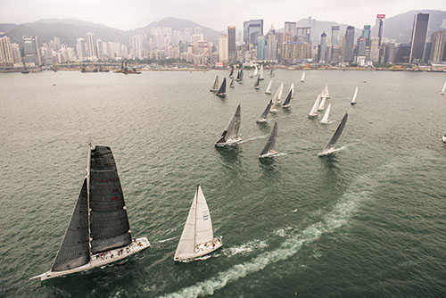
Rolex China Sea Race
photo: Rolex / Kurt Arrigo

The fleet will gather for the start in front of RHKYC’s Kellett Island clubhouse after a demanding preparation period, during which all participants have been scrutineered to ensure that they satisfy the World Sailing Category 1 offshore sailing requirements (with RORC prescriptions).

Renowned as being a tricky race, the China Sea Race typically starts with grey skies in a cool Hong Kong but, after a rough and challenging first night, the skies clear and competitors can enjoy a spinnaker ride under a full moon. Once the fleet approaches the northern coast of the Philippines a strong diurnal breeze kicks in and tactics become supremely important as boats do their utmost to keep moving in the light airs of dawn and dusk.

The boats currently being touted as likely ‘Line Honours’ candidates are RP66 Alive and Banuls 60 catamaran MACH² although in IRC Racer 0, TP52’s Freefire and Standard Subic Centennial cannot be discounted given the variable conditions approaching the finish, nor can Smith 72, Antipodes. Swan 82 UBOX, although luxurious enough to be placed in IRC Premier, is also tipped by some to lift the Sunday Telegraph Trophy if she hits the right conditions.

Current favourites for IRC Overall (on corrected time under IRC handicap) are Ker 42 Black Baza in IRC Racer 1 and, once again, Alive, however the lottery of conditions as the boats near their destination means that timing is everything and, given a perfect set of circumstances, any of the IRC entries could lift the three-legged China Sea Race trophy.

There are many different motivations for owners and crew to compete in Asia’s blue-water classic, neatly summed up by Black Baza’s Anthony Root, saying “the ultimate satisfaction is the total experience of working together as a team, the adrenaline rush of offshore reaching, harnessing the elements to maximum strategic advantage, and getting the most out of the boat.”

Armchair enthusiasts can follow the action by checking the Yellowbrick trackers at www.rhkyc.org.hk/rcsr16tracking.aspx - trackers are set to update twice an hour and have proved addictive watching for friends and family. For the more competitive voyeur, SailOnline is once again running a virtual Rolex China Sea Race. Interested armchair sailors can register for the race online at www.sailonline.org.

The Rolex China Sea Race 2016 will start in Victoria Harbour, Hong Kong, at 1320hrs (HKT) on Wednesday 23 March.

- End -

About Royal Hong Kong Yacht Club
Royal Hong Kong Yacht Club (RHKYC) is one of the oldest sports clubs in Hong Kong and is proud of its rich, colourful history, which stretches back over 160 years of social and competitive sailing and rowing. RHKYC organises a full calendar of local and international racing for both keel boats and dinghies, ranging from round-the-cans to Category 1 offshore races. The Club also provides sailing courses for members and non-members at various levels to nurture the development of sailing.

About Rolex

Leading brand of the Swiss watch industry, Rolex, headquartered in Geneva, enjoys an unrivalled reputation for quality and expertise the world over. Its Oyster watches, all certified as chronometers for their precision, are symbols of excellence, performance and prestige. Pioneer in the development of the wristwatch as early as 1905, the brand is at the origin of numerous major watchmaking innovations, such as the Oyster, the first waterproof wristwatch, launched in 1926, and the Perpetual rotor self-winding mechanism introduced in 1931. Rolex has registered over 400 patents in the course of its history. A truly integrated and independent manufacturing company, Rolex designs, develops and produces in-house all the essential components of its watches, from the casting of the gold alloys to the machining, crafting, assembly and finishing of the movement, case, dial and bracelet. Rolex is also actively involved in supporting the arts, sports, exploration, the spirit of enterprise, and the environment through a broad palette of sponsoring activities, as well as philanthropic programmes.
For enquiry:

Koko Mueller  PR & Communications Manager  Tel.: +852 2239 0342 / +852 9488 7497  Fax: +852 2838 5738 +852 2572 5399  email: Koko.Mueller@rhkyc.org.hk  Royal Hong Kong Yacht Club  Kellett Island, Causeway Bay  Hong Kong  RHKYC website: www.rhkyc.org.hk | Lindsay Lyons  Assistant Manager – Sailing and Promotion  Tel: +852 2239 0391  Email: Lindsay.Lyons@rhkyc.org.hk  Fax: +852 2239 0364  Royal Hong Kong Yacht Club  Kellett Island  Causeway Bay  Hong Kong

