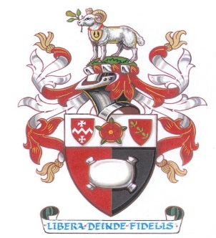

Community Support
connecting people and communities
- Are you lonely?
- Are you fed up, bored or stuck in a rut?
- Do you have time on your hands?
- Are you recently retired?
- Do you want to try something new
but don’t know where to start?
- Do you need to meet new people?
- Do you need help to find more support
with everyday living?
If so, contact Fiona, the Community Navigator, who will be happy to meet you and explore your opportunities through local activities, facilities and services that might be of interest.
If you are a carer, or know of someone that might benefit,
please get in touch.
Referrals or enquiries are welcomed from anyone.
This is a free one-to-one personalised support service.

Fiona Fyfe, Community Navigator
07717 618 815 navigator@godalming-tc.gov.uk
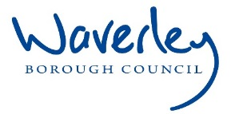
FUNDED BY

