A Practical Approach to End of Life Care

***Saturday 22nd April 2017***

***at Godalming Baptist Church***

Queen Street, Godalming, Surrey, GU7 1BA

**9.30 am for coffee, starting at 10 am – 12 midday**

***Led by Dr Martin Brunet and Dr Karen Jones, two of the GPs at Binscombe Medical Centre***

We will attempt to cover some of the big questions that occur in coming alongside those who are terminally ill, or wanting to plan for their death if they become unwell:

Can you tell if someone is dying?

What, and who, does 'End of Life Care' involve?

What is a Care Plan? Why might a good Care Plan make all the difference?

'Not for Cardiopulmonary Resuscitation' - what does that actually mean?

How do you have those difficult conversations?

Who is there to help me, or my family?

**All are welcome and there is no charge.**

It would help **to know numbers and so please could you phone or drop an e mail to let us know you are coming: please contact:**

Sally Pollard (email: [pollard3@hotmail.co.uk](mailto:pollard3@hotmail.co.uk) ), Janet Fry ([janetfry1@gmail.com](mailto:janetfry1@gmail.com) ) or the Administrator of Godalming Baptist Church (Mon., Wed. or Fri. mornings), on 01483 422105 [office@gbc.btinternet.com](mailto:office@gbc.btinternet.com) )

[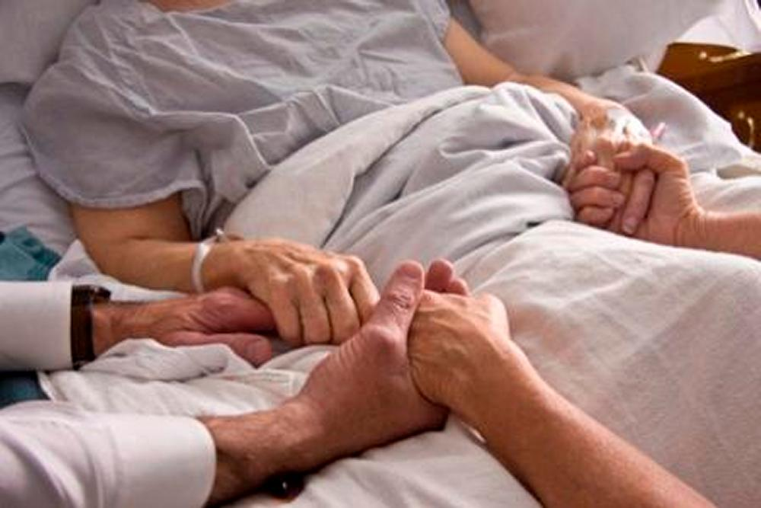](http://www.google.co.uk/url?sa=i&rct=j&q=&esrc=s&source=images&cd=&cad=rja&uact=8&ved=0ahUKEwjb-fvHssnQAhXiD8AKHdFWDlgQjRwIBw&url=http%3A%2F%2Fwww.catholicireland.net%2Fhospice-foundation-oireachtas-hearings-life-care%2F&psig=AFQjCNGq5vrxRF5ZId_Yz0of2kauSWsEJA&ust=1480351543417302)