PSYV Training Programme

STAR Template

This template supports you to plan and prepare for your learning or volunteering tasks which lie ahead. So, what is the STAR template all about?
The STAR template breaks down your experiences of the PSYV training and volunteering programme into the Situation, Task, Action, Results. It is a tool that will support learning throughout the learning journey by making sure that you understand the following:
Situation – the circumstances you are working within.
Task – planning what you are undertaking, knowing what you hope to achieve and how to make decisions or prioritise you are doing.
Action - focusing on what you want to do – the action you intend taking to achieve your goals.
Results, thinking about what you produce, create or establish and to consider the evidence - how you know and prove that you have done what you set out to achieve.

Use this worksheet to plan your learning or volunteering as part of the activities set in the module, or for your own benefit when you want to plan something else either in PSYV or other parts of your life. Save these onto your own PC, tablet or memory stick or similar. When you are happy with your answers you can submit a copy to your mentor.

STAR Diagram
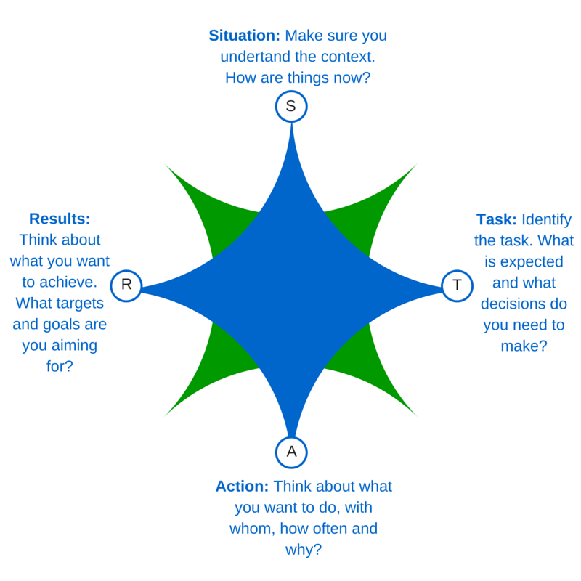

STAR Questions
Now complete the following questions:
Module | Unit | Leader | Company | Date
Enter a title here | Enter the name of the unit | Enter Your Name | Enter your group/ area | [Select Date]
Overview
Fill in the sections below as fully as possible.
Situation: Identify the task. What is expected of you and what decisions do you need to make to prepare for action? | Type here
Task: Identify the task. What is expected of you and what decisions do you need to make to prepare for action? | Type here
Action: Think about what you want to do, with whom, how often and why? | Type here
Results: Think about what you hope to achieve. What targets and goals are you aiming for? | Type here

Add other comments here:

