PSYV Training Programme

STAR Template

This template supports you to plan and prepare for your learning or volunteering tasks which lie ahead (when used for planning) or to reflect and think deeply about what you’ve learned. So, what is the STAR template all about?
The STAR template breaks down your experiences of the PSYV training and volunteering programme into the Situation, Task, Action, Results. It is a tool that will support learning throughout the learning journey by making sure that you understand the following:
Situation – the circumstances you are working within.
Task – planning what you are undertaking, knowing what you hope to achieve and how to make decisions or prioritise you are doing.
Action - focusing on what you want to do – the action you intend taking to achieve your goals.
Results, thinking about what you will produce, create or establish and to consider the evidence - how you know and prove that you have done what you set out to achieve.
When used for planning it assist you to prepare well by thinking through the whole process. When used for reflection it is like a magic key that opens your mind and lets you learn more deeply than is possible when you’re in the situation and your brain is working overtime. It gives you the space to pause, take a breath, to look back and take pride in what went well but also to think about the steps you might take to do it a bit better next time.
Use this worksheet to plan your learning or volunteering as part of the activities set in the module, or for your own benefit when you want to plan something else either in PSYV or other parts of your life.
It is available in electronic format (for those that don’t have access to word)
Save your responses onto your own PC, tablet or memory stick for your own portfolio. Submit this by writing the headings and your responses into the text area provided. Or alternatively, if you have access to Word you can type into this form, save and submit the file to the PSYV learning platform. Your mentor will be notified of your submission.

STAR Diagram
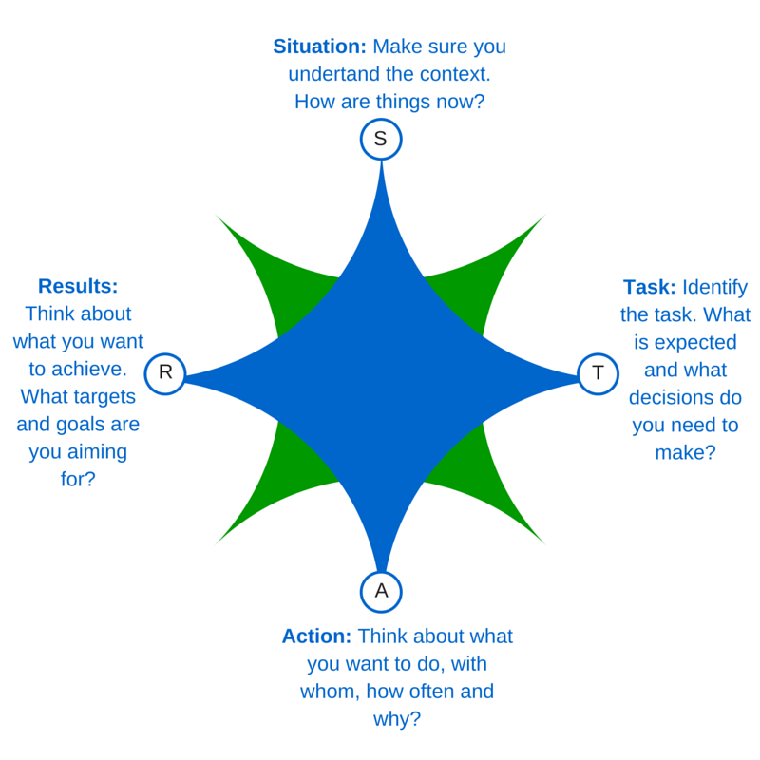

STAR Questions – Planning (use this for planning purposes)
Now complete the following questions:
Module | Unit | Name | Group | Date
Enter a title here | Enter the name of the unit | Enter Your Name | Enter your group/ area | [Select Date]
Overview
Fill in the sections below as fully as possible.
Situation: Make sure you understand the context. What are things like now, before you begin? What do you know? What is going to help, what might hinder? | Type here
Task: Identify the task. What is expected of you and what decisions do you need to make to prepare for action? | Type here
Action: Think about what you want to do, with whom, how often and why? | Type here
Results: Think about what you hope to achieve. What targets and goals are you aiming for? | Type here

Add other comments here (E.g. why do you think your plans are relevant and achievable? What skills are you going to demonstrate? What learning will you be applying? What will you do if things don’t go to plan?):

STAR Questions – Reflection (use this to reflect on what has happened)
Now complete the following questions:
Module | Unit | Name | Group | Date
Enter a title here | Enter the name of the unit | Enter Your Name | Enter your group/ area | [Select Date]
Overview
Fill in the sections below as fully as possible.
Situation: What was it actually like. Was it what you expected? Were people supportive? Was there a good atmosphere? | Type here
Task: Were you well prepared? Did you have everything you needed? Did the technology work? Did you feel like you could go ahead as planned? | Type here
Action: What did you do, with whom, how often, where, when and why? | Type here
Results: What did you achieve? Did you get to your destination? Did you achieve more or less than expected? | Type here

Add other comments here (e.g. what will this make you do differently in future? Are there specific skills or knowledge you were trying to demonstrate? Did you feel that you put your learning into practice? What is it from the learning that helped you the most? What does this tell you about the way you learn?):

