Booth Hill’s
Halloween Box Tops!
Collection Sheet
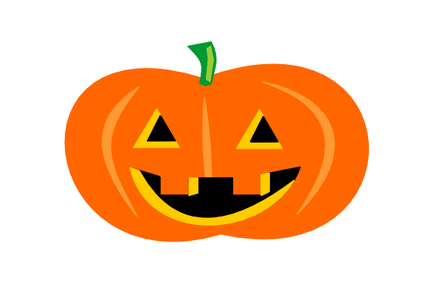
Neatly trim and tape a Box Top on each picture. Please NO STAPLES!

Booth Hill’s
Halloween Box Tops!
Collection Sheet
Neatly trim and tape a Box Top on each picture. Please NO STAPLES!

Booth Hill’s
Halloween Box Tops!
Collection Sheet
Neatly trim and tape a Box Top on each picture. Please NO STAPLES!

