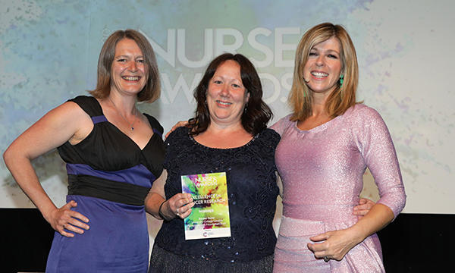

Cancer Research UK is pleased to announce Rachel Taylor from University College Hospital London as the winner of the Cancer Research UK ‘Excellence in Cancer Research’ category of the 2019 RCNi Nurse Awards. The prestigious award is the only one in the UK to recognise and celebrate the work of cancer research nurses.
Rachel began her career as a clinical research nurse in 1995. Using her research nursing experience and network enabled her to identify a need for patients with sarcoma and inspired her to set up the Sarcoma Assessment Measure (SAM) – a study aimed at understanding patients’ experiences of living with and beyond their sarcoma diagnosis. Involving a cancer research nurse in the development of the study protocol led to SAM recruiting over 1,000 patients - the biggest recruiting sarcoma study in the UK last year. The evidence collected will go towards designing interventions to support patients during their clinical journey and provide greater clinical follow up and care.
Rachel “Winning the Excellence in Cancer Research RCNi Nurse Award means so much. The protocol was developed with the assistance of one of our cancer research nurses so I hope the wider trial teams will see that clinical research nurses are more than experts in delivering research, they can make an important contribution at the point of trial conception. Clinical trials couldn’t exist without clinical research nurses.”
Congratulations to Rachel and her team.
Entries open in November for the 2020 RCNi Nurse Awards and you can read more about the Excellence in Cancer Research category here. Nominations are welcome from clinical research nurses working on cancer clinical trials or from clinical trials teams that include clinical research nurses working on cancer clinical trials.

