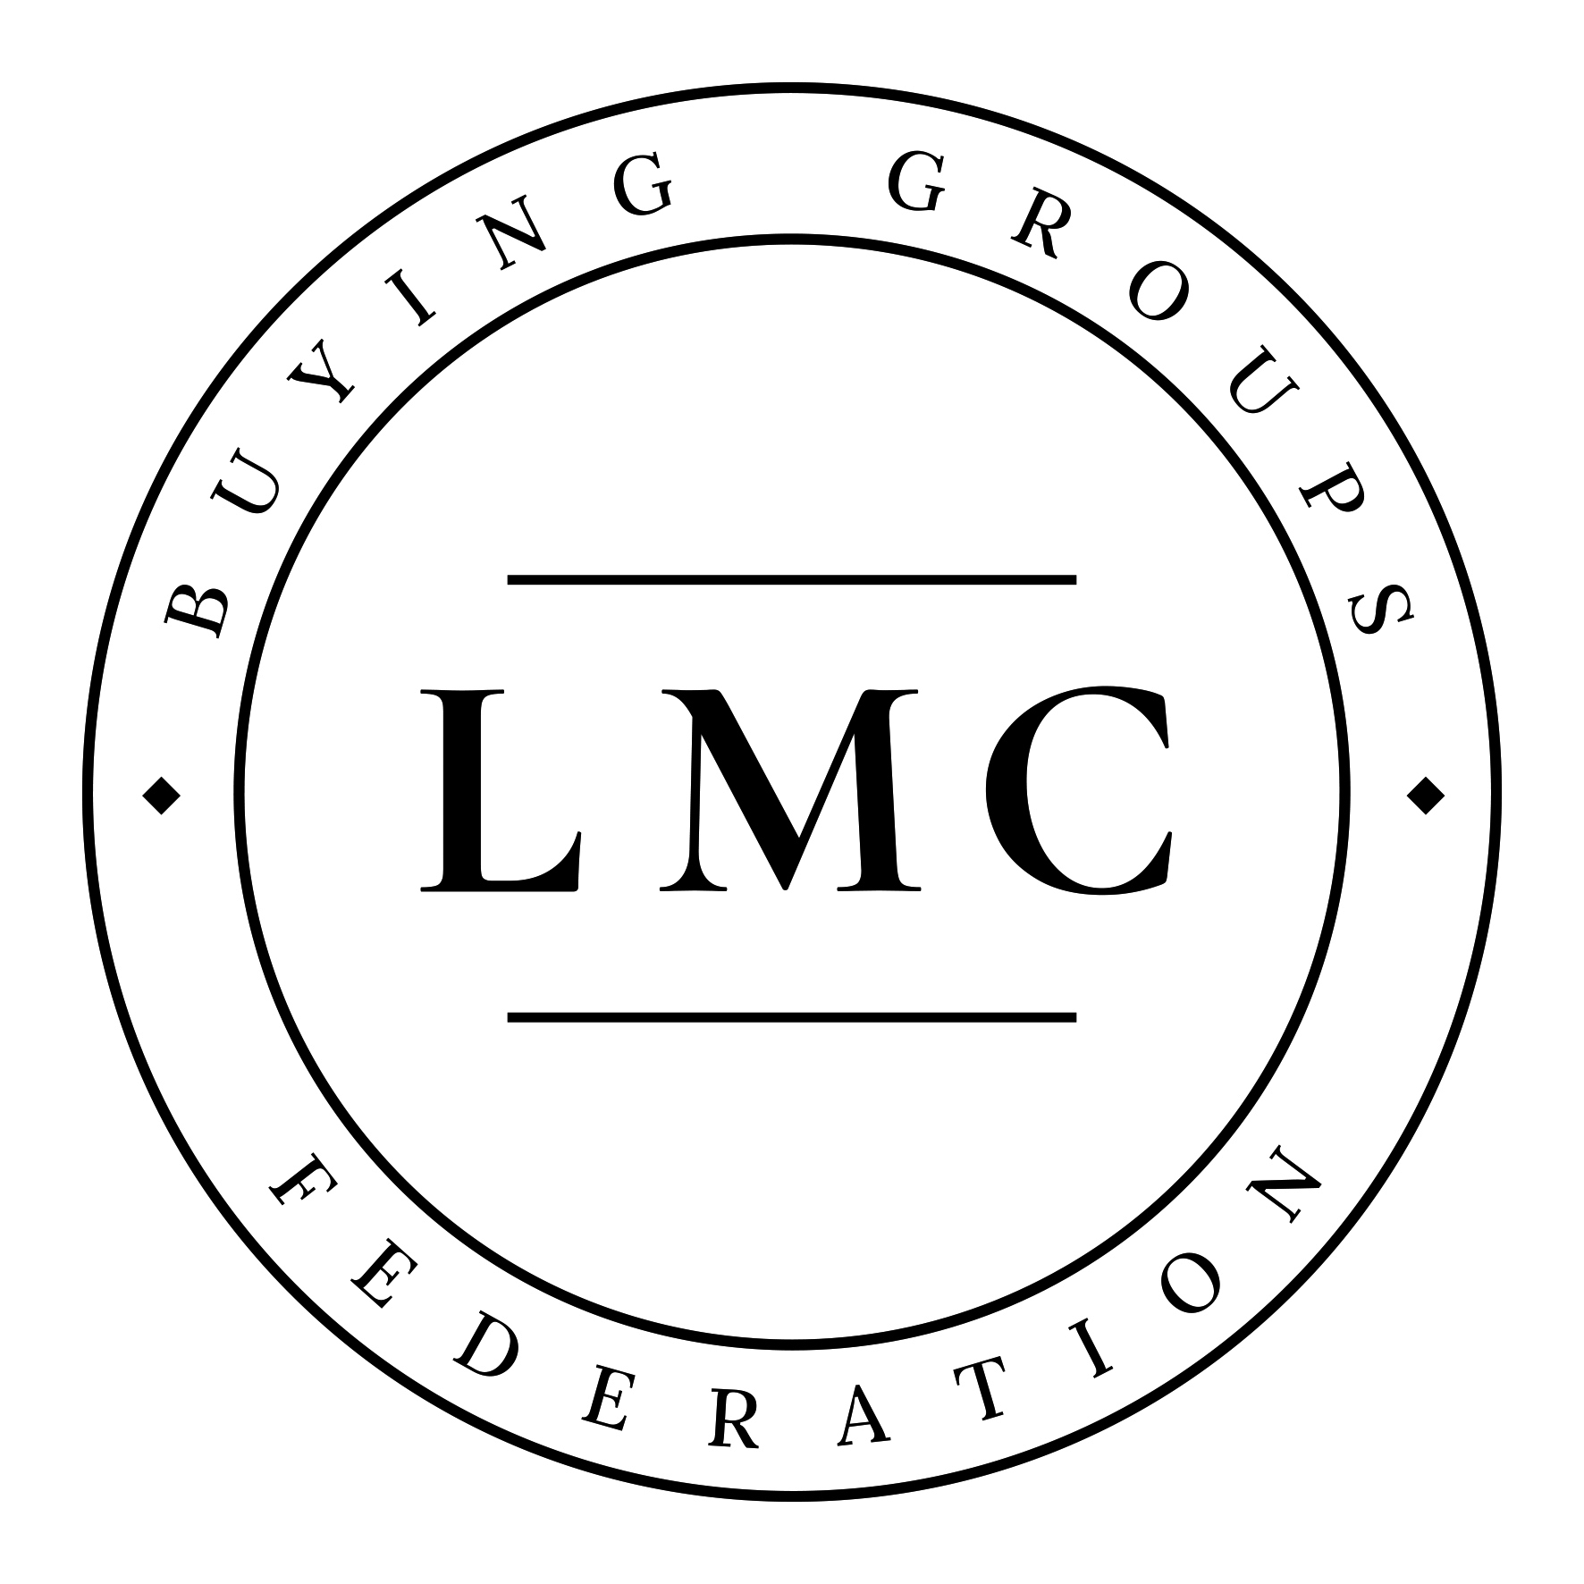

Cheshire LMC has been a member of the LMC Buying Groups Federation since 2010. This means that all practices can access the discounts the Buying Group has negotiated on a wide range of products and services.

If you're not sure what the Buying Group is all about then this short video explains what they do: https://www.youtube.com/watch?v=FekMwFI5ILg.

By registering with the Buying Group's website: www.lmcbuyinggroups.co.uk/members/ <http://www.lmcbuyinggroups.co.uk/members/> , you can view all the suppliers' pricing, contact details and request quotes. The Buying Group also offers any member practice a free cost analysis which demonstrates how much money your practice could save just by swapping to buying group suppliers.

And if your practice is part of a GP Federation group then the Buying Group Plus initiative could help you save additional money as a group. This short video explains what Buying Group Plus does: https://www.youtube.com/watch?v=BXpQmb7pVUo.

Contact

Tel: 0115 979 6910

Email: info@lmcbuyinggroups.co.uk

Website: www.lmcbuyinggroups.co.uk

