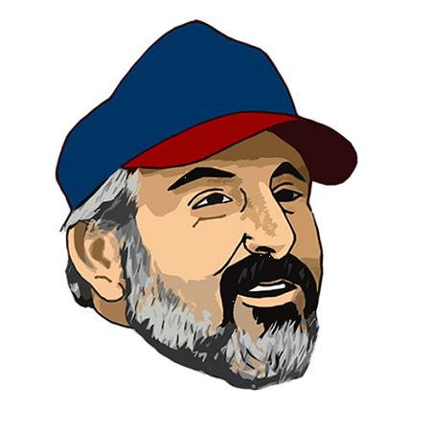
The
Basement
Doctor
Bring a can and Lose Yours’
5K Fun Run
Official Registration Form

Where: Faurot Park Pavilion, Park Dr. Lima, Oh

When: Saturday October 19, 2019. Race Starts at 9:00 Rain or Shine! WE ENCOURAGE COSTUMES BE WORN!!

Registration: At the Pavilion starts at 8:00 am, you can drop off your nonperishable donation here!

Age Groups: 14 & under; 15-19; 20’s; 30’s; 40’s; 50’s; 60’s; 70+ in both Male and Female Divisions.

Awards: Provided to the top 3 runners of each age group & first place overall male & female.

Entry Fee: $25, includes Race Day t-shirt, refreshments,

Only Pre Registered runners/walkers are guaranteed to receive a t-shirt.

Pre-Registration Deadline: September 30th, 2019

Send your registration and payment to:
Valerie Blodgett, The Basement Doctor 5K- 228 E. Pearl St. Lima, OH 45801

Make checks payable to The Basement Doctor

Have a question? Email Val here: vblodgett@basementdoctornorthwest.com

Check out our Facebook page BringACanLoseYours5K for details about the race!!

Name:____________________________________Sex:_____Age on 10/19/19_____
Address:____________________________City_____________State____Zip______
Phone____________________*T-Shirt(circle one) S M L XL XXL (+ $2)
Email_______________________________________________________________
Release
I attest and verify that I have full Knowledge of the risk involved in participation of this event and that I am physically fit and sufficiently trained to participate in the event. I understand that my signature signifies that in acceptance of my entry, I for myself, my executor, administrators and assignees do hereby release and discharge J&D Basement Systems The Basement Doctor, West Ohio Food Bank, the City of Lima and all associates, sponsors and all other race workers from all claims of damage, demands, actions whatsoever in any manner arising from my participation in this running/walking event.

Signature_______________________________________________Date_________

Parent’s Signature (if under 18)__________________________________________

