**Creating Your Own Gratitude Jar**

Gratitude is one of the many tools I use t support my mental health. Allowing me to focus on the positive aspects of my day when sometimes days don’t feel great. I first discovered this when I was really ill with vertigo and anxiety and being honest everyday felt pretty awful. But once I discovered this practice it allowed me not to focus on my illness but the joy that life can bring you.

This is a really fun activity for all ages and one I still use every day. I love to do this before bed, settling my mind into a positive place and reflecting on my day. Anytime is a good time for gratitude.

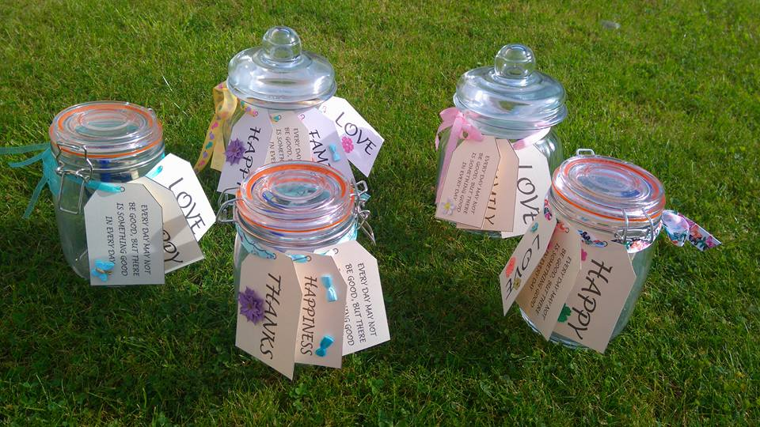

**What You Will Need**

|  |  |
| --- | --- |
| * An old jar or kilner | * Some Pretty Ribbon or String |
| * Super Glue, Craft Glue or Glue Suitable for Glass | * Scissors |
| * Items to stick and decorate, maybe gems, beads, charms, labels | * Small Notebook |
| * Pen | * This Printable |

**Instructions:** Start by printing out your chosen luggage labels and wording. I’d advise you print this on card so that they last a little longer and are more stable. You can then cut out which ever ones you have chosen and light you up. You can add additional ribbon, bows and pretty craft items. Set aside and allow to dry. You can then if you wish to decorate your jar, label it, personalise it whatever brings you joy and happiness. You can write on it with sharpies it is truly up to you. Let your creativity flow. Once dry you can then punch holes in the chosen luggage labels and thread some pretty ribbon or string through and tie around the neck of your jar.

Once your jar is complete you can then start your daily gratitude practice. Start small with recognising one thing a day your grateful for, then work your way up to 3 a day. Write these down on bits of paper then pop in your jar. Sometimes this will be easier than others. But I guarantee everyday may not be good, but there will be something good in every day! Watch all the wonderful things in your life grow.

Love and Live Your Light

Susi xxxxx



GRATITUDE

JOY

 

HAPPINESS

THANKS



FAMILY

LOVE



LOVE

HAPPY



EVERY DAY MAY NOT BE GOOD, BUT THERE IS SOMETHING GOOD IN EVERY DAY

EVERY DAY MAY NOT BE GOOD, BUT THERE IS SOMETHING GOOD IN EVERY DAY

