LESSON 1

Duration: 30 minutes

By: Dima Tahboub

www.dimatahboub.com

You need:
- Piano or keyboard.
- The Easier Piano Book 1 printed and bound.
Get your free copy at the following link: https://www.dimatahboub.com/theeasierpianobook
- Rhythm instrument of choice (Rhythm sticks, maracas, tambourine…).

How to make the most of these lessons:
- Daily practice is ideal and produces the best results. If this is not possible, 2 times a week is the minimum required to see improvement.
- Repetition is key. Repeat the lesson as many times as you need, until you feel you can move forward without overwhelming the student.
- Explain the lesson plan on the next page with the student before you start and mark with a smiley or a sticker the end of each part of the lesson.

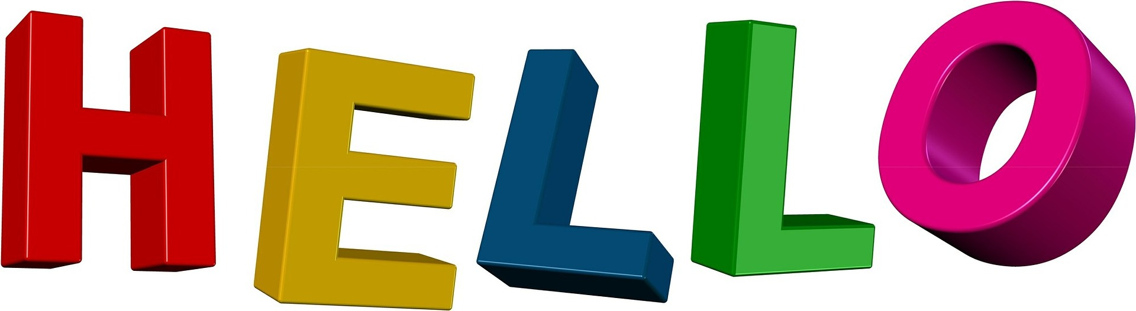
- Hello Song / Greeting

- Exploring Different Sounds
  - High
  - Low
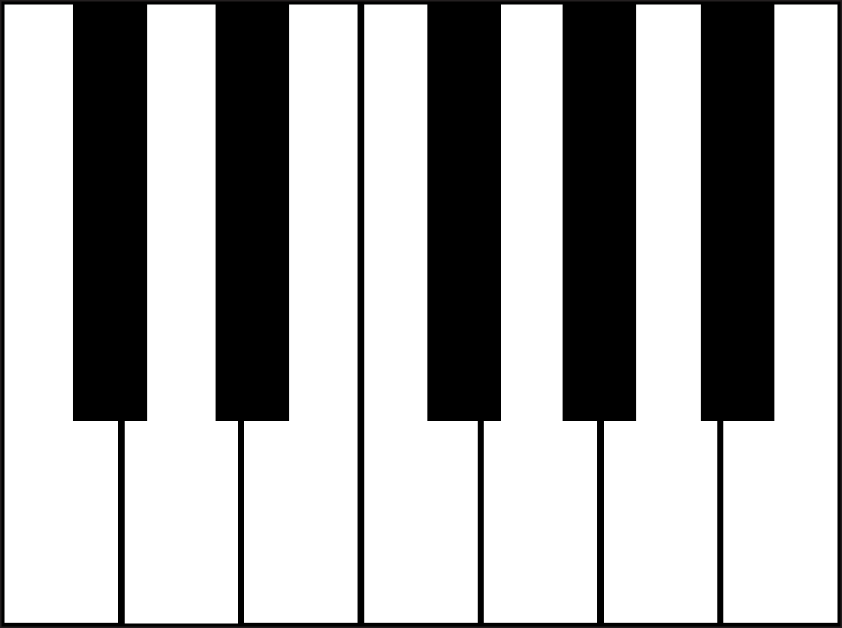
  - Fast
  - Slow
  - Loud
  - Quiet
  - Sad
  - Happy

- White and Black Keys

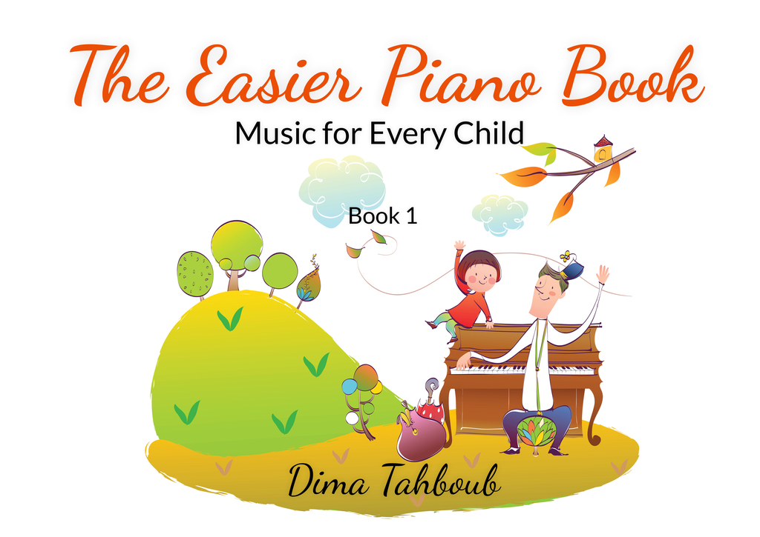

- I love singing.

- Copy Cat

- Hand Gym

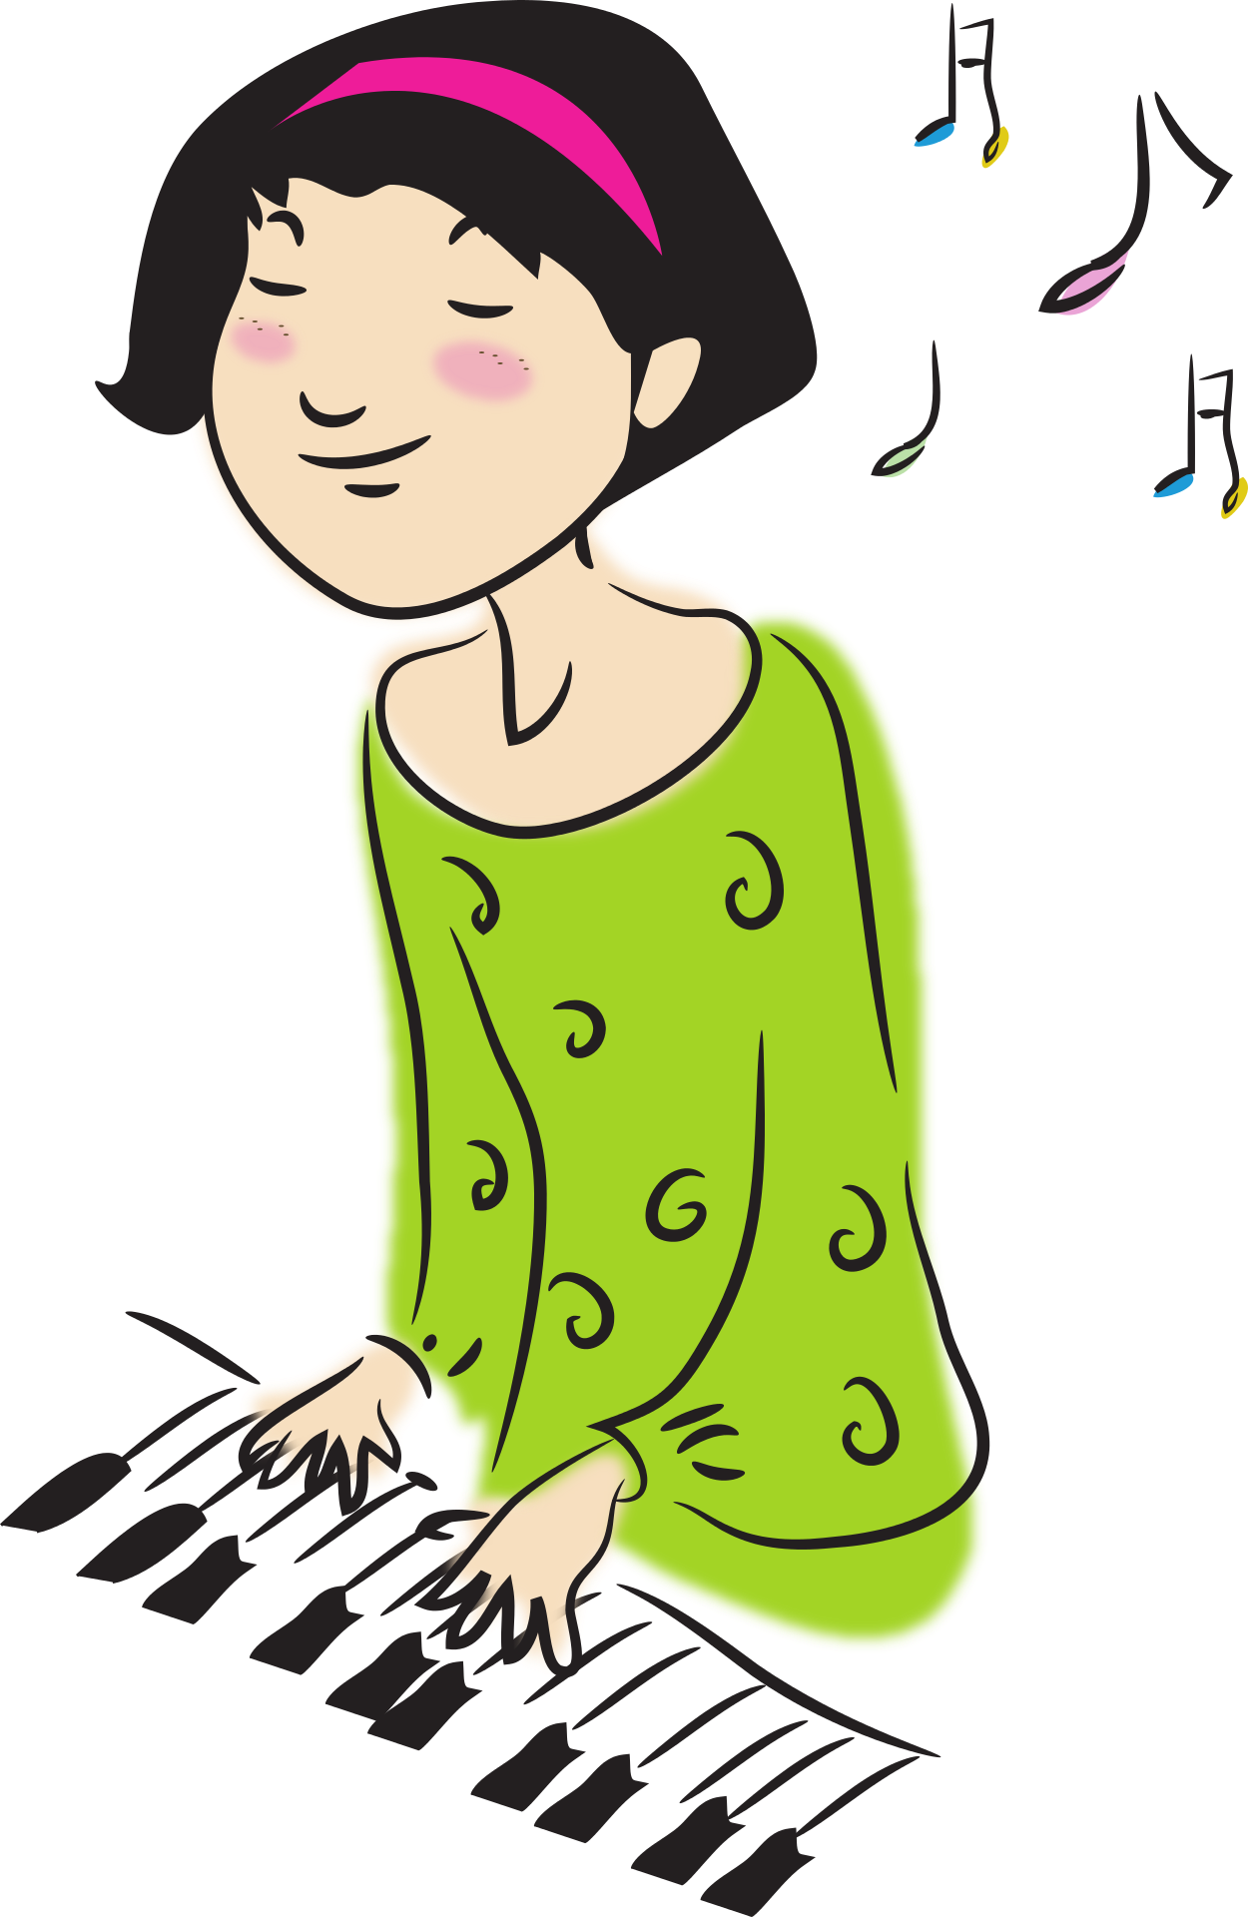
- Song Time

1. Hello song / Greeting:

Choose a song or a melody to play or sing at the beginning of every lesson. Children with special needs feel comfortable when there is a routine and they know what to expect. This is the announcement of the beginning of the lesson.

2. Exploring different sounds:

Explore the different qualities and possibilities of sounds on the piano; loud sounds, quiet sounds, animal sounds, sounds of nature, sounds of familiar objects, or sounds of cars...

Create a musical story together. Kids love to do this.

3. White and Black Keys and their pattern:

Play white keys, play black keys. Notice the pattern.

Play all black keys going from lowest to highest, each hand separately.

Play all groups of threes going from lowest to highest each hand separately.

Play all groups of twos going from lowest to highest each hand separately.

4. Black keys tune:

The Easier Piano Book 1 pages 7, 8.

You might need to hold the student hand for support.

https://www.dimatahboub.com/theeasierpianobook

5. Copy Cat:

Start by playing 2 notes and ask the student to repeat. If successful play 3 different notes. If successful, play different 3 notes with a different rhythm and ask student to repeat. Find out how far you can go with this.

6. Hand Gym:

The Hand Gym has become very popular with my students because of its quick and amazing effect on their finger movement. I have actually been asked to make a video of the exercises in order for the parents to practice them with their children at home.

Do the exercises shown in this video with your student.

https://www.youtube.com/watch?v=WOx1HoqxvEY

7. Song Time:

Always end the lesson on a good note. Make the last 5 minutes the most fun. Ask the student to choose a rhythm instrument and sing a song together using the rhythm instrument of choice and accompany your student on the piano.

 | Not able | Weak | Average | Good | V. good

Attention Span

Communication

Posture

Reads Alphabets

Sense of Pitch

Sense of Rhythm

Visual Tracking

Lesson section 2

Lesson section 3

Lesson section 4

Lesson section 5

Hand Gym Ex 1

Hand Gym Ex 2

Hand Gym Ex 3

Hand Gym Ex 4

Hand Gym Ex 5

Hand Gym Ex 6

Hand Gym Ex 7

Hand Gym Ex 8

Hand Gym Ex 9

Hand Gym Ex 10

Additional Remarks

- Name of student:

Date:

