Bethune-Height
Recognition Luncheon
Sponsorship Opportunities

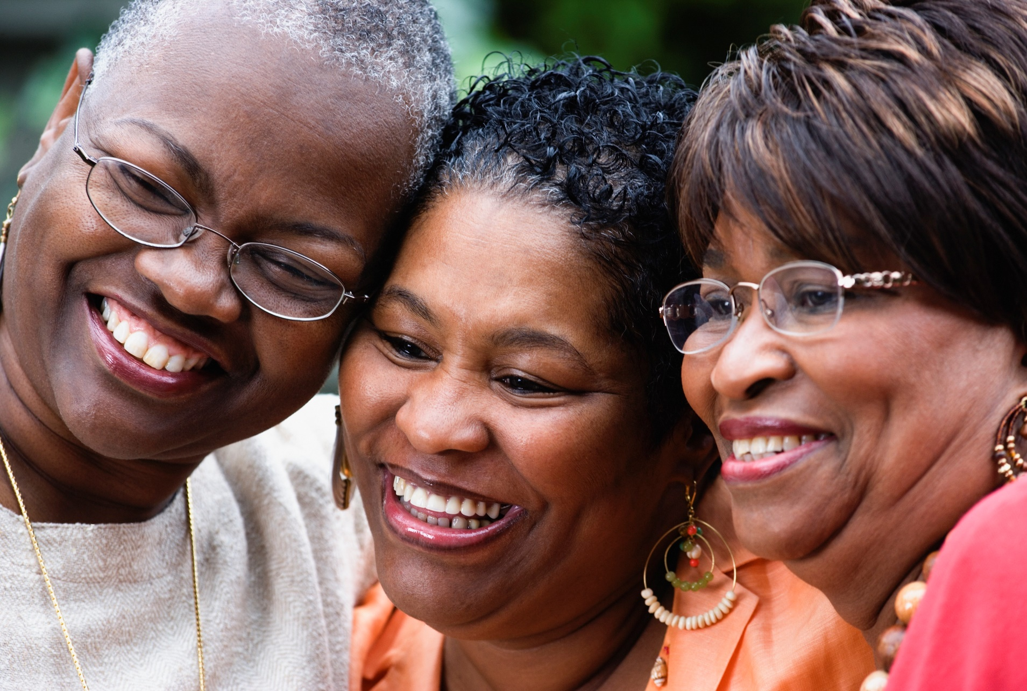
Saturday, September 22, 2018  Presented by the Southern California Area  National Council of Negro Women (NCNW) | Sheraton Fairplex Conference Center  601 W. McKinley Avenue  Pomona, California 91768

The Event
The Annual Bethune-Height Recognition Luncheon presented by the SoCal Area National Council of Negro Women (NCNW) is scheduled for Saturday, September 22, 2018. We anticipate 300+ attendees including civic leaders, elected officials, business owners and local professionals from throughout Southern California.
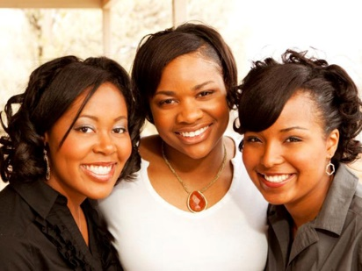
What: The Bethune-Height Recognition Luncheon
Presented by the SoCal Area NCNW
When: Saturday, September 22, 2018
11:30am - 3:00pm
Where: Sheraton Fairplex Conference Center
601 W. McKinley Avenue. Pomona, CA 91768

Who We Are
The National Council of Negro Women, Inc. (NCNW) is a nonprofit membership organization comprised of 36 national African American women's organizations and more than 230 community and campus-based sections. NCNW's mission is to lead, empower and advocate for nearly four million women, their families and communities. We seek to harness the collective power of women of African descent, so that they may realize their full potential and create a just society that enhances the quality of life for all people. The Southern California Area of NCNW is comprised of 13 sections and 2 guilds.

History
Extraordinary educator and political leader Mary McLeod Bethune (1875-1955) founded NCNW in 1935 as an "organization of organizations" to represent national and international concerns of Black women. NCNW fought for jobs, the right to vote and anti-lynching legislation. It gave Black women the opportunity to realize their goals for social justice and human rights through united, constructive action. The legendary Dr. Dorothy Irene Height led NCNW for decades, securing its legacy of enlightened leadership and influence.

The Need - Four for the Future
Education, Health, Entrepreneurship and Values drive NCNW's initiatives. NCNW serves as a catalyst for effective action to address disparities and inequities in communities of color through research. service and advocacy. We fulfill our mission through national and community-based health, education and economic empowerment services and programs undertaken by our section and affiliate volunteers in 31 states.
NCNW addresses local needs while impacting communities nationwide. NCNW'S programs promote civic engagement. empower voters, educate business owners, prevent HIV/ AIDS, tutor and mentor youth and young adults, close the digital divide and STEM gaps. encourage healthy lifestyles, promote traditional values and serve seniors and disadvantaged youth.
~Sponsorship Levels~

Commitment Sponsor $10,000
- 40 VIP seats at the luncheon (four tables in prime location)
- VIP gift for your guests
- Sponsor table sign
- Full page ad in the printed program (inside front cover)
- Logo and prominent recognition on sponsor signage
- One dedicated e-blast showcasing your company /brand
- Logo and company name included in all event related e-blasts
- Logo displayed on video screens
- Social media recognition including Facebook and Instagram posts
- Opportunity to introduce one featured speaker
- Opportunity to provide guest favors

Unity Sponsor $5,000
- 30 preferred seats at the luncheon (three tables in prime location)
- Sponsor table sign
- Full page ad in the printed program (inside back cover)
- Logo and prominent recognition on sponsor signage
- Company name included in all event related e-blasts
- Logo displayed on video screens
- Social media recognition including Facebook and Instagram posts

Self-Reliance Sponsor $2,500
- 20 preferred seats at the luncheon (two tables)
- Sponsor table sign
- Full page ad in the printed program
- Prominent recognition on sponsor signage
- Company name included in all event related e-blasts
- Your company logo displayed on video screens
- Social media recognition including Facebook and Instagram posts

Legacy Sponsor $1,000
- 10 preferred seats at the luncheon (one table)
- Sponsor table sign
- Half page ad in the printed program
- Recognition on sponsor signage
- Company name included in all event related e-blasts

~Program Ads & Tickets~

Full Page Ad $150
- One full page ad in the printed program ~ size 5" x 8"

Half Page Ad $75
- One half page ad in the printed program ~ size 5" x 3.875"

Quarter Page Ad $50
- One quarter page ad in the printed program ~ size 2.375" x 3.875"

Individual Ticket $80
- 1 reserved seat at the luncheon

Advertising Specifications
Ad Deadline: Friday, August 31st  Ad Sizing: Full Page = 5" x 8"  Half Page = 5" x 3.875"  Quarter Page = 2.375" x 3.875"  Colors: Full color or black and white.  No bleeds. | Electronic artwork format:  Please submit only high-resolution PDF or JPEG files. Files should have fonts saved to outlines if artwork was created in Adobe Illustrator, Adobe lnDesign, or other professional design software.  Submission:  Please email final artwork before the 8/31/18 deadline via email to BethuneHeight@gmail.com

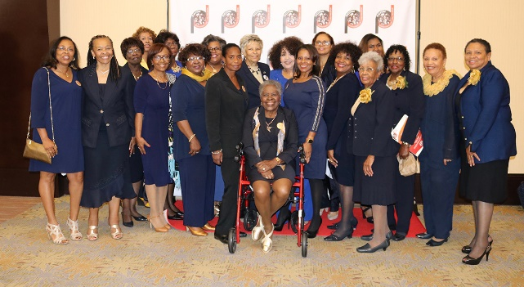
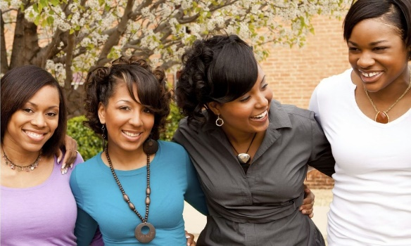
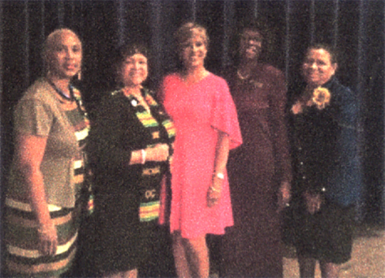

~Registration Form~

Yes! I will support The NCNW SoCal Bethune-Height Recognition Luncheon!

4 EASY WAYS TO REGISTER

- ONLINE at www.eventbrite.com  - EMAIL BethuneHeight@gmail.com this completed form  - CALL Karli Tanner at (310) 940-0074 to reserve your seats  - MAIL your check and completed registration form to:  Attn: BHRL  PVS-NCNW  P.O. Box 425  Montclair, CA 91763 | SPONSOR LEVEL  Please check all that apply below  Commitment Sponsor ~$10,000  Unity Sponsor ~$5,000  Self-Reliance Sponsor ~$2,500  Legacy Sponsor ~$1,000  Full Page Ad ~$150  Half Page Ad ~$75  Quarter Page Ad ~$50  Individual Ticket ~$80  I cannot attend but would like to  make a donation of $
CONTACT INFORMATION
Name
Company (if applicable)
City |  |  |  |  | State |  | Zip
Phone |  |  |  |  | Email

PAYMENT METHOD
Check # |  |  | Enclosed is my/our check in the amount of $
Make checks payable to: “The National Council of Women”
Credit Card Number |  |  |  |  |  |  | Expiration
 |  | Signature |  |  |  | Today’s Date

QUESTIONS? To conform your sponsorship or for questions, email BethuneHeight@gmail.com or please call Karli Tanner at (310) 940-0074 or Mona Sparks Johnson at (909) 938-8892

