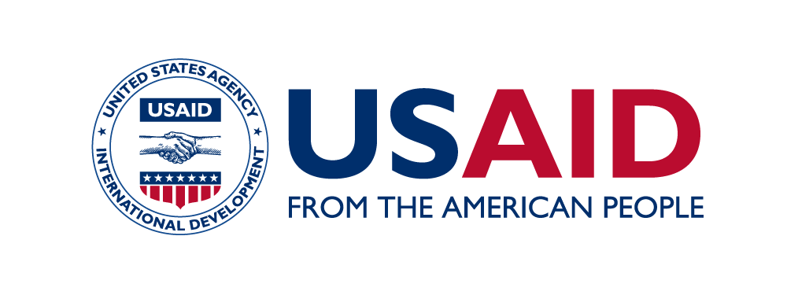
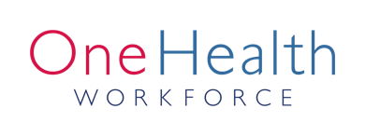
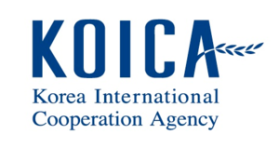

SEAOHUN 2019 Engaging Intergovernmental Organization:
Participation Approval

I confirm acknowledgement of the SEAOHUN 2019 Engaging Intergovernmental Organization program. I hereby give my approval for _____Name of applicant (first, middle, last name)_____ to fully engage and participate in the event held in Bangkok, Thailand during 29 April – 3 May 2019.

Signature_____________________
(Name)
(Position, Organization)
Date________________________

