SAVE THE DATE
May 11th and 12th 2018
5th Annual Spring OPA Tournament
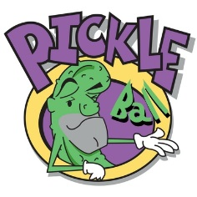
The Friday and Saturday before Mother’s Day…

