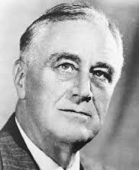

**Franklyn D Roosevelt**