Feminism

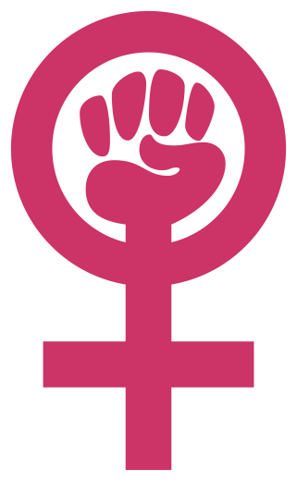**Feminism** is a range of political movements, ideologies, and social movements that *share a common goal*: to define, establish, and achieve political, economic, personal, and social rights for women that are *equal* to those of men.

Feminist movements have campaigned and continue to campaign for women's rights, including the right to vote, to hold public office, to work, to earn fair wages or equal pay, to own property, to receive education, to enter contracts, to have equal rights within marriage, and to have maternity leave. Feminists have also worked to promote bodily autonomy and integrity, and to protect women and girls from rape, sexual harassment, and domestic violence.

In 2013 Beyoncé [surprised](http://www.buzzfeed.com/mbvd/beyonce-just-dropped-her-entire-album-on-itunes) the world by dropping her fifth studio release, an [incredible](http://www.buzzfeed.com/mattbellassai/the-most-unbelievably-flawless-and-life-changing-moments) “visual album” featuring 14 songs and 17 music videos.

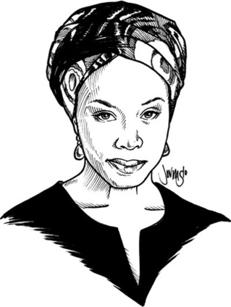In the song “Flawless” (previously released as “Bow Down”), she samples the words of the famous Nigerian Author.

“We teach girls to 1) themselves, to make themselves smaller. We say to girls, you can have 2) , but not too much. You should 3) , but not too . Otherwise, you would threaten the man. Because I am 4) , I am expected to 5) marriage. I am expected to make my life choices always keeping in mind that marriage is the most important. Now marriage can be a 6) joy and love and 7) but why do we teach girls to aspire to marriage and we don’t teach boys the same? We raise girls to see each other as 8) not for jobs or 9) , which I think can be a good thing, but for the attention of men. We teach girls that they cannot be sexual 10) in the way that boys are. Feminist: a person who believes in the social, political, economic 11) of the sexes.”