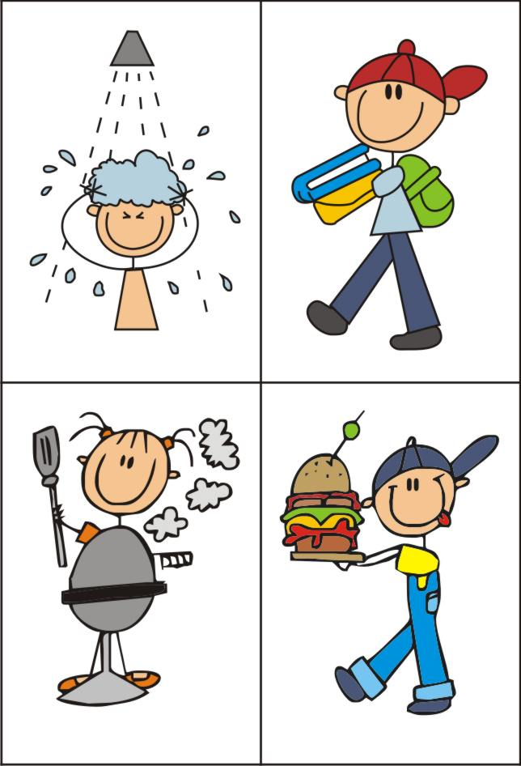
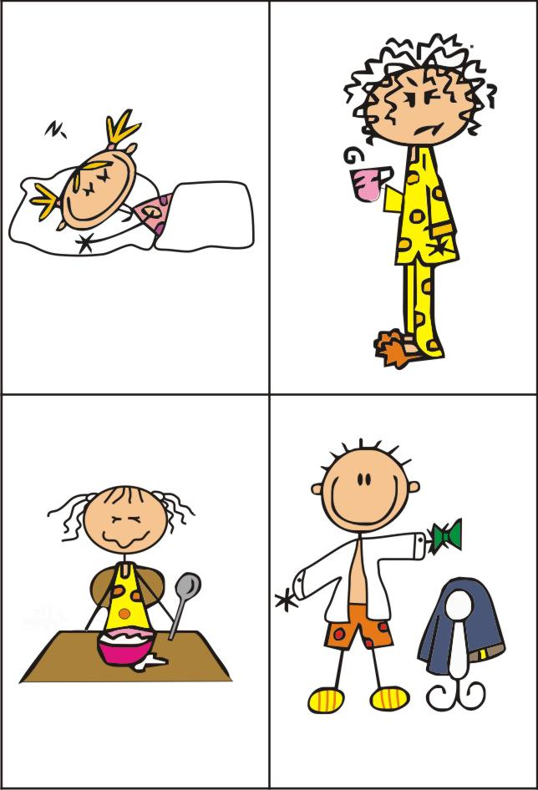
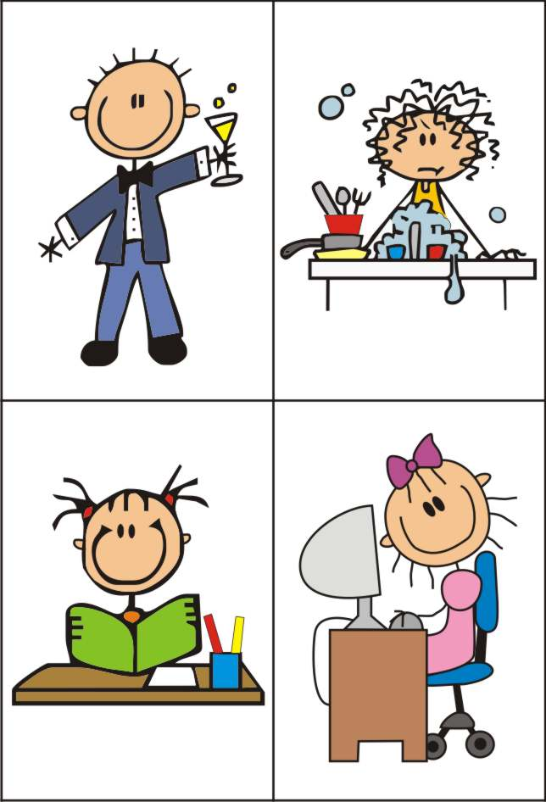
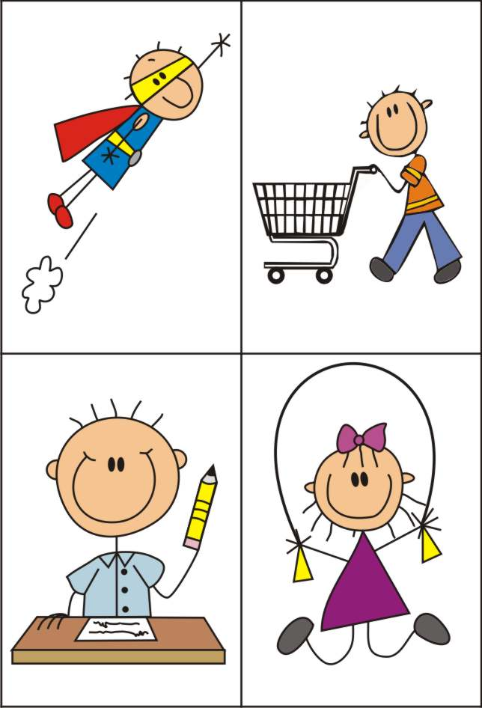
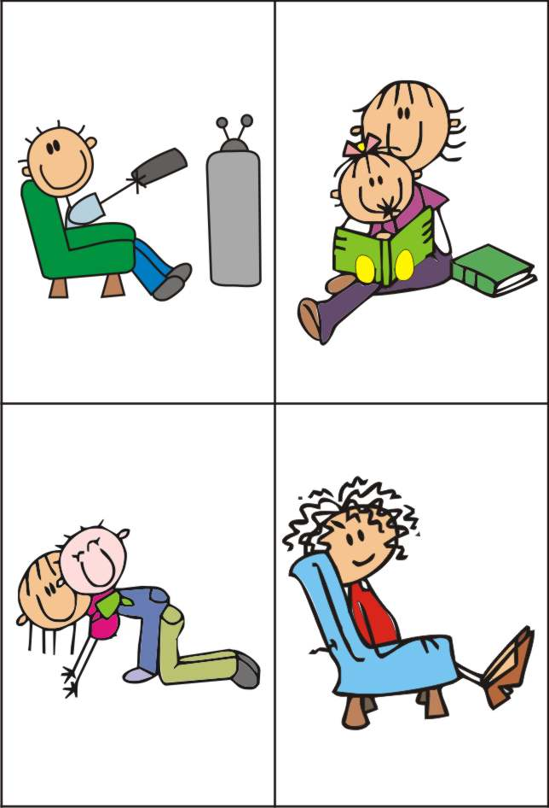
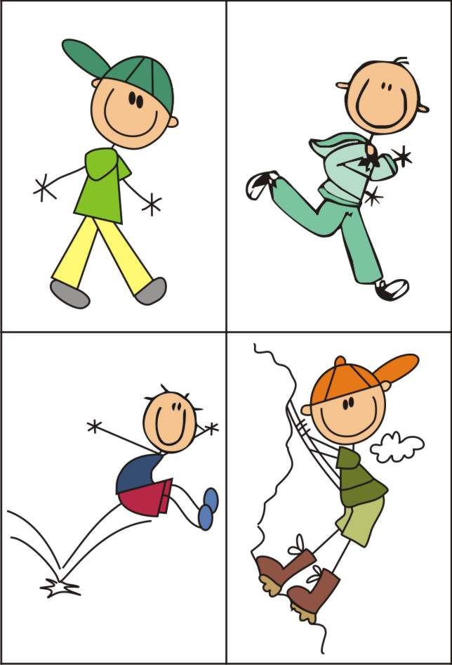
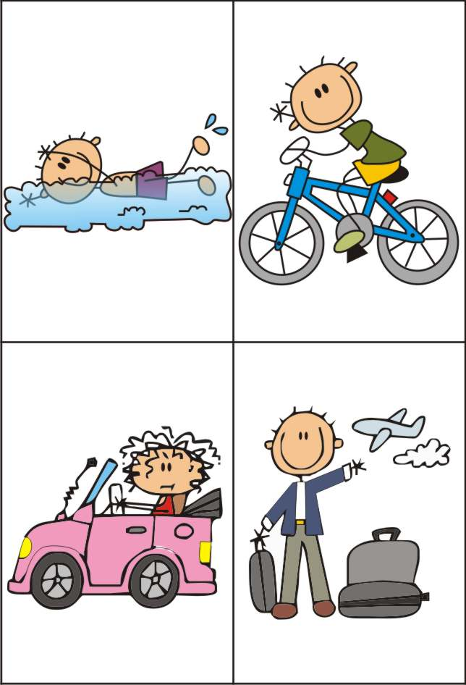
Having a shower – going to school – cooking – eating

Sleeping – getting up – having breakfast – getting dressed

Drinking – doing the washing up – doing homework – surfing the Internet

Flying – going shopping – writing – skipping

Watching TV – reading a book – playing – sitting

Walking – running – jumping – climbing

Swimming – riding a bike – driving a car – travelling

