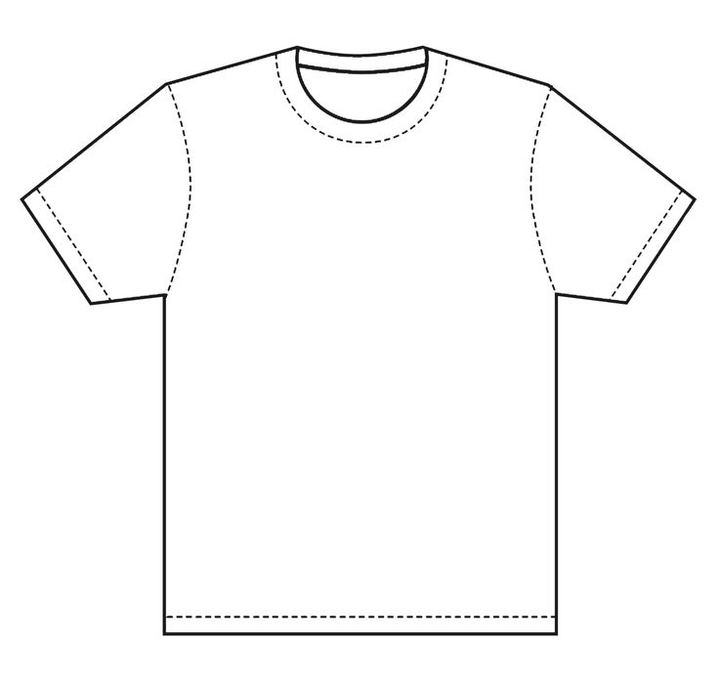
Nipper T-Shirt Design Competition
Name and Age group
Ag

