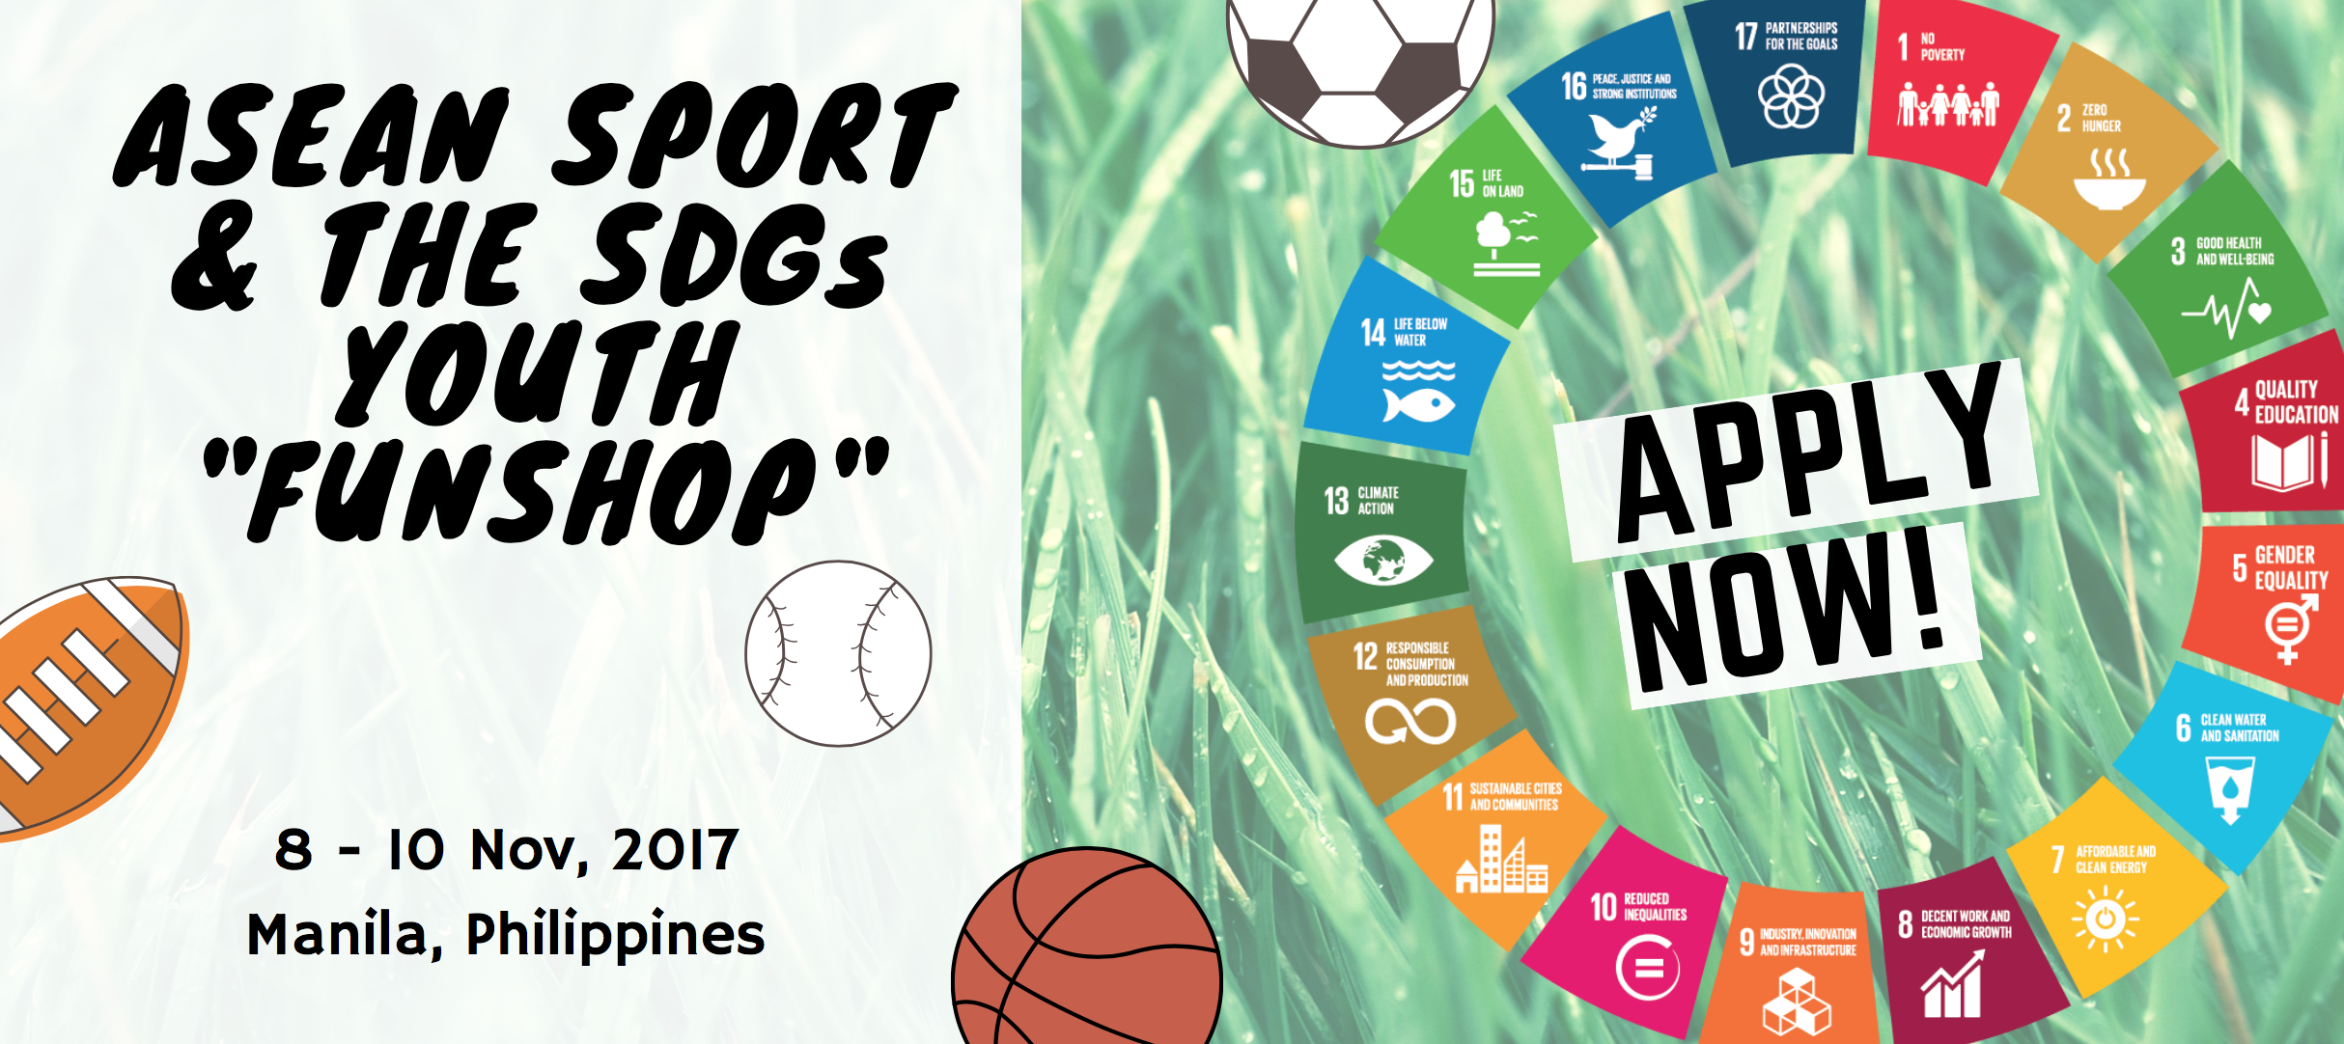

Application Form

This form is available in the following languages: English, Khmer, Indonesian, Lao, Burmese, Thai, Tetun and Vietnamese

Personal info (as stated in your passport)
First name | ........................................................
Surname | ........................................................
Date of birth | ........../.........../..............
Place of birth | ........................................................
Nationality | ........................................................
Place of residence | ........................................................
In 300 words or less, please state why we should choose you to represent your country of residence in the Sport and the SDGs Youth Funshop | ........................................................
Your sports-based social enterprise:

Name | ........................................................
Link to website | ........................................................
Link to social media | ........................................................

Please select the most relevant policy area as reflected in the Kazan Action Plan your sports-based social enterprise contributes to, noting that the Kazan Action Plan represents an approach to sports policy integrated with the UN Agenda 2030/SDGs (mark an X in the most appropriate box):
1 | Improved health and well-being of all, at all ages
2 | Inclusive, safe, resilient and sustainable cities and human settlements
3 | Quality education and lifelong learning for all and skills development through sport
4 | Peaceful, inclusive and equitable societies
5 | Economic growth and full and productive employment and work for all
6 | Advanced gender equality and empower all women and girls
7 | Sustainable consumption and production patterns and actions to combat climate change and its impacts
8 | Effective, accountable and inclusive institutions at all levels

Please email this to: youth.sport@unesco.org with the following supporting documents:
1. Your passport and/or Government or United Nations recognized ID
2. Your full CV
3. Optional: one additional document (such as an analytical report of your work, a white paper, a newspaper article or a link to your YouTube channel)

Thank you for your submission!

