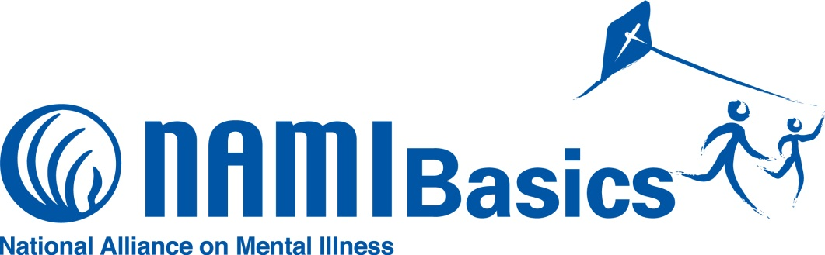

What is the NAMI Basics Education Program?
NAMI Basics is a free, six-session program designed for parents and other family caregivers of children and adolescents with emotional and behavioral difficulties. NAMI Basics helps parents and other family caregivers of children to understand the illnesses that are causing those behavioral difficulties, and the critical role families play in the treatment of those illnesses. The program is taught by trained teachers who are also the parents or family caregivers of individuals who experienced emotional or behavioral difficulties prior to age 13.

NAMI San Gabriel Valley, the local organization of the National Alliance on Mental Illness, is accepting applications for its NAMI Basics Education Program that will be offered in June 2018. Please complete and return the application on reverse to register for the next class. Visit www.namiasangabrielvalley.org for more information or contact the Education Coordinator below.

Participant Perspectives
“This is such a great step by step program that walks parents every step of the way. It is as if you are holding their hand through it all.”

“The course is inclusive of almost all aspects of family and child resources. I could have spent a lifetime getting all this information on my own. I feel supported, strong and ready to go forward.”

“NAMI Basics bridges the gap. It provides help that can’t be found in a doctor’s office.”

Contact us to register for this NAMI Basics class!

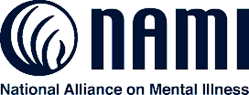
NAMI
San Gabriel Valley

About NAMI
NAMI, the National Alliance on Mental Illness, is the nation’s largest grassroots mental health organization dedicated to building better lives for the millions of Americans affected by mental illness. NAMI {Affiliate Name} is an affiliate of NAMI {State}. NAMI {Affiliate Name} and dedicated volunteer members and leaders work tirelessly to raise awareness and provide essential education, advocacy and support group programs for people in our community living with mental illness and their loved ones.
Sylvia Gil, Education Coordinator
NAMI San Gabriel Valley
2550 E. Foothill Blvd., # 135
Pasadena CA 91107
323-351-0999
sylvia@namilaccc.org

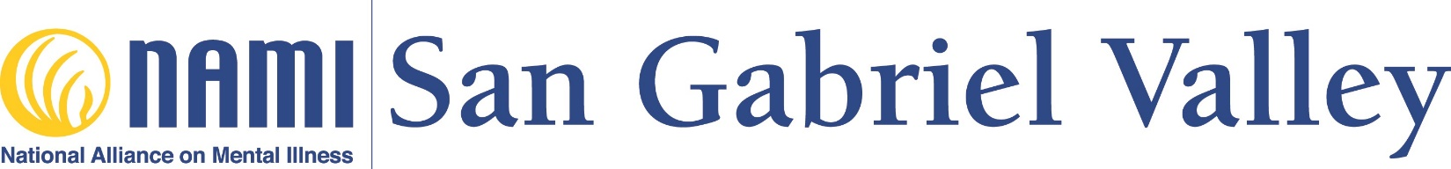Basics Application

A 6-week educational program for family members of children under 16 suffering from mental illness

Date: ___________Name of Applicant(s):_______________________________________

Address: _______________________________________________________________

City: ________________________________State: ____________ Zip: _____________

Home phone: ____________ Cell:___________________Work:____________________

Email: ________________________________________

Please tell us something about your family member who is suffering from a mental disorder. This information provided will help to determine if this program meets your needs. NAMI is here to support you and your family.

Name of mentally ill relative: _________________________________________________

Relationship to you: _______________________________________________________

Age: _____ Sex: _________Age of onset illness:___________________________________

Diagnosis/Symptoms: ______________________________________________________

Medication(s) in use:_______________________________________________________

Living arrangements: ______________________________________________________

Other information: ________________________________________________________

Please email or mail your completed application to:

NAMI – San Gabriel Valley
2550 E. Foothill Blvd. #135, Pasadena, CA 91107

Attn: Sylvia Gil, Education Coordinator
323-351-0999 or sylvia@namilaccc.org

