Family To Family Application

A 12-week educational program for family members of those suffering from mental illness

Date: ______________

Name of Applicant(s): __________________________________________________

Address: _____________________________________________________________

City: _________________________________ State: _______ Zip: _____________

Home phone: _______________ Cell:_________________ Work: _______________

Email: _______________________________________________________________

Please tell us something about your family member who is suffering from a mental disorder. This information provided will help to determine if this program meets your needs. NAMI is here to support you and your family.

Name of mentally ill relative: ______________ Relationship to you: ________________

Age: _______ Sex: ___________

Age of onset illness: ______ Diagnosis: ___________________________________

Medication(s) in use: _____________________________________________________

Living arrangements: ____________________________________________________

Other information: _______________________________________________________

Please email or mail your completed application to:

NAMI – San Gabriel Valley
2550 E. Foothill Blvd. #135, Pasadena, CA 91107,
sylvia@namilaccc.org, 323-351-0999

For questions or additional information about the Family to Family class, contact Education Coordinator,
Sylvia Gil at 323-351-0999 or sylvia@namilaccc.org .

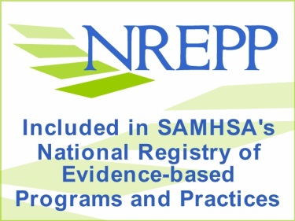
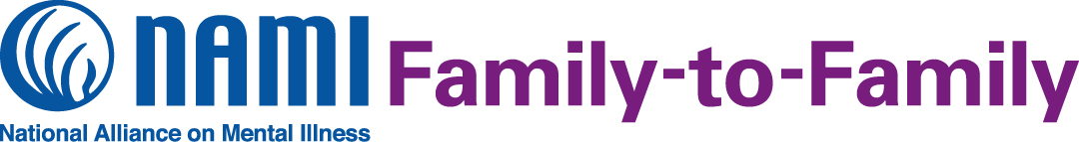

What is the NAMI Family-to-Family Education Program?

NAMI Family-to-Family is a free, 12-session education program for family, partners, friends and significant others of adults living with mental illness. The course is designed to help all family members understand and support their loved one living with mental illness, while maintaining their own well-being. The course includes information on illnesses such as schizophrenia, bipolar disorder, major depression and other mental health conditions. Thousands of families describe the program as life-changing. The program is taught by trained teachers who are also family members and know what it is like to have a loved one living with mental illness.

NAMI San Gabriel Valley, the local organization of the National Alliance on Mental Illness, will offer the Family-to-Family Education Program for 2018 beginning February 6, April 24 and July 2. Apply now for priority in the next class. Contact the Education Coordinator for more information and to return your completed application. Pre-registration is required.

Participant Perspectives
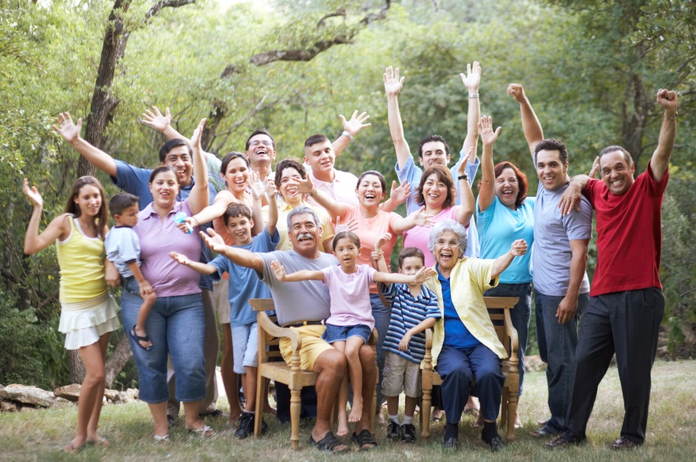

“This course overall was the single most, without a doubt, helpful and informative thing ever offered in all my years searching for answers… It has helped me to understand better and communicate more effectively with my brother.”

“The course has helped me to realize that my son is still inside the body that is often times hidden by the mental illness and that I am not alone in this.”

Contact us to register for this NAMI Family-to-Family class!

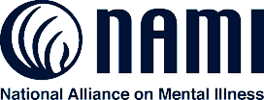
San Gabriel
Valley

About NAMI
NAMI, the National Alliance on Mental Illness, is the nation’s largest grassroots mental health organization dedicated to building better lives for the millions of Americans affected by mental illness. NAMI San Gabriel Valley is an affiliate of NAMI California. NAMI San Gabriel Valley and dedicated volunteers, members and leaders work tirelessly to raise awareness and provide essential education, advocacy and support group programs for people in our community living with mental illness and their loved ones.
Sylvia Gil, Education Coordinator
NAMI San Gabriel Valley
2550 E. Foothill, #135
Pasadena CA 91107
323-351-0999
Sylvia@namilaccc.org

