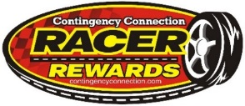2015 Racer Rewards Championship Bonus Packages
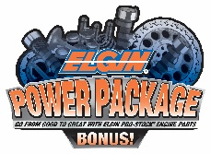Elgin® Power Package Bonus will offer a complete high-performance engine valvetrain package to one champion at each Contingency Connection track and series. The Elgin Power Package will include an Elgin PRO-STOCK® camshaft, push rods, rocker arms, valves, and valve springs for one engine of the winner's choice! $500 value
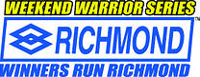 Richmond Gear Weekend-Warrior Bonus Series Contingency Connection tracks and series will host nearly 150 Richmond Gear Weekend Warrior events rewarding (3) Weekend Warriors at each track/series with a $200 Prize Package including a Richmond Gear product certificate and racing apparel! $600 value per track
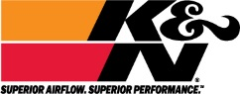K&N Superior Performance Bonus K&N will recognize ONE champion at each Contingency Connection track and series for their "Superior Performance" with a $250 K&N product and apparel package! $250 value
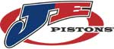JE Pistons Sportsman of the Year One winner from each track/series will be selected as the JE Pistons Sportsman of the Year receiving a $200 product certificate, JE Pistons apparel package, and an etched piston trophy $250 Value
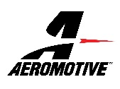 Aeromotive Phantom Fuel System Series Aeromotive will reward ONE championship race-team at each Contingency Connection track and series with product, apparel, and a decal package! $200 Value
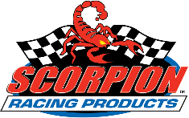 SCORPION SUPER STAR Bonus will recognize ONE Super Star driver for their performance, attitude, and professionalism. Scorpion Super Stars will receive a certificate for Scorpion Products, team apparel, and a decal package $200 value
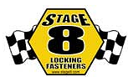Stage 8 Fasteners WORLD’S BEST Bonus will recognize One Stage 8 World’s Best champion at each track/series with a championship prize package including a $100 product certificate, apparel, and a trophy/plaque $150 value
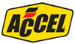ACCELNation.com Club ACCELNation.com brands ACCEL, Mallory, Mr. Gasket, Lakewood, Hays, and Quick Time will induct one top performing racer into the ACCELNation Club. Winners receive product, apparel, and other awards. $150 value
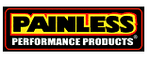 Painless Performance CIRCUIT Challenge will recognize ONE overall Contingency Connection Grassroots Racing Champion from each track and series with a Painless Performance product award and decal package. $100 value
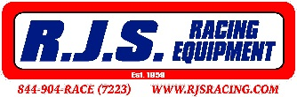RJS Racing Equipment Championship Challenge will reward an SFI-1 Driving Jacket to ONE
Top-performing champion at each Contingency Connection track/series. $100 value
Lincoln Welders Champions Bonus will award one champion from each track and series with a $100 Lincoln Welder gift certificate good towards welding gear. In addition, Lincoln will award THREE (3) grand prize Lincoln Electric MIG welders through a national Contingency Connection sweepstakes! $100 value
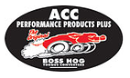The Original BOSS HOG Torque Converter Championship Bonus $200.00 Gift Certificate towards "Street Bandit" Torque Converter Series –OR- $300.00 off "OutLaw" NOS/Trans-Break Torque Converter Series $200 value

See your track/series operator for details on how to qualify for Contingency Connection Bonus Packages!
Email: info@contingencyconnection.com Website: www.contingencyconnection.com

