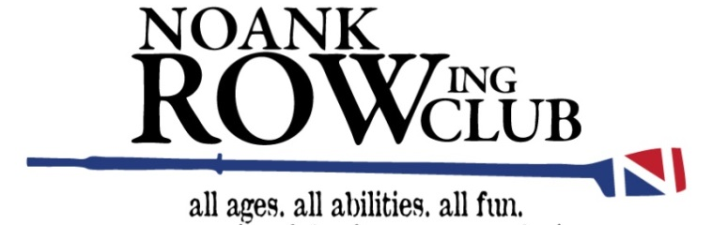
NRC Pasta FUN-draising Supper
Friday, Oct 21, 2016
at the
Noank Baptist Church
(½ mile from the boathouse)

Dear Parents, Students, Noank Rowing Club Members & Supporters!

Join us for a fun and joyful evening while enjoying a delightful pasta supper! How does this pot luck pasta supper work? Just like in rowing - many hands make lite work! The Noank Rowing Club coaches have asked the following:
- We request each students sign up for supper item(s) (as listed on the following pages).
- We request assistance in the kitchen (as outlined on the following pages)
- Should the inspiration grab you, offer one of the following by Thurs 10/13 (8 days prior):
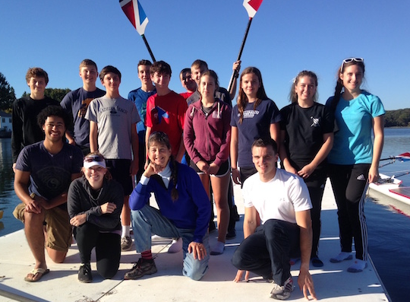
*FUN gift basket (e.g. men’s grooming collection)
*Local Gift Certificates (e.g. 99 Restaurant or a shop like Starbucks),
*$10 toward a rowing basket (rowing moms have volunteered to buy items & create a basket)
*Item(s) for a basket (eg a basket (for a rowing mom to fill!), a set of coffee mugs for coffee basket, wine rack for a wine basket, candy for a movie night basket – you get the idea?
This is a FUN and Yummy way to have a FUNdraiser! Together with all our donations, we create a pasta, salad & dessert extravaganza, with an entertaining raffle & great fun!!
2016 Fall Youth Novice & Experienced Rowers and Coaches
Parents & Adults: Since the students have signed up for these items, would you please review the list to confirm you are comfortable with your donations.
Families & NRC Club Members are encouraged to offer fun ”baskets” or “bits” for raffle as outlined above. Past years raffles include: two jars of homemade pasta sauce (added NRC salad dressings to make a basket), plants potted from a bumper crop in a rower’s back yard, ice cream basket, home baked goods (pie, cookies) coffee basket, video night home basket, pup basket … get the idea?
You are encouraged to
- Bring your Raffle items by Thurs 10/13, eight days prior to the event, so we can organize / include them!
- Bring Supper items (Tues 10/18 or Thurs 10/20) the week of the event. Place them in coach Kristen’s car (older Silver Honda Pilot) so we can bring them to the church kitchen & refrigerator!
- If you wish to deliver a hot item (pasta or sauce) then bring it between 3:30-4:30 the day of the event.
If you have any questions or concerns, please contact Kristen knegaard@yahoo.com or call 860-885-4629.
In the Spirit of Rowing –
The Coaches of Noank Rowing Club
Keith Wlison, Allie Socha, Kelsey Butta, Dale Hoxie, Andy Hammond & Kristen Negaard O’Brien!
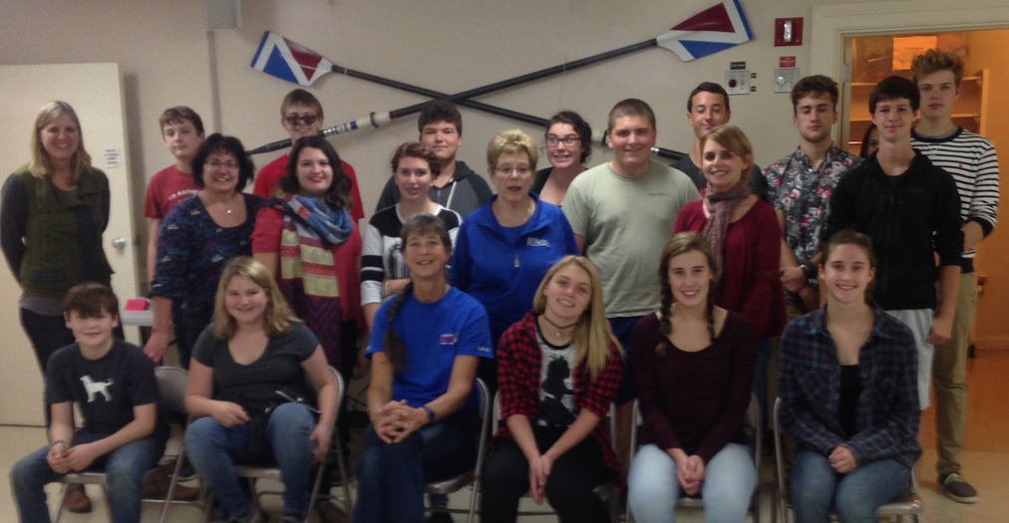
Noank Rowing Club’s Pasta
FUN-draising Supper

Please fill in a ‘blank’ line to help complete this FUN supper!

BRING ONE ITEM
Meat Red Sauce (30 servings) - krupansky
2015 & 14 Fall Students hang oars, make bread baskets & salad bar bits
Meat Red Sauce (30 servings) – ceci m
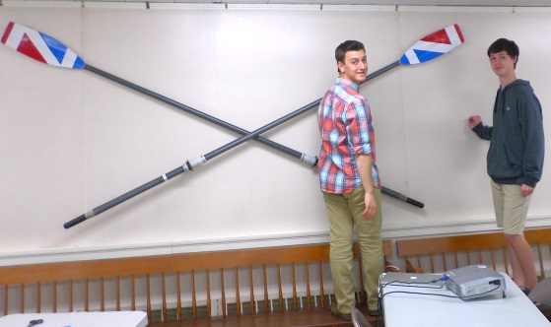
Meatless Red Sauce (30 servings) – derek r
Pesto Sauce (20 servings) – weston c
Pesto Sauce (20 servings) – weston c
White Cheese Sauce (20 servings) – sam b
White Cheese Sauce (20 servings) – adrian c
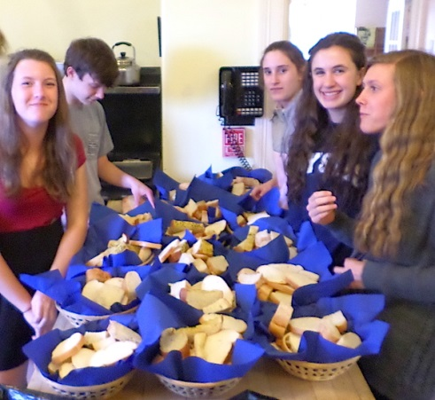
BriNG One GROUPING (eg paper)

Paper – Sam b
100 - 8 ounce paper cups
(coffee cups – already have)
50 blue napkins, 50 red napkins (Kristen will purchase)
(inexpensive white napkins – already have)
100 sturdy white plates
100 dessert plates

Condiments 1 - knob
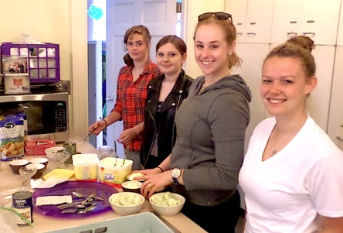
black olives, green olives, sunflower seeds,
1 container cottage cheese, 1 cuke, 4 carrots,
3 cups fruit bits (cranberries, raisins)

Condiments 2 - knob
1 can chick peas, 2cups dried tomatoes, peas &
corn (frozen), 2 bags-o-croutons,

BRING ANY TWO ITEMS
Meatballs (one 5 lb. bag) –- kelci g
Meatballs (one 5 lb. bag) – kelci g
Meatballs (one 5 lb. bag) – walter g
Meatballs (one 5 lb. bag) – max h
NRC Pasta FUN-draising Supper
BRING ANY TWO ITEMS (con’t)
1 Dessert – zach a  1 Dessert – zach a  1 Dessert – zach a  1 Dessert – walter g  1 Dessert – bethany b  1 Dessert – Bethany b | 1 Dessert – Kelsey B  1 Dessert – ___________________  1 Dessert – ___________________
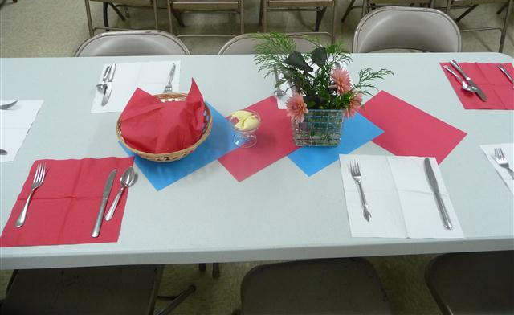
BRING ANY THREE ITEMS
Large Box of spring mix – jack d
Large Box of spring mix – jack d
Large Box of spring mix – jack d
3 (sets of 3 heads) romaine lettuce – max h
Tables are set by the students
3 (sets of 3 heads) romaine lettuce – Sue Bibeau
2 head red cabbage – sarah c
2 heads of red lettuce - sarah c
5 pounds/boxes of cooked (al dente) WHOLE WHEAT spaghetti – Kelsey B
5 pounds/boxes of cooked (al dente) spaghetti – sarah c
5 pounds/boxes of cooked (al dente) spaghetti – jack mac
5 pounds/boxes of cooked (al dente) spaghetti – John Thornel
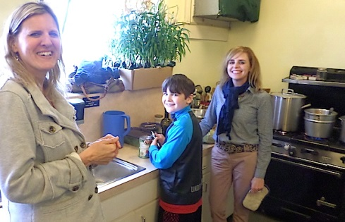
5 pounds/boxes of UNcooked ANGLE HAIR spaghetti – KNOB
3# Low Carb, 3# Gluten Free (al dente) Wheat Pasta - John Thornel
4 loaves of Italian bread - sarah c
4 loaves of Italian bread – max h
4 loaves of Italian bread - dale h
Moms heat pasta sauces to serve 4 different pasta toppings!
BRING ANY FOUR ITEMS
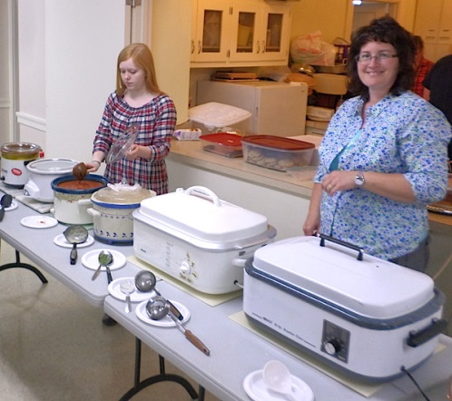
1 large tub of I Can’t Believe It’s Not Butter – Sue Bibeau
1 box of gallon zip lock bags - Sue Bibeau
1 large can of iced tea – NRC
1 large can of lemonade - Weston C
1 can decaf coffee - NRC
Sugar and milk for coffee - John Thornel
4 containers 8 oz. Parmesan Cheese – Sue Bibeau
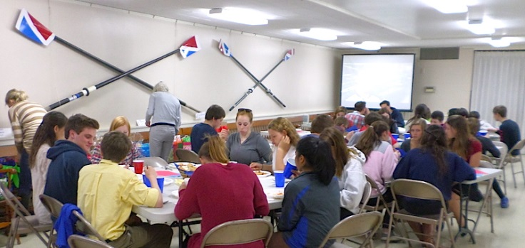
NRC Pasta FUN-draising Supper
May we request parents sign up for a task
Kitchen prep (two persons) (tasks include assisting with cutting bread loaves & salad makings)
2:30-5:00 1. Tessa Castleberry 2. _____________

Hot stove (task includes boiling large pots of water to reheat pasta, bake-ready meatballs & as needed, reheat
Students eat before folks arrive
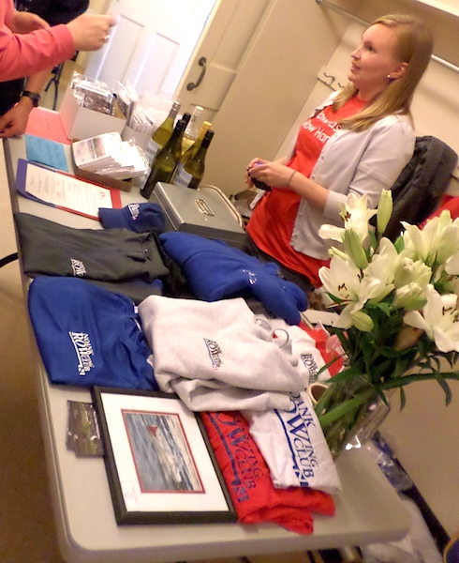
sauces prior to placing them into serving crock pots)

4:00 - 5:15 (two pers) 1. Bethany Bonner (4:15) 2. Deb Adamson
5:15 - 6:30 (two persons) 1. Andrea Lanoux 2. _____________

Ticket & Merchandize Sales (task includes selling NRC merchandize
including sculler sauce, rowing cards, & posters)

4:45-5:45 (two persons)
Merchandize: 1. _____________ 2. ___________________
Supper Tickets: 4:45-5:45 1. Holly Davis 2. Dale Hoxie
Silent Auction Registration: 4:00-5:00 1. Maureen H 2. Kit Talbot

5:45-6:30 (two persons)
Merchandize & Entry tables!
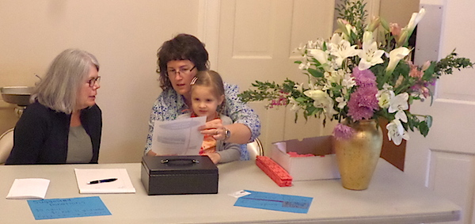
Merchandize: 1. Eric Sorensen 2. Chuck Toal
Supper Tickets: 5:45 – 6:30 1. George O’Brien 2. Sue Bibeau

Attending Refills During Supper (tasks includes encouraging students to refill salad makings, & soft drink pitchers)

5:00-5:45 (one person) ___________________

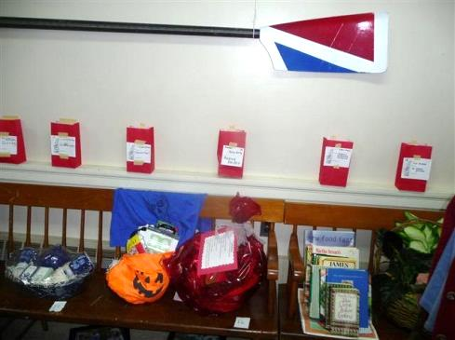
5:45 - 6:30 (one person) Nick Bibeau

Clean up (tasks includes loading/unloading dish washer of serving ware & distributing leftovers (give or toss) 6:30- 7:30 (six pers)

1. Andrea Lanoux  2. Adrian Lanoux  3. Barbara Leisik | 4. Chuck Toal  5. ___________________  6. ___________________  Silent Auction Items donated by rowers!
Baskets of all sorts
1. Family Movie Night -Wes  2.basket Sam Beebe  3. Kelci Gilot - coupons | 4. basket – zach adamson  5. Kelsey B  6. Chuck Toal – local gift certificates | Donations towards Baskets  $10 Adrian,

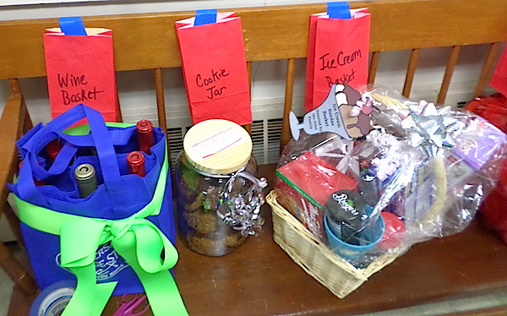
These suggested recipes are an estimated ‘single unit’ multiplied by 3 or 6 is to feed a larger group. We are cooking for approx. 100 persons. You may certainly use your own recipe. Simply create a quantity that will feed approx. 40. Kristen will be happy to transport your sauce or meet you at church prior to the day of the event. The cooks will reheat it for you. If you choose to bring it the day of the event, please have it ready to serve by 4:30pm that afternoon!
Wine, Cookie & Ice Cream baskets
Youthful Red Sauce (multiply by 2 for 80 persons)  olive oil (1 1/2 T)  sautéed onion (1 - 2)  sautéed mushrooms (1 box)  sautéed green pepper (2)  roasted garlic cloves (4 scoops from chopped garlic in a jar)  tomato pieces (4 cans of 1#, 12oz)  tomato sauce with basil & thyme ( 4 cans of 1#, 12oz) tomato paste (1 can) Spices: salt, dry oregano, dry basil, & dash of sugar | Special Spinach Pesto (x3 for 80 persons)  4 scoops minced/chopped garlic from a jar  1 small jar of prepared pesto  Dash of lemon juice (to keep pesto from browning)  1 bag of frozen spinach – rinsed & squeezed dry-ish  ½ - ¾ bag of shelled walnuts  fresh parsley (chop whole bundle – stems et al)  ¾ - 1 ½ cup flavorsome parmesan cheese  Olive oil to enable the food processor to chop mixture. Chop until chunky, not smoooooth.
White Cheese Sauce (x 2 for 20)  3 tablespoons unsalted butter  2 tablespoons flour  salt to taste  white pepper to taste | 2 1/2 cups milk  Parmesan cheese to taste, freshly grated  “5 fresh Italian cheese mix” is the name on the package  2-3 slices American Land-o-Lake individually wrapped cheese slices
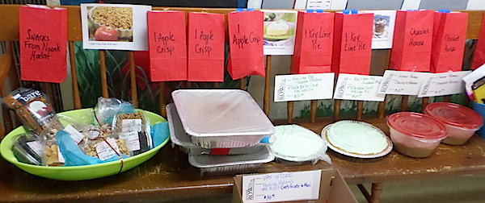
Chocolate Mousse, Key Lime Pie, Apple Crisp, & snack baskets

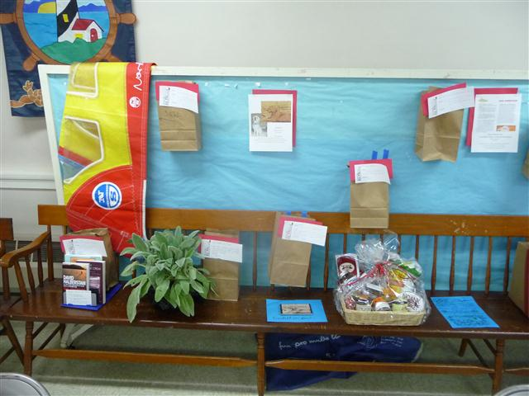
NRC Pasta FUN-draising Supper
Below is a general overview of the event!
2:00-3:00pm Student to arrive at Noank Baptist Church for supper setup
Fitch HS and Cutler MS students are able to take the Noank bound school bus.
Marine Science, Ledyard, and homeschool students chat with fellow teammates to arrange rides to Noank Baptist Church
Books, a Plant,& a Coupon. All joyful raffle offerings
3:00 - 5:00 Adult assistance is encouraged as schedules allow, so the students do not have to work with hot foods (water for reheating pasta and reheating sauces).
There are members of Noank Baptist Church who are also members or very supportive of the Noank Rowing Club who will volunteer to assist.
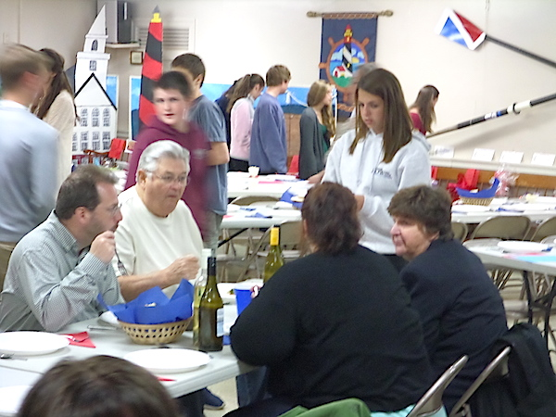
4:30-5:00 Students to eat supper! Smelling all that yummy food for all those hours will make us hungry! This will also accommodate students enabling so they may be free to assist during supper, sell raffle tickets and offer musical entertainment!
5:00 – 6:30pm General Admission
Noank Rowing Club Slideshow!
Noank Rowing Club Merchandize!
Raffle Ticket Sales!
Students offer raffle tickets to diners
We are requesting folks to make up fun Gift Basket / $10 donation / items or local gift certificates for a gift basket to be raffled off at this supper. This aspect of the FUNdraising supper was very joyful and successful last fall! Some of the ideas include: Picnic Basket, Movie Night, Car Washing, Grill Nite, Gardening, Reading, Cooking, Entertaining, Music, etc!! Creativity is welcome. Place your ‘finds’ in baskets, boxes, or fun paper bags-you name it!
5:30 – 6:15(ish) Students Offer Entertainment! (hoping students have a talent to share?)
6:15 -ish Raffle Gift Baskets Awarded – do not have to be present to win!
6:30 -ish Supper Closes – We offer remaining pasta sauce for sale.
Kitchen Kleeenuppp 6:15 – 7:30pm Students & Adults will clean and clear the public rooms and assist as directed in the kitchen. We are seeking a few adults to offer assistance, in shifts to assist in the clean up!
There are members of Noank Baptist Church who are also members or very supportive of the Noank Rowing Club who have volunteered to assist.
In the Spirit of Rowing – Thank you for your ardent support!

