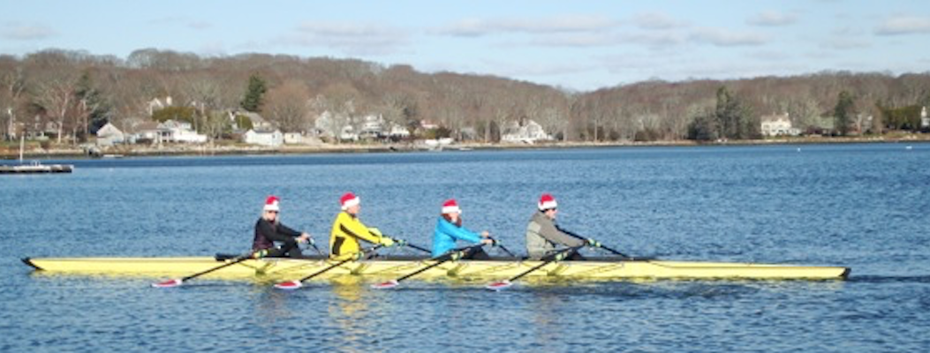

Upcoming Rowing Events
One or more NRC Rowers are planning to participate in each of these events – Chat them up – ask around & join in on the rowing events in our greater community!!!

Northeast Erg Sprints
Saturday, January 28th, 2017, at Merrimack College, in North Andover, MA
The Northeast Erg Sprints aims to be a fun and competitive indoor rowing event, taking place on Saturday, January 28th, 2017, at Merrimack College, in North Andover, MA. Hosted by Greater Lawrence Rowing, a program of the Greater Lawrence Community Boating Program, the day will feature events for all ages and skills, including races of 2000 meters, 1000 meters (for middle school-aged athletes), 1 minute dashes, 4 x 500m relays, and 2x and 4x 1000 meter team events.
The event is open to all athletes, including members of rowing clubs, high school teams, college programs, and fitness/crossfit clubs.
Come test your rowing skills and fitness against other local rowing enthusiasts, and get a warm-up race prior to the C.R.A.S.H.-B sprints.
Youth Rowers Pizza in the Cro’s Nest
Friday Feb 3 at 4:30 – 6pm at Conn College Cro’s Nest
Pizza Party for Jr & Novice Rowers (and anyone else from NRC who would like to come!)
Calling all junior and novice rowers! Please join us for pizza, conversation, and good company on Friday, Feb. 3 from 4:30 to 6:00 p.m. on the Connecticut College campus. We will meet in Cro's Nest on the second floor of Crozier Williams Student Center, and take a walking tour from there to visit the CC rowing facilities (weather permitting).
Questions? Please contact Andrea Lanoux, 860-856-5446, for details or directions.
2017 CGA Crew Return to the River Dinner Saturday, February 11, 2017 Otto Graham Center for Athletic Excellence
The USCGA Crew Team would like to invite you and your spouse to join us at this year's Return to the River Dinner as our guest. We will be holding the dinner in the new Otto Graham Center for Athletic Excellence which is in Billard Hall on Saturday, February 11, 2017 at 1700

C.R.A.S.H.-B. World Indoor Rowing Championships will be held on Sunday, February 12, 2017 at Boston University's Agganis Arena, Boston MA.
C.R.A.S.H.-B. (Charles River All Star Has-Beens) History:
In the beginning, C.R.A.S.H-B. was a group of 1976-1980 US Olympic and World Team athletes who lurked on the Charles River, never rowing the same lineup twice, never practicing before a race, always jumping the start against Harvard and having a lot of fun too.
The 1980 U.S. boycott of the Olympics was not fun though, and about the same time, Concept2 invented their later-named Model A rowing ergometer, the one with the bicycle wheel, a wooden handle and an odometer. The men (and a few women) of C.R.A.S.H.-B. led by the likes of Tiff Wood, Jake Everett and Holly Hatton, formed a fun little regatta of about twenty rowers in Harvard’s Newell Boathouse, to break up the monotony of winter training.
Within a few short years C.R.A.S.H.-B. grew into the International World Indoor Rowing Championships that it is now. The regatta outgrew Newell, and then the IAB (The indoor Athletic Building, now the MAC, the Malkin Athletic Center), The QRAC (Radcliff Quadrangle Athletic Center), moving to MIT’s Rockwell Cage for many years. In 1995 the regatta moved to Harvard’s Indoor Track Facility, perhaps three times the size of the Rockwell Cage. In 1997 C.R.A.S.H.-B. moved to and even larger and ultra-modern facility, The Reggie Lewis Track and Athletic Center at Roxbury Community College. Since 2008, the venue is Boston University’s Agganis Arena, a state of the art facility just downstream of the original C.R.A.S.H.-B. site.
In the beginning, the race was five miles on the Concept2 Model A ergometer. From the introduction of the Model B ergometer in the mid-1980’s through 1995, the big race in mid-February was 2,500 meters on the new digital display, because the times were comparable even with the equipment change. To meet specific training demands of international coaches who stress 6K and 2K rankings in the winter, starting with the 1996 World Indoor Rowing Championships the distance changed to 2,000 meters. The race is currently rowed on the latest Concept2 Model D ergometers, which are used by athletes at universities, clubs, schools, and national teams around the world.
In the late 1980’s, when Tiff Wood moved to Seattle, Kurt Somerville, a member of the 1980 US Olympic Eight, took over as Commodore. A few years ago, when he wasn’t looking, we decided we liked him so much that we elected him Commodore for Life. While Kurt retains this title in our hearts, rower and coach Linda Muri took over as the third president in 2008. Under Linda’s watch, the regatta grew even more with the inclusion of events for adaptive athletes. Linda is always easily found during race day on the competitions floor. Just look for the lady in the leopard print robe! Since 2012, athlete Laura Macfarlane has held the position of Commodore.
Although C.R.A.S.H.-B. as an organization maintains a nontraditional irreverence to all things that are not fun, nonetheless this ergometer has become serious business, threatening to replace fun with pain, unless you can equate the two.
.
7th Annual SHS Crew Erg ThROWdown
date to be announced, will be held at the Mystic YMCA

39th Annual Snow Row
Saturday, March 4, 2017 Windmill Point Boathouse 185 Main St., Hull, MA
Upcoming Races via Hull Life Saving Museum, MA
HLM's signature-rowing race, the Snow Row, covers a 3 3/4 mile triangular course starting off the beach at Windmill Point, continuing around Sheep Island, past the Peddocks Island day marker, and back to shore. Huge crowds gather on the beach beside HLM's Windmill Point Boathouse to share in the wild, LeMans-style start, unpredictable weather, and one-of-a-kind gathering of gorgeous boats and athletes. Entirely within view of the Boathouse, the event is a much of a thrill for spectators as for participants. It is also a rare opportunity to see, up close, rowers of all ages and their stunning array of wooden pulling boats -- peapods, dories, wherries, whitehalls, ocean shells, kayaks, pilot gigs, captain's gigs, and Irish currachs. Youth and adult crews and rowers from all over New England, New York, and along the East Coast will join them.
Talk with Bob Berry to learn more!

