Rowing lessons
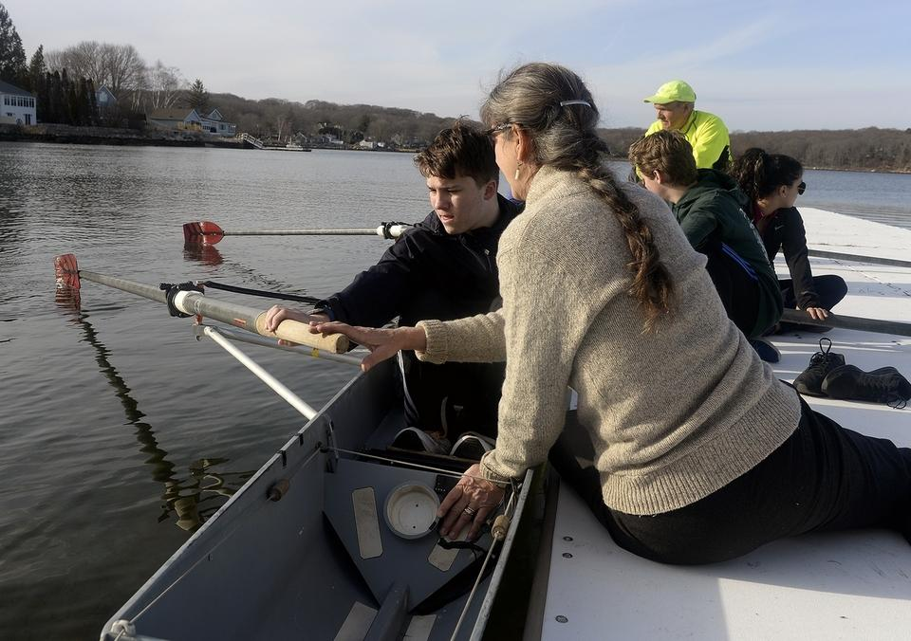
Fitch High School junior Austin Lewerk, a member of the Noank Rowing Club works with coach Kristen Negaard O´Brien, right, as he learns to row during practice on Thursday, March 30, 2017, at Beebe Cove in Noank. Rowers from local high and middle schools participate in the program where they learn to row and compete in regional regattas. The club features classes for students and adults, go to www.noankrowing.org for more information. (Sarah Gordon/The Day)
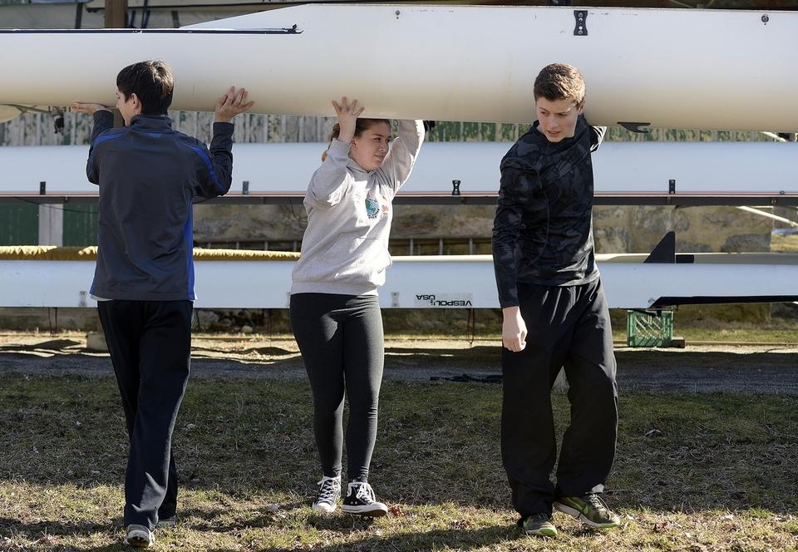
Published March 30. 2017 8:07PM
By Sarah Gordon
Fitch High School junior Austin Lewerk, a member of the Noank Rowing Club works with coach Kristen Negaard O'Brien, right, as he learns to row during practice on Thursday, March 30, 2017, at Beebe Cove in Noank. Rowers from local high and middle schools participate in the program where they learn to row and compete in regional regattas. The club features classes for students and adults, go to www.noankrowing.org for more information.

Members of the Noank Rowing Club, from right, Weston Courtright, a homeschooled sophomore, Samantha Beebe, a sophomore at Marine Science Magnet School, and Jack McCrea, a freshman at Fitch High School, carry a racing shell during practice on Thursday, March 30, 2017, at Spicer Park in Noank. Rowers from local high and middle schools participate in the program where they learn to row and compete in regional regattas. The club features classes for students and adults, go to www.noankrowing.org for more information.
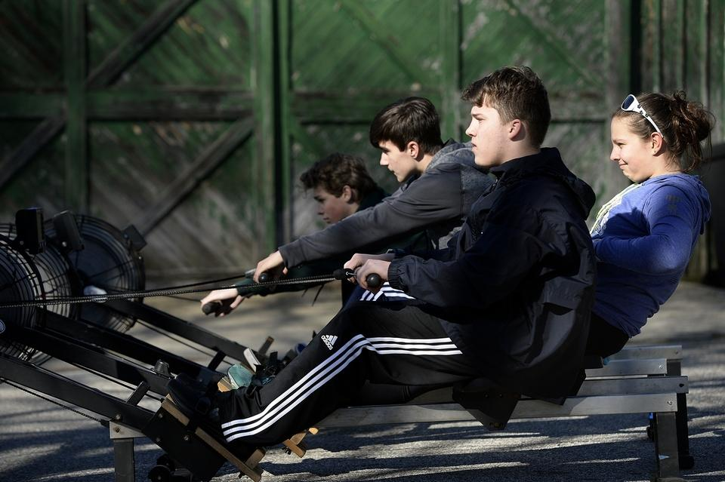
Members of the Noank Rowing Club, from right, Lily Haghpassand, eighth grader at Mystic Middle School, Austin Lewerk, junior at Fitch High School, Hal Crimm, eighth grader at Mystic Middle School, and Ethan Lopes, eighth grader at Mystic Middle School, work out on rowing machines during practice on Thursday, March 30, 2017 at Spicer Park in Noank. Rowers from local high and middle schools participate in the program where they learn to row and compete in regional regattas. The club features classes for students and adults, go to www.noankrowing.org for more information.
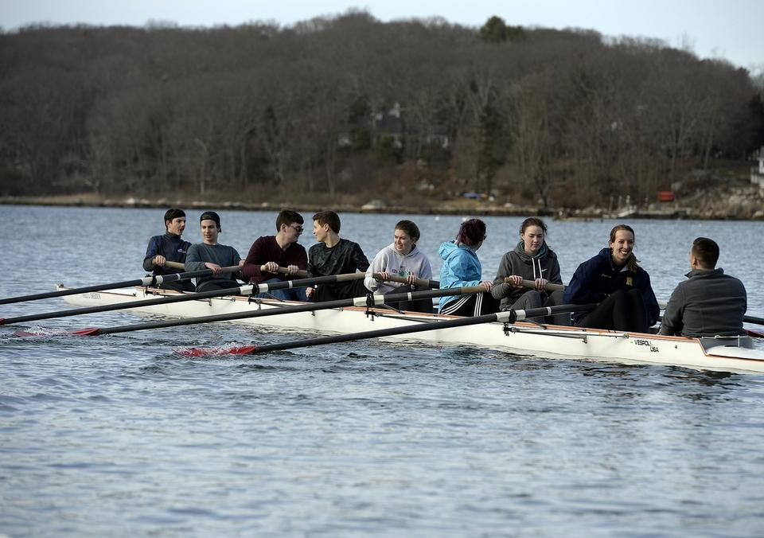
Members of the Noank Rowing Club take to the water during practice on Thursday, March 30, 2017 at Beebe Cove in Noank. Rowers from local high and middle schools participate in the program where they learn to row and compete in regional regattas. The club features classes for students and adults, go to www.noankrowing.org for more information.

