Modern Boat Construction for Rowers
By Eric Sorensen

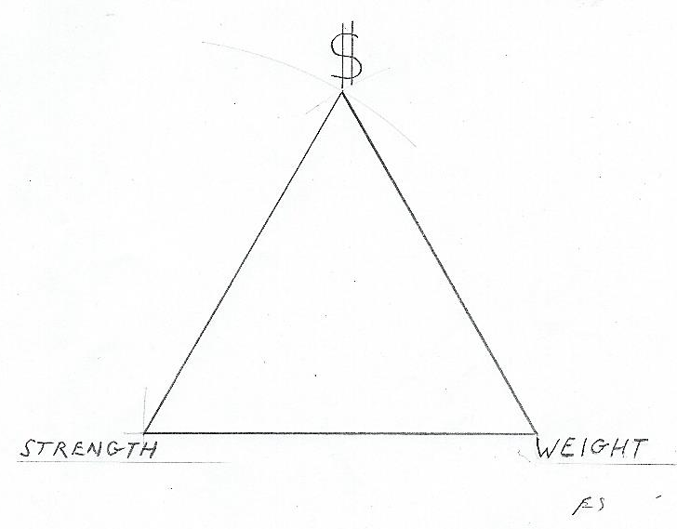
1 –Why are some boats expensive?
Weight, Strength, Cost
It’s easy to make a boat stronger by adding more stuff, making it heavier. It’s not easy to make it both light and strong.
The trade-off is between weight, strength, and cost.
- You can make a boat lighter and stronger with expensive materials and lots of skilled labor time.
- You can make strong and heavy boats cheaply.
- Or you can build cheap, light and weak boats! Not built to last.

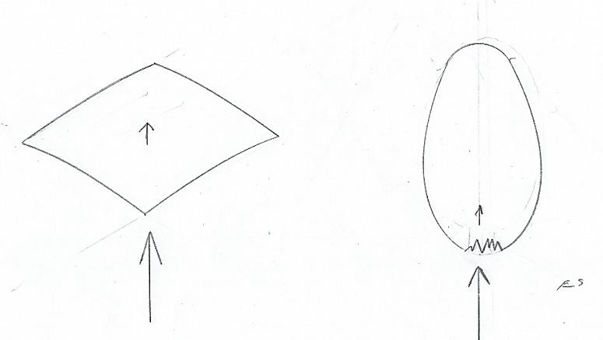
2 – Why is it easy to punch holes in some boats, and not in others?
Stiffness versus Strength
A thin flat sheet of anything, especially fiberglass reinforced polyester resin (called FRP, the common boatbuilding material), bends very easily. If we took the exact same material with the exact same thickness and made an eggshell shape it would be very rigid.
But, this stiffer section would be easy to punch a hole in. It has a lower impact resistance. As a flat sheet it would be really hard to hammer a hole in the middle of it, it would just bend. It has high impact resistance but poor stiffness.
Keep in mind we’re using the same thickness and weight of material, different shape.
So – the strength and stiffness of material depends on the shape it’s molded into, other things being equal.
You’ve probably have seen Sunfish and Sailfish sailboats, originally designed for plywood. Bent plywood is inherently stiff, but for high production they used FRP. To make the bottom stiff enough they built them much heavier than the original boats. They could have stiffened the flat areas with a core, adding thickness without adding much weight, but adding the cost of hand labor.
Things to note -
-“Fiberglass” is one of the flabbiest things you can build a boat with. It’s also heavy. (85-125 lbs/cu ft, compared to softwood at 35lbs or hardwood at 45 lbs.
-Stiffness depends on both the thickness and the shape of the section.
-Weight depends on how much heavy material you use.

So – how do we get strong and stiff boats?

3- What you don’t see – cores
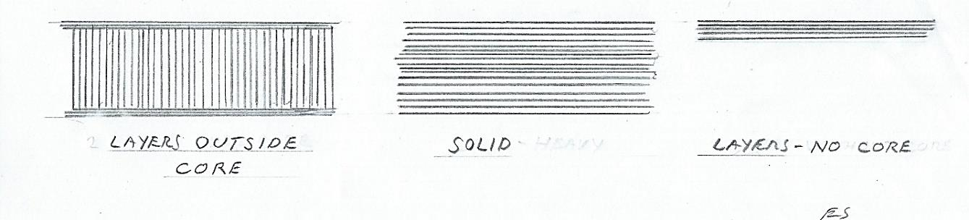
The purpose of a core is to add thickness without adding weight.
Cores are made of light fluffy stuff.

Most boat decks (not rowing shells) are wide and nearly flat. So - this means they have little inherent stiffness. If you look underneath the deck you can see the areas that contain a core. They’re easy to see because the cores are thick. Those cores are usually small squares of balsa wood on end.
Modern small boats use a variety of cores, often very thin ones, where there isn’t much shape in the section. These are hard to see but you can usually hear them when you tap different spots on the boat.

4- Nothing as a core
So – applying the idea of a core to the whole boat –
What could be lighter than air?

Consider the whole hull and deck as a single structural beam that has an air core. If the hull’s sides are prevented from flexing in and out by the deck, the deck can then act as the top of a beam with the hull as the bottom. The deck can be stiffened by being crowned, by a core, or with a lengthwise foam core beam down to the keel. The hull, with its eggshell shape, is naturally stiff. This produces a very stiff, strong, and light result. Know any long skinny light boats?
Other ways to prevent longitudinal flexing (porpoise-ing in a rowing shell, hogging in other boats, animals all) are used where there is no structural deck or molded cockpit. You may have noticed a foam or wood core keelson running lengthwise down the hull bottom. This and the hull bottom which it stiffens act as the bottom of the beam (the keelson forms a “T” beam with the hull) and the gunwales (rails) act as the top. The rails and hull sides are then prevented from flexing in and out with frames or bulkheads. This is more or less what was done in wooden boats.

5- Fibers
A lot of marketing hype here - Most boats are “fiberglass”.

Fiberglass really is thin fibers of glass. The fibers give tensile strength to the resin in which they’re embedded. (forming the matrix).
There are boats with no fibers at all, such as the polyethylene kayaks you’ve seen everywhere. This stuff is flexible, and so resists breaking. But it’s not very stiff, so it works only for short rounded egg shaped boats. Some kayak bottoms have ridges molded in the bottom for stiffening.
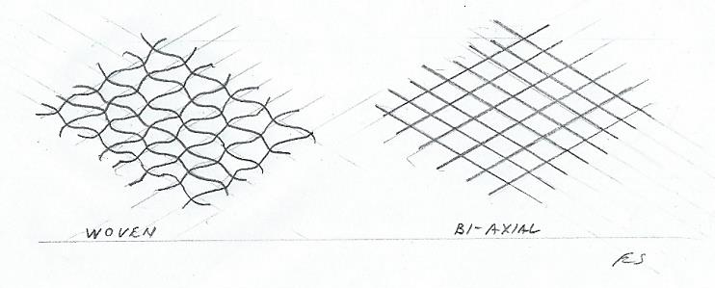
Long thin light kayaks are usually fiberglass.
Almost all the glass fibers in boats are “E” glass. Believe it or not, this stands for electrical glass. Turns out to have good properties as a structural fiber, unlike “A” glass, which is in your windows. There is also “S” glass in high performance boats. (S stands for strength!) It’s stronger and stiffer than E glass.
-Which brings us to the most important part. S glass was a big disappointment when boat builders first used it.
6- Why are boats, stronger, and stiffer, and so much lighter than they were just a few years ago?
Since the S glass is stiffer, it makes a thicker fabric when it’s woven than does the same amount of E glass. When it’s laminated with resin into a boat, it needs and holds more resin to wet it out. The result for the same weight of fiber is a thicker laminate. The woven S glass has a poor fiber to resin ratio, making a heavier and weaker laminate than woven E glass.
So – this got fixed. There are cloths that are bi-axial, tri-axial, etc. These are layers of fibers crossing each other, but laid flat, not woven. They’re only held together with some light basting/stitching. They lay flat and absorb just enough resin to bond them. This is now done with all sorts of fibers.
This was a big change. Only recently have the skills and knowledge required to use them have dramatically changed the possibilities in boat design.
So- why did it take so long to get the most out of these materials?

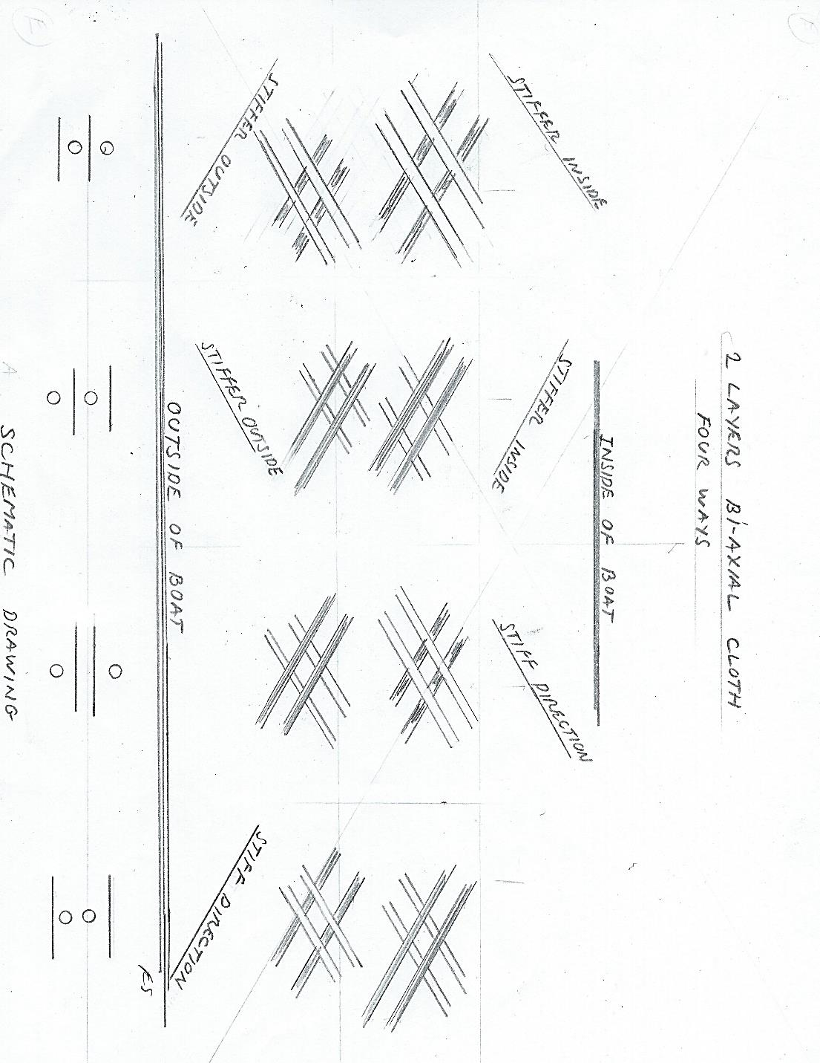
Putting just two layers of bi-axial together can be done in four different patterns, and that’s laying them in the same direction!
The laminate then flexes differently in different directions, depending on the pattern that the cloths were laid up in.
The strength and stiffness of the laminate varies with where (surface, interior) and in what direction the fibers are oriented.
The strength and stiffness can be made larger or smaller in any direction, by the direction and sequence of the fabric. This allows the boat builder to control stiffness, flex, and strength almost anywhere in the boat. Needless to say, there have been years of experimentation, skill building, and failed prototypes spent here.
And yes, there is carbon fiber and Kevlar. Carbon has much more tensile strength than glass, and stretches less. You see it in oars, making the looms are very light and stiff.
Carbon fibers must be straight to make use of their amazing properties, otherwise a load just tends to flex them , and in turn rely on the resin for strength. When oar shafts are built, the fibers are pulled over a male mold, straight, without bends or kinks. (Note: Male molding means you are building up laminate from the inside out; the outermost layer goes on last.) It’s nearly impossible to pull fibers of any kind in a female mold, it’s a mess. (Personal experience, ugh) (Note: Female molding means you build the outermost layer first.) This is why you don’t see many production carbon hulls. Molding those really high performance hulls over a male mold is hideously expensive, and requires hand finishing.
Kevlar© and aramids are also stronger than glass, but don’t add the stiffness of carbon. You don’t see it often in boats except in reinforcing patches, and in the older mixed Kevlar weaves that appeared before the non-woven revolution.

7- What is that smell?
Resin
You see a lot of small tough/durable parts molded in nylon reinforced with glass. For no reason these are almost always black.
But for boat hulls and decks, there are four types of resin in different uses, three polyesters, and epoxy.
The fibers have no smell. That “fiberglass” boat smell is Styrene (a trade name, actually vinylbenzene), a part of polyester resin.
The cheapest polyester and by far the most common is ‘ortho’. That’s what you get if you buy a can of “fiberglass” resin in the store. It works very well for most things. It also contains dissolved wax. More about the wax later.
One of the things it doesn’t work well for is gel coats, which are usually ‘iso’ resins. The old ortho (pre-1970) gel coats blistered and got chalky.
Before the first energy crisis, resin was dirt cheap. Fiberglass boats were designed to be cheap and heavy. High performance boats were made of wood in one form or another. This is when fiberglass boats got a reputation for being roughly built with unskilled labor, no longer true.
A newer resin, vinylester, was originally developed for chemical resistance. It turned out to be stronger and stiffer than the others, and the most water vapor resistant of all the resins, including epoxy. More expensive and trickier to work with, it’s what’s used now for high performance, high end production boats.
Note that you don’t see many epoxy production boats. Epoxy is not good for production. Polyester resins can be “kicked off”/cured within minutes of mixing, which is routine for gel coating. Epoxies have a long cure time. The boats have to be supported in their mold, often for days, or weeks before the next hull can be built. They don’t have a reliable “leather” stage of hardening when excess can be trimmed with a knife. So much for production.
Epoxy does get used for one-offs and prototypes, and there are different types with all kinds of properties exceeding polyester’s (including toxicity!).
Epoxy boats don’t have the styrene smell.

8- Why do some builders take a long time to laminate a hull?
Speed of building
All resins shrink as they cure. They also produce heat, which accelerates the curing reaction and increases the shrinkage. For this reason, boats and molds are built a few layers at a time, to avoid heat build-up.
It’s cheap and fast to build up a laminate all at once, or in just a few sessions. It also causes the finished product to distort from the shrinking resin. You can see this at the transom corners and bow knuckles of cheap fiberglass dinghies, they are visibly and permanently bent inwards. Long thin boats built too fast, or removed from the mold too soon are called “cigars from hell”, or worse.
That resin you buy in the store is “finishing” resin because of the added wax. When it cures the surface will not be tacky.
You might think this is a good thing, but for the next layer of a laminate to adhere to the previously cured layer, the surface must be uncured (tacky). This occurs naturally (polyesters are air inhibited). But the added wax migrates to the air surface during curing, and allows the surface resin to harden. This is why you have to sand your homemade stuff thoroughly before adding a new layer, something they don’t do in boat shops with “laminating” resin. The only difference is the wax.
NOTE- Repairers beware, epoxy will stick to itself and to polyester resins. Polyesters will not bond to epoxy.

9- Why are some boats gel coated, others painted, and some clear?
All resins have the drawback of ultraviolet degradation. They deteriorate from sunlight. There are ultraviolet inhibitors added to some resins for clear coating, but in general, structural parts need to be protected from sunlight. They could be pigmented, like Nylon, but it’s impossible to see what you’re doing as you build with pigmented resin.
This is where gelcoat comes in. Gelcoat has no fibers. Gelcoat is used instead of paint - because in the process of building in a female mold the outside finish is built first!
Gel coat needs some thickness to harden, and it is very difficult to apply it in a thin enough layer to avoid adding 20 pounds to a small boat. There are only a few boat shops that do a thin lightweight gelcoat, as it requires a lot of skill and timing.
Very light boats are often painted to save weight, but it consumes a lot of production time and skill. Gel coated hulls and decks are already finished when they are pulled from the mold!
Note that white is the overwhelming color for production hulls – it doesn’t show scratches as visibly as other colors!

