





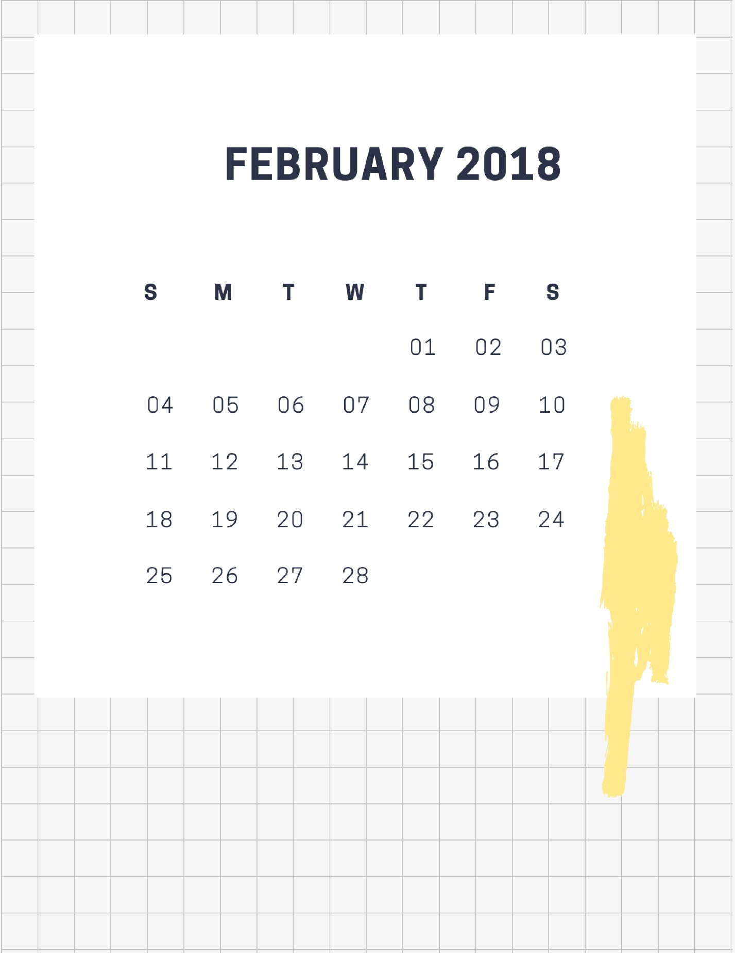


 | mon | 29 | tue | 30 | wed | 31
sched
due
tasks | □  □  □  □  □ |  | □  □  □  □  □ |  | □  □  □  □  □

 | thu | 1 | fri | 2 | sat | 3
sched
due |  |  |  |  | sun | 4
tasks | □  □  □  □  □ |  | □  □  □  □  □ |  | □  □  □  □  □

 | mon | 5 | tue | 6 | wed | 7
sched
due
tasks | □  □  □  □  □ |  | □  □  □  □  □ |  | □  □  □  □  □


 | thu | 8 | fri | 9 | sat | 10
sched
due |  |  |  |  | sun | 11
tasks | □  □  □  □  □ |  | □  □  □  □  □ |  | □  □  □  □  □

 | mon | 12 | tue | 13 | wed | 14
sched
due
tasks | □  □  □  □  □ |  | □  □  □  □  □ |  | □  □  □  □  □


 | thu | 15 | fri | 16 | sat | 17
sched
due |  |  |  |  | sun | 18
tasks | □  □  □  □  □ |  | □  □  □  □  □ |  | □  □  □  □  □

 | mon | 19 | tue | 20 | wed | 21
sched
due
tasks | □  □  □  □  □ |  | □  □  □  □  □ |  | □  □  □  □  □


 | thu | 22 | fri | 23 | sat | 24
sched
due |  |  |  |  | sun | 25
tasks | □  □  □  □  □ |  | □  □  □  □  □ |  | □  □  □  □  □

 | mon | 26 | tue | 27 | wed | 28
sched
due
tasks | □  □  □  □  □ |  | □  □  □  □  □ |  | □  □  □  □  □


 | thu | 1 | fri | 2 | sat | 3
sched
due |  |  |  |  | sun | 4
tasksd | □  □  □  □  □ |  | □  □  □  □  □ |  | □  □  □  □  □


thu
1
fri
2
sat
3
sun
4

mon
5
tue
6
wed
7
thu
8

fri
9
sat
10
sun
11
mon
12

tue
13
wed
14
thu
15
fri
16

sat
17
sun
18
mon
19
tue
20

wed
21
thu
22
fri
23
sat
24

sun
25
mon
26
tue
27
wed
28





