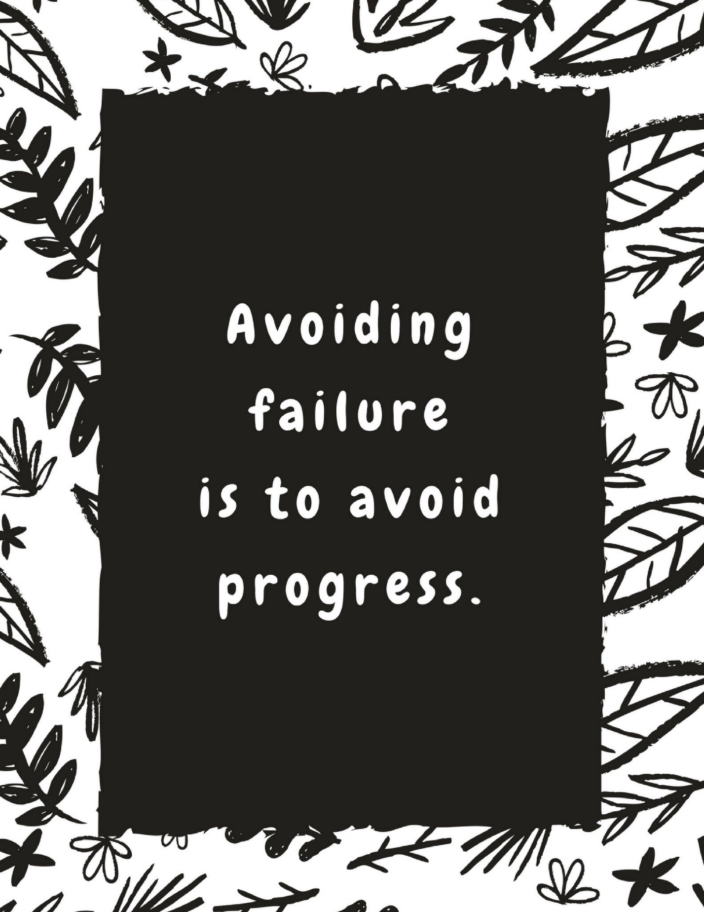





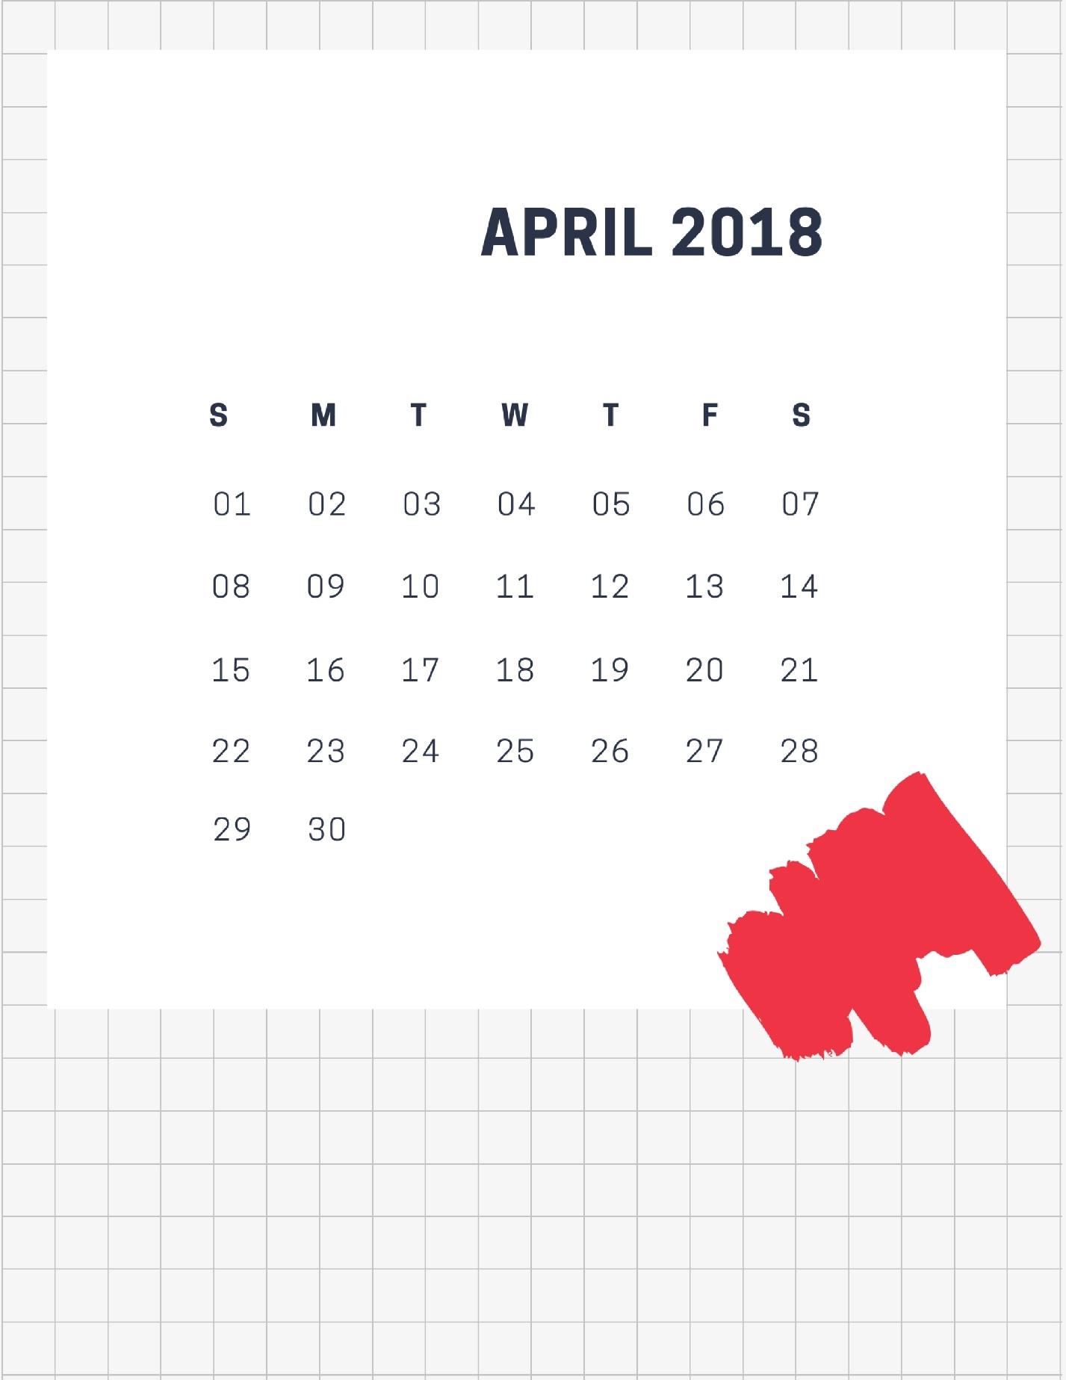


 | mon | 2 | tue | 3 | wed | 4
sched
due
tasks | □  □  □  □  □ |  | □  □  □  □  □ |  | □  □  □  □  □

 | thu | 5 | fri | 6 | sat | 7
sched
due |  |  |  |  | sun | 8
tasks | □  □  □  □  □ |  | □  □  □  □  □ |  | □  □  □  □  □

 | mon | 9 | tue | 10 | wed | 11
sched
due
tasks | □  □  □  □  □ |  | □  □  □  □  □ |  | □  □  □  □  □


 | thu | 12 | fri | 13 | sat | 14
sched
due |  |  |  |  | sun | 15
tasks | □  □  □  □  □ |  | □  □  □  □  □ |  | □  □  □  □  □

 | mon | 16 | tue | 17 | wed | 18
sched
due
tasks | □  □  □  □  □ |  | □  □  □  □  □ |  | □  □  □  □  □


 | thu | 19 | fri | 20 | sat | 21
sched
due |  |  |  |  | sun | 22
tasks | □  □  □  □  □ |  | □  □  □  □  □ |  | □  □  □  □  □

 | mon | 23 | tue | 24 | wed | 25
sched
due
tasks | □  □  □  □  □ |  | □  □  □  □  □ |  | □  □  □  □  □


 | thu | 26 | fri | 27 | sat | 28
sched
due |  |  |  |  | sun | 29
tasks | □  □  □  □  □ |  | □  □  □  □  □ |  | □  □  □  □  □

 | mon | 30 | tue | 1 | wed | 2
sched
due
tasks | □  □  □  □  □ |  | □  □  □  □  □ |  | □  □  □  □  □


 | thu | 3 | fri | 4 | sat | 5
sched
due |  |  |  |  | sun | 6
tasks | □  □  □  □  □ |  | □  □  □  □  □ |  | □  □  □  □  □


sun
1
mon
2
tue
3
wed
4

thu
5
fri
6
sat
7
sun
8

mon
9
tue
10
wed
11
thu
12

fri
13
sat
14
sun
15
mon
16

tue
17
wed
18
thu
19
fri
20

sat
21
sun
22
mon
23
tue
24

wed
25
thu
26
fri
27
sat
28

sun
29
mon
30





