




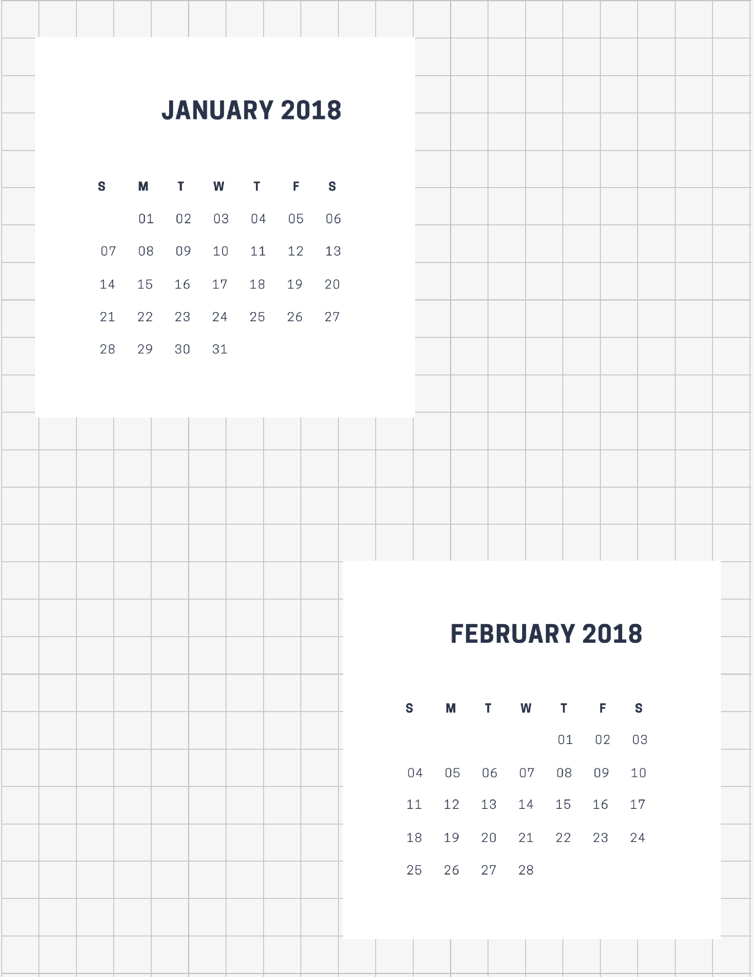

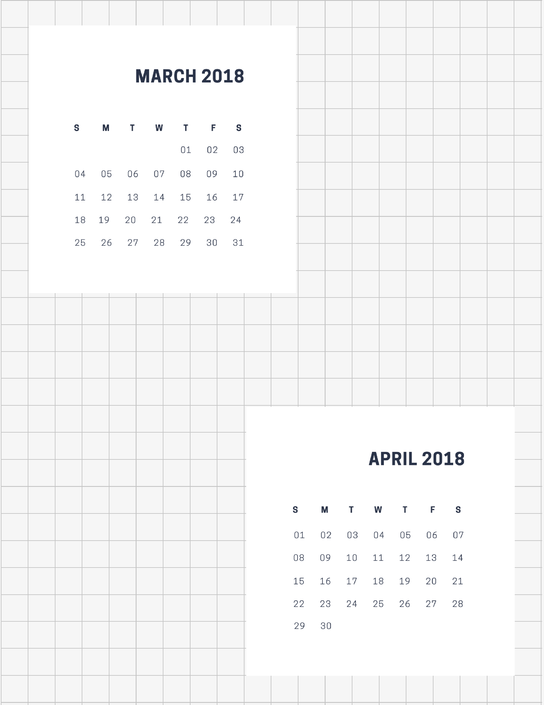

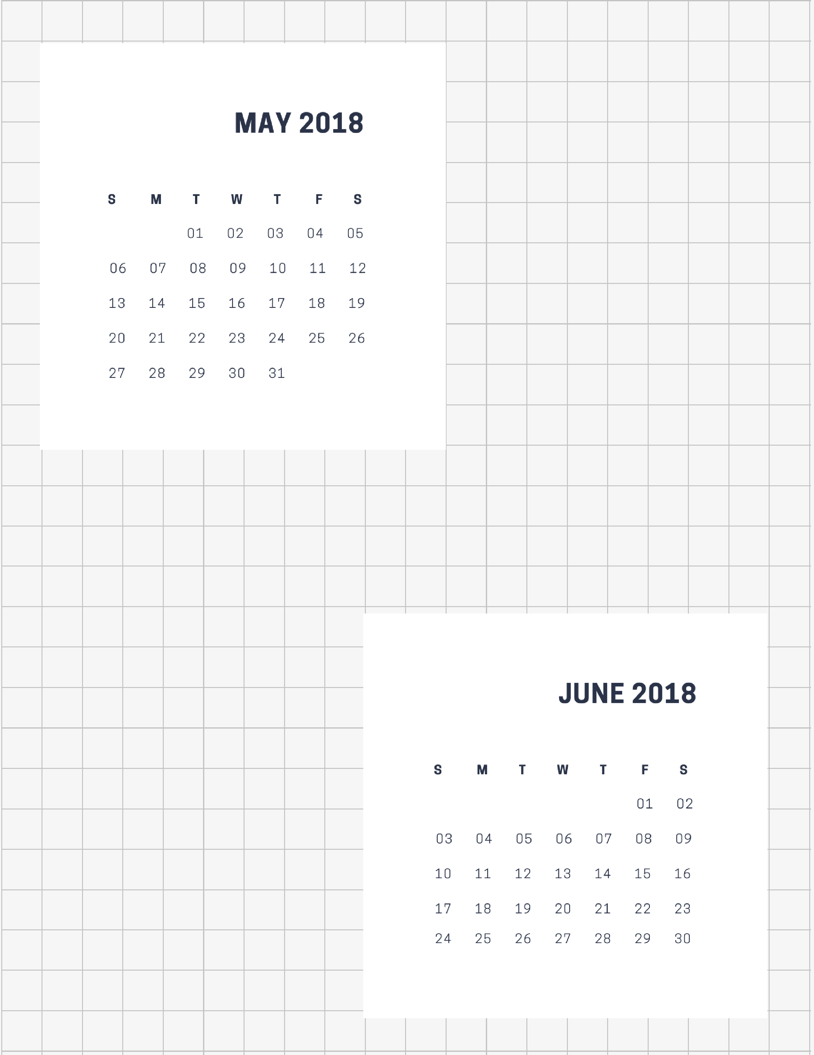



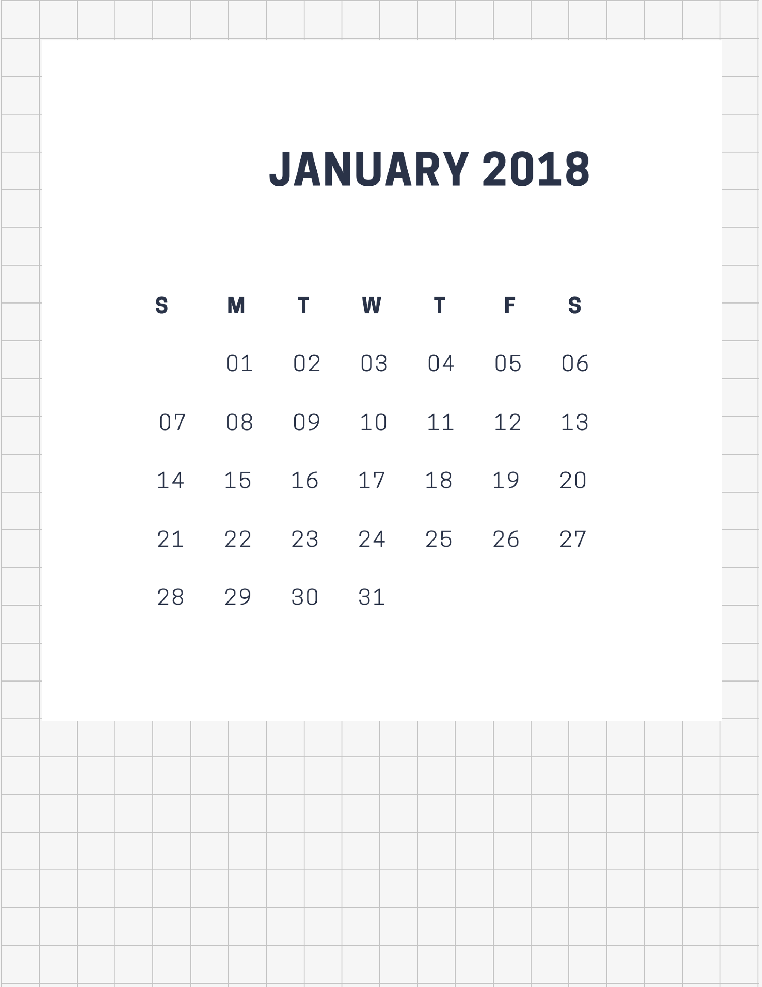


 | mon | 1 | tue | 2 | wed | 3
sched
due
tasks | □  □  □  □  □ |  | □  □  □  □  □ |  | □  □  □  □  □


 | thu | 4 | fri | 5 | sat | 6
sched
due |  |  |  |  | sun | 7
tasks | □  □  □  □  □ |  | □  □  □  □  □ |  | □  □  □  □  □

 | mon | 8 | tue | 9 | wed | 10
sched
due
tasks | □  □  □  □  □ |  | □  □  □  □  □ |  | □  □  □  □  □


 | thu | 11 | fri | 12 | sat | 13
sched
due |  |  |  |  | sun | 14
tasks | □  □  □  □  □ |  | □  □  □  □  □ |  | □  □  □  □  □

 | mon | 15 | tue | 16 | wed | 17
sched
due
tasks | □  □  □  □  □ |  | □  □  □  □  □ |  | □  □  □  □  □


 | thu | 18 | fri | 19 | sat | 20
sched
due |  |  |  |  | sun | 21
tasks | □  □  □  □  □ |  | □  □  □  □  □ |  | □  □  □  □  □

 | mon | 22 | tue | 23 | wed | 24
sched
due
tasks | □  □  □  □  □ |  | □  □  □  □  □ |  | □  □  □  □  □



 | thu | 25 | fri | 26 | sat | 27
sched
due |  |  |  |  | sun | 28
tasks | □  □  □  □  □ |  | □  □  □  □  □ |  | □  □  □  □  □

 | mon | 29 | tue | 30 | wed | 31
sched
due
tasks | □  □  □  □  □ |  | □  □  □  □  □ |  | □  □  □  □  □


 | thu | 1 | fri | 2 | sat | 3
sched
due |  |  |  |  | sun | 4
tasks | □  □  □  □  □ |  | □  □  □  □  □ |  | □  □  □  □  □


mon
1
tue
2
wed
3
thu
4

fri
5
sat
6
sun
7
mon
8

tue
9
wed
10
thu
11
fri
12

sat
13
sun
14
mon
15
tue
16

wed
17
thu
18
fri
19
sat
20

sun
21
mon
22
tue
23
wed
24

thu
25
fri
26
sat
27
sun
28

mon
29
tue
30
wed
31





