BISV Senior Year Research Project Proposal: Quantification and Analysis of the Orientation Angle of a Galaxy’s Disk on the Galaxy’s Measured Dark Matter Content

Sharvani Jha, Class of 2017

**I. Background and Significance**

Dark matter is currently one of the most popular fields of astrophysics. However, it is also one of the most mysterious.

Imagine throwing a ball in the air. You would expect the ball to come back to Earth because of gravity; the gravitational force dictates that objects will return to Earth unless they achieve enough velocity to escape the Earth’s gravitational pull. (See Fig 1.)

Similarly, planets and galaxies also experience gravitational pulls. The gravitational pull from a massive object is what keeps planets in orbit and galaxies intact –the Sun is the massive source of gravitational pull in our solar system and analogously, black holes are the source of gravitational pull in galaxies. Both the planets in the Solar System and the objects in galaxies (planets, stars, asteroids, and so on) experience this gravitational pull and thus orbit their respective centers of mass. This motion is governed by Kepler’s Laws (more so for the Solar System.)

However, imagine that you throw a ball in the air and instead of coming straight back down, the ball shoots to the left. (See Fig 2.) This is an unexpected action which goes against what the laws of gravity dictate, moving us to assume something else is affecting the way the laws of gravity work on the ball.

 

**Fig 1 (above):** The path that describes **Fig 2 (above):** What the ball actually

what we expect the ball to do, as does; it shoots to the left inexplicably.

described by the laws of gravity.

A situation analogous to this resulted in the creation of the theory of dark matter. Refer to Fig 3 below:

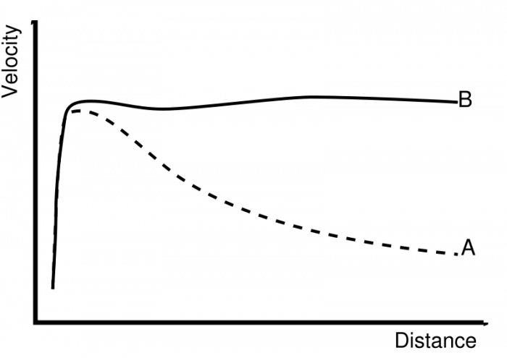

**Fig 3 (above):** Two rotation curves. *Distance* refers to distance from the center of the galaxy. *Velocity* refers to the velocity of that part of that specific part of the galaxy. *A* represents what scientists expected a galaxy’s rotation curve to look like, and *B* is what a typical galaxy’s rotation curve actually looked like.

Scientists expected the velocity of a galaxy to slow down as they got farther from the center of the source of the gravitational pull (see A in Fig 3), but instead the galaxy’s velocity remained constant (see B in Fig 3). Scientists attributed this discrepancy by theorizing that there must be more mass in the galaxy than they could see, causing a greater gravitational pull between the center of the galaxy and its components and accounting for the consistent velocity. Since this matter was invisible and unable to be detected using conventional methods, scientists called this theoretical extra matter “dark matter.”

The dark matter of a galaxy is typically quantified by comparing the dynamical mass of a galaxy to the luminous mass of a galaxy. The dynamical mass of a galaxy is the mass of a galaxy calculated through gravitational force. Dynamical mass includes the dark matter content of a galaxy because gravity acts on all matter, including dark matter. The luminous mass of a galaxy is calculated by analyzing the stars in a galaxy and their various luminosities – their brightness – as well as other objects in the galaxy such as gas to determine the total mass of the galaxy based on visible content. These two values are then compared, and the difference between the two proves there is another factor that must be accounted for, and the dark matter theory accounts for this difference.

While these values do prove something other than normal matter exists, they are not always accurate – the observation of galaxies is an inherently biased process, and these biases in measurement lead to inaccuracy when calculating dark matter content. The goal of my research project is to account for one of the most prominent measurement biases: the orientation angle of the galaxy.

To understand this measurement bias better, let us return to the example of the ball that shoots to the left when thrown up instead of returning to the ground. Imagine that instead of watching this scene head-on and being “parallel” to the plane of action, you are at now “perpendicular” to the plane of action and are watching from an angle. Everything looks different to you and if you attempted to measure the movement of the ball for yourself, you may not be able to accurately do so because you do not have a clear view of all of the ball’s movements.



**Fig 4 (above):** This is the same scenario as Fig 2, but seen from a different angle; since the ball is moving towards us from this angle when it shoots to the “left” as described before, we can’t notice that the ball has moved except for the fact that it looks slightly larger since it moves slightly closer to us.

The same concept applies when analyzing galaxies. The dynamical mass of a galaxy, which is needed to calculate dark matter content, is calculated using the rotational velocity of the galaxy. This is a value that is found by analyzing the rotational velocities of both “ends” of a galaxy. Rotational velocities are calculated using the redshift and blueshift of a galaxy. The redshift and blueshift of a galaxy work like the Doppler effect; imagine hearing a siren that is passing you. As the siren gets closer, the noise seems to get higher. However, as the siren subsequently gets farther, the noise becomes lower. (See Fig 4 below.)

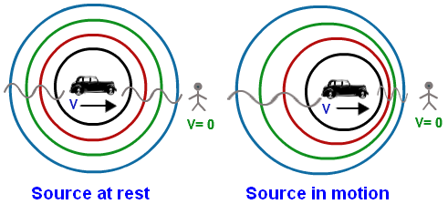

**Fig 4 (above):** As an object moves towards us (assuming we are the stick figure), the waves get closer together. This is what a blueshift is. Thus, the opposite is also true; as the object moves away from us, the waves get farther apart. This is a redshift. As the galaxy rotates, one end comes toward us and the other moves away from us. The side that comes toward us has a blueshift in the values we record from it, while the side that moves away from us has a redshift. The difference between the redshift and blueshift helps us calculate rotational velocities and thus a galaxy’s dynamical mass and dark matter content.

The orientation angle effects how accurately we can analyze rotational velocities; if the galaxy is not at a favorable angle, then we do not measure completely accurate redshift and blueshift values. This inaccuracy throws off the calculation of rotational velocities, dynamical mass, and thus dark matter content. See Figures 5, 6, and 7 below.

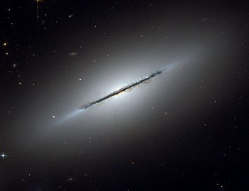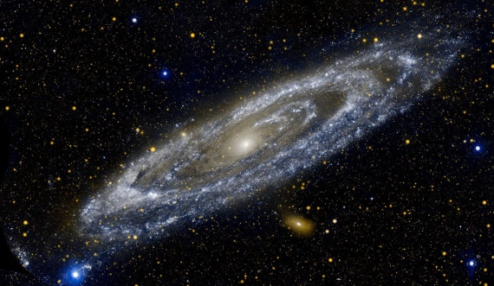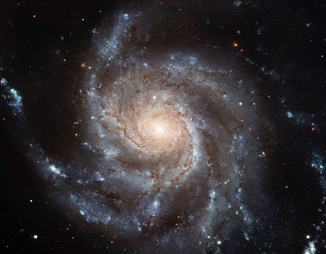

Fig 5 Fig 6 Fig 7

**Figure 5** is the best possible orientation angle of a galaxy because the galaxy’s disc is parallel to our plane of vision. We can exactly measure the blueshifts and redshifts of the galaxy since they are coming directly toward and away from us. **Figure 6** will give us slightly inaccurate results; because the galaxy is tilted, the galaxy isn’t parallel to our plane of vision. The galaxy’s arms are not moving directly toward or away from us, making it harder to accurately measure the redshifts and blueshifts. **Figure 7** is an extremely difficult, if not impossible, galaxy from which to find the redshifts and blueshifts. Since the galaxy is perpendicular to our plane of vision, neither of the galaxy’s arms are moving toward or away from us. Thus, it is very hard or impossible to determine the redshifts and blueshifts of the galaxies, which in turn makes it impossible to determine the galaxy’s dark matter content.

Through my project, I aim to quantify and analyze the effect of a galaxy’s orientation angle on the measured dark matter content. In simple terms, I aim to correct for any inaccurate input values due to a galaxy’s orientation angle one may receive when attempting to analyze a galaxy’s dark matter content. I wish to determine whether it is possible to correct for this effect for all galaxies, and if possible create a program that automatically corrects for this effect for me.

This research project has great value because it helps make dark matter data more accurate, which is the first step toward gaining a greater understanding of what dark matter is. By producing more accurate data, we can more clearly look for relationships or patterns in dark matter content (or any of its other characteristics). Dark matter itself is an integral field to the future of astrophysics because it theoretically makes up a relatively large portion of the universe, but we understand very little about it. Matter we consider normal, which is everything around us from the paper this is printed on to what the most distant stars are composed of, only makes up 4% of the universe. Dark matter, on the other hand, makes up 27%, thus playing a much larger role in the composition of the universe itself. Understanding dark matter is a stepping stone to more clearly understanding the composition and formation of the universe itself, an endeavor all of humanity currently yearns to answer. Dark matter is the field that holds the most promise for helping answer these questions, and hence it is in my and BASIS Independent Silicon Valley’s best interest for me to pursue this line of research.

**II. Research Process**

I will complete my research project through observation and by accessing various databases and previously captured data. I already have data for various galaxies from my project at COSMOS, and will most likely be able to access more. The data I used are 2-D spectra collected from the Keck Telescope in Hawaii by off-site faculty member for Project Halo7D and the Rainbow database, a cosmological survey database.

Using this data, I can then access the galaxy’s apparent orientation angle, either by calculating it myself or by using a database. I currently do not have an internship, but my off-site mentor, Professor Puragra (Raja) Guha Thakurta of UC Santa Cruz, will help me structure my research and provide me with access to the information I need. I hope to consult him as well as my faculty advisor, Mr. Hrin, to structure my research, make sure I am covering every possible angle from which I can tackle this problem, and am going through this research process as professionally as possible.