TRADER JOE’S:
Future of Marketing

Prepared for
Tara Miller
Marketing Director
Trader Joe’s, Inc.

Prepared by
Christopher Rutledge
Taylor Gomez
Marjon Hakimioun
An Nguyen
David Kim

Dr. Peter Nezafati
BUAD 301
7 May, 2017

Contents

Current Marketing Reaches Only a Fraction of Potential Customers ……………………………..1

Traditional Versus Modern Uses for Social Media…………....…………………...…………......1

Popular Social Media Networks……….……………………………..…………..……………….2

Instagram……………………………….……………………………………………….…2

Facebook………………….…………………………………………………………….…3

YouTube………………………...……………………………………………..………….3

Achieving Trader Joe’s Mission …………...………....…………………………….………….…4

How Social Media Will Make the Trader Joe’s Customer Happy…………………...……….…..4

Implementation………………………………………………………………………….………...5

Conclusions………………………………………………………………………………..……....6

References…………………………………………………………………………………………7

List of Illustrations

Figures
1- Communication with with television, mail,
and email versus social media………………………………………..………………….……...2

2- The mission statement of Trader Joe’s…………………………………….…………………...4

3- How social media costs are allocated.………………….……………………………….....…...5

Tables
1- Social media cost estimations………………….………………….………...………………….5

Current Marketing Reaches Only a Fraction of Potential Customers

A significant 53 percent of all shoppers use social networking sites to help them plan, shop, and share food experiences with online users (Food Market Institute, 2016). Therefore, Trader Joe’s marketing strategies are outdated since they do not use any social media platforms to reach their customers. Creating a social media presence will complement current marketing mediums and will benefit Trader Joe’s and its customers.

Trader Joe’s relies on socially outgoing crew members inside the store to attract customers. Outside of stores, customers browsing the web mostly hear about “negative” press and Trader Joe’s has no platform to reply (Gardiner, 2013). While the “Fearless Flyer” may appeal to the older generation, younger readers often do not have time to read the flyer’s lengthy descriptions (cf. Trader Joe’s, “Fearless Flyer”). Finally, while the website announces product recalls and product information, this information may not reach people who spend most of their time on social media (Trader Joe’s, “Recalls”; Trader Joe’s, “Customer Updates”).

Unofficial Trader Joe’s accounts exist all over the social media world. We searched Instagram and Youtube to find pages about Trader Joe’s created by fans with thousands of followers. This demonstrates the demand for a social media presence. With the creation of official social media pages, Trader Joe’s will gain the voice they need.

Traditional Versus Modern Uses for Social Media

Using traditional methods of marketing to provide information like newspapers, AM / FM radio and television was once an excellent and viable solution for businesses across the world. However, in this day, these traditional methods have been quickly losing popularity due to the rise of social media and technology. For example, a vast majority of printed newspapers and magazines cannot logistically keep pace with digital online formats like blogs, tweets, and instant messengers. Therefore, news media site have begun moving towards online news articles. Going online allows them to instantly release information as it happens, and keeps them relevant and competitive against other online outlets. Similarly, radio still retains an impressive audience of 91 percent across the United States, but experts believe it will soon lose out to online streaming services (O’Reilly, 2016). The availability of stream services like Spotify, Pandora, and even YouTube have been drawing in younger millennials who have been increasingly moving away from traditional radio.

Trader Joe’s, like the rest of the world, will greatly benefit from utilizing social media for their marketing and information output. They will be able to reach millions of current and potential customers instantly and worldwide. When compared to using printed flyers and reaching only a few thousand people within a store’s community, millions is a colossal increase. To illustrate, according to Adweek, Instagram currently has 700 million active users logging in per month, and the community continues to grow steadily (Swant, 2017). Also, CNN Tech reported that Facebook currently holds a whopping 2 billion active users checking in each month, and is also continually growing in size (Fiegerman, 2017). Furthermore, traditional television has been losing ground to online stream services like Youtube, and more people each day have been “pulling the plug” to move towards the online format. According to Engadget, Forbes, Techcrunch, and various other sources, people tune-in and watch a combined 1.25 billion hours of live recorded shows per day on traditional televisions. However, Youtube at 1 billion hours of watched videos per day, is quickly catching up to television numbers, and will eventually surpass television (MarketingCharts Staff, 2017; Magid, 2013; Frizell, 2015).
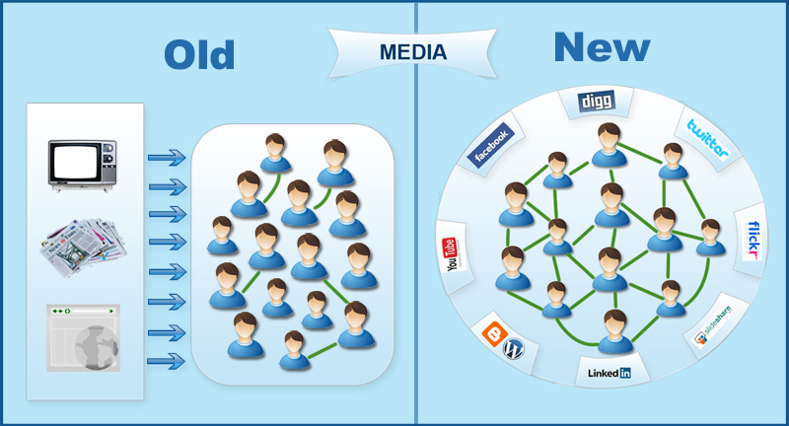
Figure 1- Communication with with television, mail, and email versus social media. Retrieved from https://digitalpatang.wordpress.com/2015/05/14/old-vs-new/

Lastly, using social media will increase profits. With increased brand awareness from utilizing social media, Trader Joe’s will inevitably have increased inbound traffic which can lead to a much higher conversion rate. Therefore, if potential customers decide to shop at Traders Joe’s after seeing something on social media, that potential customer just converted to a customer. More customers lead to higher profits.

Popular Social Media Networks

It is in the best interest of the company to implement and utilize popular channels like Facebook, Instagram and Youtube immediately. Trader Joe’s should use these social media channels to interact, participate, and engage with customers. This will enhance their competitive advantage in the marketplace.

Instagram

The first step in creating a wider social media presence is creating a Trader Joe’s official Instagram page. Instagram, a social networking application that is made for sharing photos and videos from a smartphone, can be used several ways to engage customers. The official Instagram page for Trader Joe’s will include product-related photographs, short, 10 to 15 second advertisement videos and announcements for upcoming items and events. According to professional marketer, Gerry Moran, the perfect Instagram profile should include a caption that grabs audience attention, use multiple hashtags to reach people who are searching for related topics, have a company hashtag, and include the company’s urls to the other channels (Moran, 2013). The Instagram marketers will hire professional photographers to showcase Trader Joe’s products. The photos will feature products, display events, recognize employees and the store community and promote healthy lifestyles. At the end of every Instagram post, a special hashtag will be used, for example, #TJforlife. Customers can partake in the use of these hashtags to create an online community of related pictures.

Facebook

Trader Joe’s will create an official Facebook page. Facebook, a social networking platform that lets users interact with one another, will allow the company to communicate better with its customers. According to the Facebooks Business page features, there are many useful features that would boost methods of online marketing. Features include page insights track online traffic, showing how many users are going online, “Schedule Post” option, which allows managers to make a draft, and then select a time at which the post will go live, and “Ad Targeting”, which allow managers to reach the desired Facebook audience according to demographics. (“Facebook Business”, n.d.). They can also post products and store information.

YouTube

Lastly, we will create an official YouTube channel to illustrate the various uses of Trader Joe’s products. A study found that 45 percent of grocery shoppers are “very willing” to make a new meal based on social media suggestions (Ryan, 2017). Trader Joe’s will create fun and delicious recipes for their families. The analysis suggests Trader Joe’s will hire a professional chef to develop full-course meal recipes using only Trader Joe’s products. The chef needs to be “upbeat, spunky,” and will promote the ingredients while they cook and bake the food. Trader Joe’s may also feature a competition with customers submitting cooking videos to receive gift cards. Lastly, Trader Joe’s will hire experienced and trusted employees to create a second official channel, called the “Trader Joe’s Insider”, to post videos of “secret” items and store details that would entice customers to shop. These strategies will help the company interact and engage with its customers, learn customers’ preferences, and spread their values.

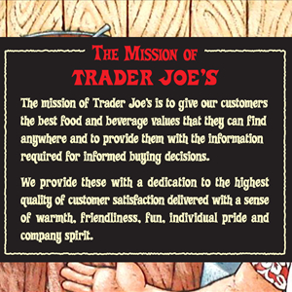
Achieving Trader Joe’s Mission

Figure 2- The mission statement of Trader Joe’s. Retrieved from https://www.simplemarketingnow.com/blog/flooring-the-consumer/bid/168520/what-great-brands-do-with-mission-statements-8-examples

If Trader Joe’s took advantage of the social media platforms available, their mission could be achieved more effectively. Communication with their customers would improve, and information required for informed buying decisions could be relayed more efficiently. The result would be an increase in customer satisfaction (Whittemore, 2014; Schiff, 2015).

How Social Media Will Make the Trader Joe’s Customer Happy

Daily, customers come into the store and find out that their favorite product has been discontinued. Since soon to be discontinued items are not listed or posted anywhere, customers are not given a last chance to “stock-up” on their favorite product, or to buy it one last time. Social Media would be the perfect place to notify customers of the “soon to be discontinued” items. In addition, “soon to come” items could be highlighted to get people excited about “up-and-coming” products.

The Trader Joe’s website states: “Should a recall become necessary, we waste no time in providing our customers details relevant to our products. Our recall-related communications go well beyond regulatory requirements: we share news through in-store signs, on our website, and through email alerts.” (Trader Joe’s, “Recalls”) In addition to the measures already taken, Trader Joe’s should announce a product recall on social media platforms. A social media alert would be seen sooner and by a larger audience making it the most efficient way for Trader Joe’s to inform customers about these recalls. (Schiff, 2015).

Holiday hours are only posted at each store front; this leads to hundreds of phone calls from inquiring customers the day before and the day of a holiday. Trader Joe’s should post these special holiday hours on their social media accounts to keep customers better informed, alleviating confusion during the stressful holidays (Trader Joe’s, “Special Trading Hours”).

Trader Joe’s currently highlights a very small number of seasonal items on their website, most of which are already out of season (Trader Joe’s, “Dig In: Seasonal”). Social media could be used as an up-to-date way to inform customers when seasonal products will arrive and when they will be done for the year.

Currently, the only way for Trader Joe’s customers to communicate with the company is via the Trader Joe’s website. This process involves going online, scrolling to the bottom of the home page, clicking on “Contact Us”, selecting a category, filling out personal information, then finally typing a comment. From many customers, we hear that this is too much of a hassle. This means many valuable customer opinions and ideas go unheard. With the help of social media, communication with the company will be made easier. Customers will be more inclined to comment on a social media post or send a direct message. This will increase the amount of customer input Trader Joe’s receives daily, helping the company stay in tune with what their customers desire.

Implementation

A social media team will be hired to efficiently implement the digital marketing strategies. The team will be in charge of creating and posting content on all Trader Joe’s social media platforms, and will help customers engage with the brand. The social media project manager will be in charge of organizing the plan of action, managing the set budget, and making sure everything is up to par. The photographer and videographer will take the photographs, create the commercial advertisements and chef-led cooking videos. The content creator will brainstorm creative content: themes, captions for advertisements, posts and hashtags. We also allocate $25,000 for the Facebook Business ads. The community manager will be responsible for the overall vision and accountability towards achieving business goals. The community manager will also monitor online mentions and conversations around Trader Joe’s and what is going on in the industry. They will also respond to positive and negative feedback, and answer questions.

Lua (2017), Kroger Executive Chef Salaries, (n.d.), and “Florida Photographer/Videographer Salary” (n.d.), “Structuring a Social Media Team” (n. d.), provide costs estimates for covering various social media positions. We include our annual cost calculations in the following table:
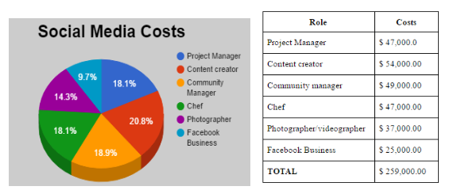
Figure 3- How social media costs are allocated. Table 1- Social media cost estimations

Conclusions

By implementing social media, Trader Joe’s will inform customers and receive feedback at a faster rate than earlier methods of mail, radio and word of mouth. This new form of communication and decision making will allow the company to promote its brand and extend its reach to a modern audience.

References

Arora, P (2015, May 14). Digital Patang. Retrieved from https://digitalpatang.wordpress.com/2015/05/14/old-vs-new/

“Facebook Business”. (n.d.). Facebook Ads. Retrieved April 09, 2017, from
https://www.facebook.com/business/products/ads

Fiegerman, S. (May 3, 2017). Facebook tops 1.9 billion monthly users. Retrieved from
money.cnn.com/2017/05/03/technology/facebook-earnings/

Food Market Institute (2016). U.S. Grocery Shopping Trends, 2016. Retrieved from
www.fmi.org/docs/default-source/webinars/fmi-2016-us-grocery-shopper-trends-overview-webinar5ce7030324aa67249237ff0000c12749.pdf?sfvrsn=2

Frizell, S. (2015, Feb 18). Millennials Are Abandoning Their TV Sets Faster Than Ever.
Retrieved from time.com/3713134/millennials-tv-cord-cutting-cable/

Gardiner, M. (2013, Jan 24). Why The Most Social Brand in the World Isn’t Even ‘Social.’https://www.brandwatch.com/blog/why-the-most-social-brand-in-the-world-isnt-even-social/

Kroger Executive Chef Salaries. (n.d.). Retrieved April 06, 2017, from https://www.glassdoor.com/Salary/Kroger-Executive-Chef-Salaries-E386_D_KO7,21.htm

Lua, A. (2017, Jan 24). Social Media Team: Building an All-Star Team in 5 Simple Steps. Retrieved April 06, 2017, from https://blog.bufferapp.com/social-media-team

Magid, L. (2013, Mar 19). Households Abandoning Cable and Satellite for Streaming.
Retrieved from
https://www.forbes.com/sites/larrymagid/2013/03/19/households-abandoning-cable-and-s
atellite-for-streaming/#608972b22d98

MarketingCharts staff (2017, Apr 24,). The State of Traditional TV: Updated With Q4 2016
Data. Retrieved from
www.marketingcharts.com/television/are-young-people-watching-less-tv-24817/

Moran, G. (2013, May 05). How To Build The Perfect Instagram Profile Infographic. Retrieved
April 11, 2017, from
https://marketingthink.com/infographic-to-build-the-perfect-instagram-profile/

O'Reilly, L. (2016, Apr 17). ‘TV is the new online’: Why a bunch of online media empires
suddenly want to get on the box. Retrieved from
www.businessinsider.com/why-online-media-companies-are-moving-into-tv-2016-4

Ryan, T. (2017, Feb 17). Do consumers want to follow grocers on social media? – RetailWire. Retrieved April 11, 2017, from http://www.retailwire.com/discussion/do-consumers-want-to-follow-grocers-on-social-media/

Schiff, J. L. (2015, Sept 15). 7 ways social media can improve customer satisfaction.
Retrieved April 05, 2017, from http://www.cio.com/article/2984024/social-networking/7-ways-social-media-can-improve-customer-satisfaction.html

Structuring a Social Media Team (n.d.). Retrieved May 1, 2017, from
http://web.ragan.com/raganforms/Structuring_A_Social_Media_Team.pdf

Swant, M. (Apr 26, 2017). Instagram Now Has 700 Million Monthly Users. Retrieved from
www.adweek.com/digital/instagram-now-has-700-million-monthly-active-users/

The Florida Times- Union Photographer/Videographer Salary (n.d.). Retrieved April 08, 2017, from https://www.glassdoor.com/Salary/The-Florida-Times-Union-Photographer-Videographer-Salaries-E237193_DAO.htm?filter.jobTitleExact=Photographer%2FVideographer

Trader Joe’s (2017). Customer Updates. Retrieved April 05, 2017, from http://www.traderjoes.com/announcement/category/customer-updates

Trader Joe’s (2017). Dig In: Seasonal. Retrieved April 05, 2017, from http://www.traderjoes.com/digin/tag/Seasonal

Trader Joe’s (2017). Fearless Flyer: As Always, Free. And Worth Every Penny. May ed. Print.

Trader Joe’s (2017). Recalls. Retrieved from
http://www.traderjoes.com/announcement/category/recalls

Trader Joe’s (2017). Special Trading Hours. Retrieved from

http://www.traderjoes.com/announcement/category/special-trading-hours

Whittemore, C. B. (2014, May 1). What Great Brands Do With Mission Statements: 8
Examples. Retrieved from https://www.simplemarketingnow.com/blog/flooring-the-consumer/bid/168520/what-great-brands-do-with-mission-statements-8-examples

