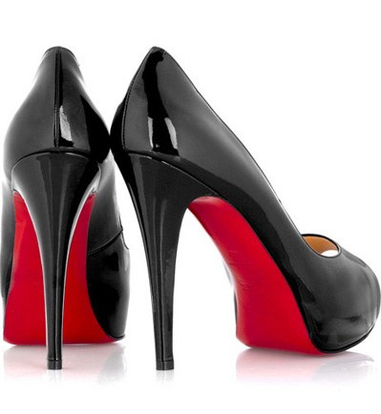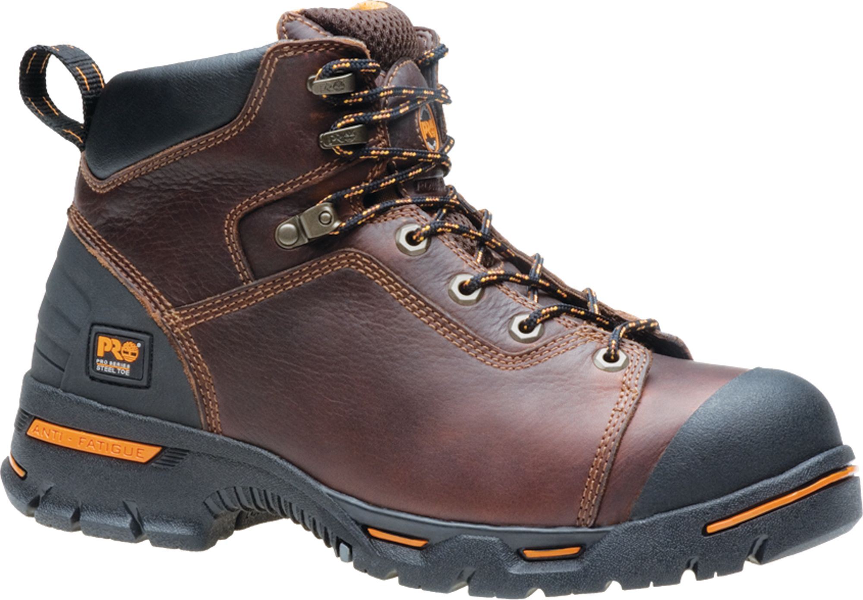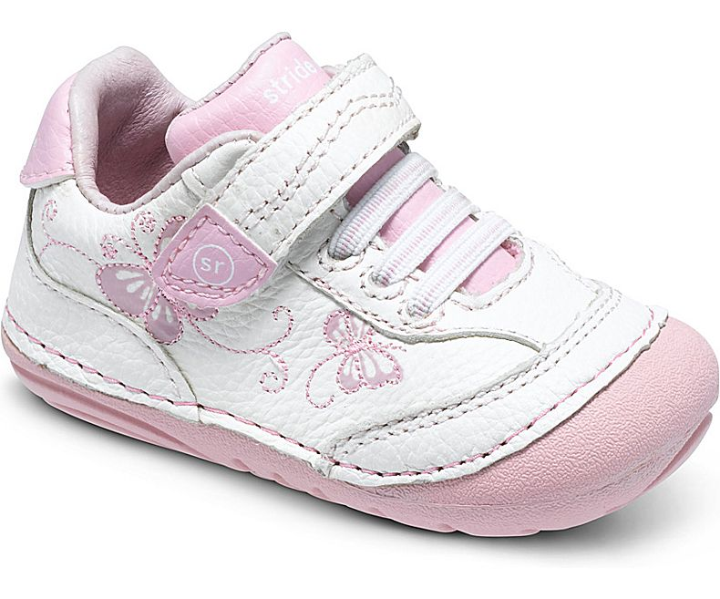  Marketing Project  An Analysis of Three Footwear Companies | (Nina) Marjon Hakimioun  Professor Anicich  MKTG 351 Tu/TH 8:30 AM  30 November 2017

1. SEGMENTATION VARIABLES
The following table gives an overview of the segmentation variables used to target the customers for Stride Rite for Toddlers, Christian Louboutin Women’s shoes and Timberland Company Work boots:
 | Stride Rite for Toddlers (**Most variables determined by parents**) | Christian Louboutin Women’s shoes | Timberland Company Work Boots
Geographic Variables:
Location | US, Europe, Asia | Worldwide | US, Europe, Canada
Climate | All | All, preferably dry | Cold/Rough
Market Size | Medium | High | Medium
Demographic Variables:
Age | 0-5 | 20+ | 25-40
Gender | All | Mainly Women | Mostly Men
Income | Medium to High | High | Medium to high
Psychographic Variables:
Personality | None (active kids) | Confident, Outgoing, Flirtatious, Trendy | Outdoorsy, Hardworking, Safe, Stylish
Lifestyle | Fun, New, childhood | Luxurious, Active, lavish | Active, Outdoors, Rugged
Motive | Durability, Functionality, Practical | Fashion, Iconic, Flashy | Functional
Benefits sought Variables:
Benefit | Outlasting, Comfortable, durable, non-hazardous | Make a statement, feel confident/sexy | Durable, safe, Comfortable, Trend

Stride Rite for Toddlers
"Built for Childhood- Since 1919"
The Stride Rite shoes are designed and made for babies, toddlers and preschoolers. Stride Rite shoes are made to support and stabilize new walkers. Their shoes have a strong structure and a flexible design so that babies are able to walk indoors and outdoors. Parents buy these shoes for their babies and toddlers both for fashion and for when their kids start walking. These segmentation variables are all used for their market:
Geographic Segmentation:
Since these shoes are made for children who cannot think for themselves, Stride Rite campaigns and aims to reach millennial parents. Stride Rite focuses on regions that involve new, educated parents who want the safest and most functional type of clothing and shoes for their kids. The main areas that Stride Rite places its products in are in regional shopping malls and in go-to retail stores like Target. The company sells its shoes both in the United States and internationally.
The best and most popular locations the company markets towards are places where highly populated regions of young and new parents occupy. States like California and Texas, with a larger density of new parents are the best places Stride Rite sells its products. They have stores across the country and sell in many retail stores like Kohl’s and Payless Shoes. Internationally, modern countries and cities in Europe and Asia are also the best locations for Stride Rite.
The specific environment the kids’ shoes are designed for are walking inside with hardwood floors and carpeted floors. They also design shoes for kids who have started their first steps towards walking and want to explore their new skills outside of the home; thus, their shoes are structured both externally and internally for rough surfaces and natural areas like soil, wet and snowy. Based on the consumer behavior and demand, the company also makes shoes for each season, where they market boots for kids during the winter or cold seasons and light-weight shoes during warm seasons like spring.
Psychographics Segmentation:
Stride Rite uses psychographic variables like personality, motives, and lifestyles. The company is all about personality. Their advertisements online and their stores evoke a very friendly, safe and fun environment to shop in. Young parents like to be unique and follow the latest fashions, so they would want their kids to also be as fashionable as them. Stride Rite fulfills this need by providing a wide variety of shoes that fit styles like casual, trendy and relatable.
For the motives aspect, the company sells their brand to parents to buy because they love their kids. Also, the company markets its shoes to rational parents because any parent would want the most useful and durable item for their child or baby. A pair of shoes that does not hurt the baby and allows for them to walk and run on the playground is a huge factor in buying Stride Rite products.
The baby or child is just starting their life and wants to explore and go on little adventures to discover the world. As the baby finds his or her ability to walk, parents want to help their child reach this experience as easy and as fun as possible. The baby’s lifestyle is all about childhood and the parents who take care of that baby are all about giving the baby as much attention and comfort as possible to let them grow freely. Stride Rite understands that and markets its shoes and ad campaigns to connect with this lifestyle as much as possible.
Demographic Segmentation:
Since the age group Stride Rite makes their products for range from infancy to 5 years of age, they mainly want to address the specifications of parents. Thus, the company targets the parents and position their products to satisfy their needs and wants. The trend for new parents are buying products that are stylish but safe and high in quality. Most millennial parents, who are the most educated, favor products that are sustainable and rely on online media and advertisements. Stride Rite communicates the best with Millennial parents because the website is easy to use with a catalog of all their shoes; they also rely on promoting their shoes through Instagram. The posts and pictures they use on their website and profile show stylish babies taking their first steps, and or taking on adventures in the outdoors where it is both fun and messy.
The company produces shoes and boots for both boys and girls. The design and variety in style of their shoes fit the styles of most little boys and girls. The shoes made for little girls are categorized based on sneakers, boots, Kate Spade New York and boots. The color and style of these shoes mainly involve variations in pink and red, have flowery, feminine, sparkly patterns on the shoes and display a more delicate, pretty and dainty feeling. The boy's shoes, however, portray a more masculine and cool-look. The colors are more solid, darker and have little to no patterns on the shoes. Also, the boy's shoes sport a more athletic, casual and relaxed look versus the girl's shoes with more details.
In regard to income segmentation, the company's most successful consumers are parents with medium to high income. Parents who prioritize the comfort of their baby and like for their babies to be fashionable and do not worry as much about the pricing enjoy purchasing Stride Rite shoes. The shoes are not expensive; however, low-income families may not purchase Stride Rite shoes because the lowest prices for their shoes sell at $19.99. The quality of Stride Rite and the attention to flexibility and comfort are all characteristics of shoes parents would want in a kid's shoe, but when money is tight, these features may not be a key factor in the decision to purchase the shoe, since children's shoe sizes grow rapidly.
Benefits Sought
Lastly, the benefit segment Stride Rite tailors to parents are the type that are protective over their children and care about the development of their children. Thus, they will purchase clothes and shoes that provide the most comfort and the highest quality in design. For this reason, through their shoes under the "Made2Play" brand are modified and designed for comfort. The company makes shoes under this brand that are lightweight, comfy, flexible, breathable material, memory foam and easy on/off closures for the shoes. These qualities are all beneficial for parents worried about their kid's feet from hurting and/or being protected from their walking when outside on the playgrounds. A child's life style, is full of active playing and exploring. Stride Rite tests all of their shoes to ensure the shoes are tough enough to withstand all of the activities a child may go through while wearing his or her shoes.
Christian Louboutin Women’s shoes
"To make shoes that are like jewels"
For over two decades, Christian Louboutin has been the designer of not following the norms and breaking away from conventionality and from standards. The red sole is an iconic symbol for a woman who is confident, luxurious and a trendsetter. These are the segmentation variables that are part of Louboutin:
Geographic Segmentation:
Louboutin shoes for women are specifically designed to be worn as pieces of their fashion statements. The stores across the country are limited because they are high-end, designer products. There are about 14 Louboutin stores in the United States, 6 stores in China, 4 stores in Japan, 4 stores in France and 4 stores in Russia, and the rest of the regions around the world, with high developed cities, have one to two stores. These stores are placed around the world and in the states where there are highly influential and fashionable women reside.
Psychographic Segmentation
Louboutin also uses psychographic variables for their brand. Since Louboutin is the most iconic and most sought out for in designer and luxury footwear. The company markets towards highly influential women who use Louboutin shoes to complete their unique and trendy outfits. Celebrities and famous models across the globe are seen strutting these shoes on red-carpet events, runway and in the busy, fashion streets of New York and Hollywood. The shoes are made for women who portray a confident, sexy and outgoing personality.
Any woman with the motive to show off her style and class wears Louboutins. Celebrities like Kim Kardashian, Angelina Jolie and Lady Gaga are all fashion icons and are high-status individuals who own several pairs of Louboutins. The shoes are not to be worn for sports and/or for comfort, they are art pieces of a women’s ensemble. They mark the fashion statement of powerful women for extravagant life styles.
The motives of these women who buy the red sole heels are mainly due to their wants. Their motives are far from saving money or being comfortable. They like to dress fashionably and do not care if the shoe is hurting their feet or if they are barely able to walk. The woman who buys and wears these shoes like being noticed; thus, their motive in buying the shoes are to grab attention and be fashionable. They purchase these shoes to show everyone or their followers that they are modern and have the money to buy whatever they want, even if the costs are very high. 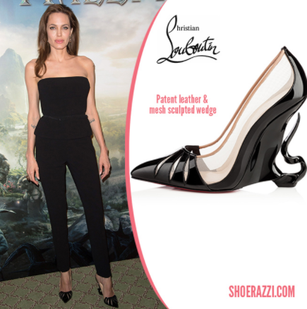
Demographics
As mentioned before, the designer shoes are mainly worn by highly influential people who want to show off their wealth; the shoes do not specifically target a certain race or age group. The age that most women purchase Louboutins is 25 and up to about 50. At this age, a woman is young and already has her set style. However, these women need to have financial stability either through their own high income or from their wealthy family. The shoes are sold at $500 to $6000; a price range that only the well-off can afford and not worry about financial burdens.
Louboutin started with making these shoes for women and they are still mainly targeted to women who enjoy following the latest trends and wearing the most lavish clothing. The brand advertisement for Louboutin’s are mostly marketed to the female audience; their advertising online and outside displays an array of women wearing the iconic red-sole heels with “against the standards” clothing.
Benefits Sought
The women that sought to purchase these designer shoes are mainly women who sought after luxury over comfort and rationality. The benefit in owning these shoes are being regarded as highly fashionable and wealthy. The women sough to be perceived as someone who is social, fearless, independent, edgy and confident.
The Timberland Company Work Boots
“We are all united by craft”
The Timberland Company is a reputable brand that is best known for their work boots to be both strong and comfortable. Work boots are designed for the outdoor settings and mainly made for men who are hiking mountains or on rough terrains, performing manual labor. These shoes can withstand hard weather conditions, water resistant, and are durable for most outdoor settings. They protect the feet and toes of the person wearing the shoes from accidents and from slipping.
Geographic Segmentation
The Timberland Company markets its work boots in regions where there is a high amount of workers who work outside on a daily basis and need to be protected from differing weather conditions and harsh environment. The Timberland Work Boot is for a man who typically works in a hard or manual type labor. The man is someone who works for long hours and long periods of time. Therefore, the company markets these types of shoes are in areas that involve agriculture, construction sites and around areas where the population is involved in nature, like the mountains.
The company has stores in the United States, and around the globe in Canada, Spanish countries like, Brazil, in South Africa and in the Netherlands. These areas are the best places to market in because they are involved in activities that involve the outdoor and construction/landscape work. Industrial companies require their employees to wear protective clothing and footwear. The workers in these locations and job settings need shoes that prevent their feet from being crushed by falling debris, heavy equipment or lumber and from slippery surfaces.
In regards to climate, these specific shoes are heavily based on the types of climates customers are in. As mentioned before, the weather of regions like Canada and in the Spanish countries are large factors in the buying of these work boots. The work boots that the Timberland company markets are made to be durable and safe to withstand the hardest of weather conditions. They can outlast watery and/or snowy climates to protect the feet of the customer.
Psychographic Segmentation
The type of lifestyles, personality traits and motives consumers who purchase these work boots are distinct. A man who buys work boots is the type to be active and on the go in building sites. The personality a person who buys these work boots from Timberland are the outdoorsy and safe type. The durability and bold style of the boot appeals to the customer because they are the type to not worry so much about looking good but getting the job done.
The lifestyle of a customer who would best fit the Timberland work boots is one that works long hours in the outdoors. These men will most likely wear their boots for up to 15 hours, more than half a day. They are more focused on handling their duties on the field rather than worrying about a shoe that is breaking apart or is uncomfortable. Also, lifestyles of these customers can be both dangerous and adventurous. Men who are always active in backpacking, hunting and hiking will need the balance, support and protection from these activities, qualities they can find in Timberland’s work boots.
Benefits Sought
The main benefits that customers sought when purchasing Timberland work boots to be long lasting, waterproof, safe and durable. Customers who work in harsh environments purchase accessories that will protect them. The men could be working with sharp blades, heavy equipment and machinery, or other hazardous tools, so they sought to protect their feet from getting cut or crushed. The more durable a shoe is the better it is for the customer, because they sought for a shoe that will last as long as their job or activity. Lastly, customers also sought to keep their feet from being in pain as much as possible. They want work boots that cushion their feet and keep their toes warm in cold weather conditions.
Differences:
When comparing the three chosen products and looking closely into all of the various ways each company uses its segmentation variables, the products have many similar and different tactics. Stride Rite sells shoes for toddlers but their target market is the parents of those toddlers, where as Louboutins and Timberland work boots are especially targeted to the consumer. Louboutin shoes are mainly targeted to women who live lavish lifestyles whereas the target group for Timberland work boots is men who are in the outdoors. Stride Rite customers are babies are just starting to walk. The three products are footwear, but they each have different benefits their customers sought. The work boots and toddler shoes are for individuals who need to be safe, comfortable and protected from their activities while Louboutin shoes take comfort and safety out of the picture. The age group for the work boots and Louboutins are mainly the same, young to middle aged, but the age for Stride Rite is much younger.
2. MARKETING MIX (FOUR P’S)
This chart illustrates the summary version for the marketing mix for all three products:
Four P’s | Stride Rite for Toddlers | Christian Louboutin Women’s shoes |  | Timberland Company Work Boots
Product Strategies
- Color/Style | Colorful, Fun, Vibrant, Patterns | Iconic, colorful, sexy, unconventional | Bold, rugged, solid colors
- Packaging | Cute, Clean, Simple, Patterns | Simple, w/Brand name | Simple, large, strong
Pricing Strategies
- Pricing | Varies, $20 + | High, $600+ | High, $100+
Promotion Strategies
- Advertisements | Online discount codes, coupons | Celebrity, Social Media, Fashion Magazines | Print ads, Social media
- Promotions | % off sales, free shipping and returns | Free shipping | Online discounts, Free 3 day shipping & free returns
Place Strategies
- Stores | Family retail stores, specialty stores | Louboutin Boutiques, Nordstrom, Saks Fifth Ave, Niemen Marcus | Dick’s Sporting Goods, Walmart, Macy’s
- Online | Yes | Yes | Yes
Stride Rite
These toddler shoes are consumer products that satisfy the needs of new parents who have small children starting to take their first steps. The following discusses the marketing mix for Stride Rite toddler shoes involves a successful combination of product strategies, place, promotion and pricing for its target markets.
Product Strategies
The type of products that Stride Rite sells are heterogeneous products due to the fact that there is a wide variety of children’s shoes that vary in pricing, quality and features. Thus, consumers compare different brands to pick the best product for their children. Stride Rite makes shoes that are suitable and appropriate for babies and toddlers. Their products have different styles, colors, features, and themes. Parents can buy stylish shoes for their babies or stick to a more casual and conventional type of shoe. For example, Stride Rite uses patterns like rainbows or flowers and bright colors to make a shoe “cute” for parents that want their babies to look cute. And, Stride Rite also has shoes that present a more classic look with subtle designs and modest colors. These shoes are made to protect the owner’s small feet and have the durability to last a couple of months before the baby’s shoe size changes.
For the packaging, the shoe boxes that the shoes come in are fun and attractive for both parents and kids. Some of their shoes that are superhero themed or have Marvel characters on their shoes come with boxes and packaging that have the superheroes on the box. In addition, the shoe boxes are small in size but have a clear font of the brand name and the brand’s slogan on the box. The box also contains some of the features the shoe has like, “machine washable.” Stride Rite also offers returns and exchanges for the shoes as long as the purchase is within 45 days. These features on the packaging help reiterate how Stride Rite has a reputable brand.
Place Strategies
The placing of Stride Rite’s shoes is key to its success. Besides the Stride Rite stores set in places that have young parents, they also have their products in well-known retail stores. The toddler shoes are not in stores like Niemen Marcus, but in stores like Marshall’s, Target, and TJ Max. These stores mainly cater to families’ needs and target young parents with medium income and an interest to take care of their family. Stride Rite shoes are placed in the shoes section of these stores and near babies’ clothing and products.
The company also sells its shoes online through their website, striderite.com and Amazon.com. This convenient option has made the company reach more consumers. Since parents are already busy taking care of their babies and families, they may not always have time to go to the store and purchase necessary items like shoes. Thus, Stride Rite has made it easier for parents to quickly find the appropriate footwear for their children with the least fuss and stress both on the parent and the child and can make these purchases in any time of the day.
Promotion Strategies
The company has several brand and promotion strategies to advertise its products to its consumers. Stride Rite uses internet and paper advertising to reach its customers. The print ads are mainly placed in magazines targeted towards parents or babies. The online advertisements are in popular social media sites like Twitter, Instagram, and Facebook. They promote and display these advertisements to young parents who use these sites.
The company also makes use of deals, discounts, coupons, and sales to reach customers. They offer discount codes on their website for a limited time to reach customers who are looking for affordable shoes for their children. These advertisements are profitable in that they are enticing the customers to try and buy their products through the idea of saving money.
Pricing Strategies
In regards to pricing, Stride Rite bases its prices on cost-plus pricing strategy and on customer value and quality. The prices start from around 20 dollars and up. The prices may be changed during specific peak seasons in order to reach maximum profits. Their original pricing may be lower for some of the shoes but the company sells the product for a higher price while offering a discount that reduces it close to the original amount. This makes consumers and parents think they are getting good deals.
Louboutin
Louboutin shoes are also consumer products that fit the style and personality of its buyers who strive to look the best. Since these shoes are more specialized and are designed specifically for people who want to feel confident, edgy and high end, Louboutin strives to feed these wants. These are the following strategies Louboutin uses in its marketing mix for their women’s shoes:
Product Strategies
Louboutin heels for women are designer, specialty products that come in various forms. There are women’s shoes called flats, pumps, platforms, sandals, boots, bridal, special occasion and wedges. These specific shoes fall under the women’s shoes category. They are products that are heterogenous products in that they come in various prices, styles and features. For example, some pumps will have one solid color and some will have colors and/or various beads or spikes on the shoes.
The one feature that these shoes all have in common are the red soles. The red soles are the iconic design by Christian Louboutin; only Louboutin shoes own and trademark with the red sole. The identity of this company is unique and is set apart from all other shoes and brands because of this famous red sole. This feature is what helps with the success of the company because the customers stay loyal to the brand for its iconic the brand and iconic appeal is built around it
The packaging for these shoes are simple and the shoe boxes are not cluttered with words or pictures. The shoe box has Christian Louboutin written in cursive on top of the box and the box itself is solid, light brown, like paper bag color. On the side of the box, the size and name of the shoe is printed for the customer to identify what shoe is in the box. The box represents elegance and keeps the unique quality through the Louboutin signature on the box.
Placing Strategies
Louboutin shoes are available in the boutiques open around the world and in several department stores like Nordstrom, Saks Fifth Avenue and Neiman Marcus. These stores are commonly known to carry high-end and luxury brands to consumers. The Louboutin boutiques are bold and extravagant. The tone that the stores set off to the moment the customer walks in is chic and trendy. These stores and boutiques are located in areas and cities, like London, are populated with wealthy consumers and with consumers who desire to be fashionable.
The company also sells its shoes online through their website and through the online sites from the retail stores mentioned above. This makes it convenient for the consumer that is not near the cities that have the Louboutin boutiques. Since Louboutin shoes also target young, independent, professional women, they are busy working and find it easier to order online. It also allows the consumer to go through the catalog of shoes available and get a taste of the style and features each shoe has.
Promotion Strategies
The advertising and branding for Louboutin is achieved in a variety of ways. Louboutin only goes by the designer name and the signature red sole, which is part of every product and shoe sold. This allows for the company to be known and remind the customer of its reputable brand. The advertisement is creative, sexy and confident, much like the target market they pursue.
Social media has allowed the company to reach many young consumers looking to become more like the celebrities they admire and follow. Through various social media sites like Facebook and Instagram, consumers can see celebrities and wealthy people showing off their Louboutin shoes. These celebrities who are not necessarily being sponsored by Louboutin are advertising the brand by just wearing the shoes at events or on the streets. Famous actors, who are also icons of fashion and ultimate beauty, like Angelina Jolie, are used as endorsers of the shoes to promote the shoes.
Pricing Strategies
The pricing for women’s shoes varies but it is highly expensive, with a range starting at $600 as the minimum and an average cost of $1,000. Since Louboutin is a famous brand and is a leader in the luxury shoe market, it utilizes prestige pricing and value based pricing techniques. Louboutin measures the value a customer is willing to pay for their product and then determines the maximum price the customer is willing to pay. Since customers who have bought the shoes find that the shoes are high in quality and turns heads, they become loyal to the brand and are the least to be cost conscious. This in turn creates a demand for the product since the higher a customer pays the better the quality and the more pleasure they will feel. Thus, the high pricing of the shoes is a success for Louboutin.
Timberland Company
The work boots are also consumer products that are made for the outdoorsy type male or a construction worker who needs to be and feel safe. These are the following strategies the Timberland Company uses its four p’s for their work boots:
Product Strategies
The Timberland company produces work boots that are made differently from regular shoes and boots. The designing of these specific type of shoes are not based on stylishness, or colorful patterns. They are based off on more masculine and manly visuals. This is because the work boots are going to be worn in places that are about manual work and construction or in the woods where being discrete and not flashy is necessary. The shoes are meant to get dirty and be worn in tough conditions, where being clean is not important. The colors of the boots are solid and neutral. Most of the work boots being sold are either, shades of black, brown, gray and blue. They are built to be strong and durable to outlast difficult weather and work sites.
The packaging for these shoes are larger and stronger than compared to other shoes because of the shoe’s larger size and weight. The boxes that Timberland Company places the shoes in are solid in color and would represent more natural colors. Similar to the shoes, the box is not flashy with patterns. The boxes are plain in color and design and only show the brand name on the top.
Placing Strategies
The placing of Timberland Company’s work boots are part of the reason why the company is successful. The company not only has specialized stores throughout the country, but also sells in popular sport and outdoors type stores like DICK’s Sporting Goods and Walmart. These stores cater to the demands of those who are looking for shoes, particularly work boots, that will help them be safe in the environment they plan to work in. Their shoes are placed right in the shoe section, where the men’s boots are to make it easier for the customer to find.
The company also sells its shoes on their website. This option has allowed for customers to easily look through their catalog of shoes and order online. Most of the times, people who are trying to find the best work boots for their outdoors or labor intensive purposes, they are checking online reviews. The ability to check the reviews for the shoes and the easy ordering allows for a quicker process in purchases and better sales.
Promotion Strategies
The company has some brand and promotion strategies to advertise its products to its consumers. Timberland uses the internet and print advertisements to reach its customers. The print ads are mainly placed in magazines targeted towards the laborer and now towards millennials looking to feel outdoorsy but stylish. The online advertisements are in popular social media outlets like Instagram and Facebook. They promote and display these advertisements to young individuals who want look fashionable and are ready to hike. The print ads mainly target an older group who are looking for work boots that are suitable for their working conditions.
The company also makes use of deals in shipping and returns and occasionally offer discounts off some items to reach customers. They offer discount codes on their website for a limited time to reach customers who are looking for shoes that function for the outside but can be worn in the city but still want to save money on extra costs. These advertisements are successful in that they are grabbing customers to try and buy their products through the idea of saving some money.
Pricing Strategies
The company has a competitive price range at $100 to $300 for their work boots. The pricing of some of these work boots may be higher than the other brands but they make up for it for the quality of their boots. The higher the price the more features and qualities the shoe owns. The strategy is based on customer value and quality. If customers value the company as a higher end company then they are more likely to accept the prices of these boots because of the trust.

3. WEBSITES
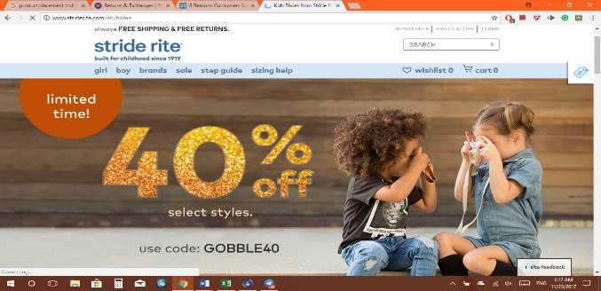
At first glance, the website that Stride Rite has created is very cute and easy on the eyes. The website has several images of little kids and babies in different clothing wearing stride rite shoes. The site also offers a big discount of 40% off almost everything with their discount code, free shipping and free returns. The website also includes a search bar for the user to search by keywords or by style to find the exact or similar product.
Another interesting detail, the font and capitalization of the titles on the site are small and lower case. This is a because to represent their clientele who are young children, this choice shows that they are a company for children’ products. It has many different tabs like “girl,” “boy,” “brands” and “sale” to click on to take the user to the category of shoes they are looking for. If you hover over one of the tabs, like the “girl” tab, a square that covers half of the screen displays the different subcategories in will which a user can click and the site will lead the user to a new page showing the shoes and products related to the category the user chose. The categories listed on this screen are: age range, style, featured, and accessories.
When the user clicks on one of the tabs the screen displays the wide selection of shoes related to the tab the user selected. There is a medium sized picture of each shoe with the name of the shoe and the price under the picture. On the left of the screen, there are various key words a user can select to be directed to shoes with that certain characteristic. For example, a customer can pick a size to be shown available shoes in the size they picked. This is very helpful for consumers because the catalog of the shoes is clear and does not force the customer to go through several tabs just for a price or for the picture of the item.
Once the user clicks the picture of the shoe, the user is directed to a new page with larger display of the shoe and other pictures from different angles of the shoe. The page also has a couple more options on the left to select from and direct the consumer to exactly what they are interested in buying. The website also has useful information like step guide and sizing guides. These help new parents with figuring out what type of shoe is best for their child and how to measure their child’s feet to find the best fit.
Other features on their website include a store locator and a live chat section to speak to a represented about product details and ask any questions they may have about Stride Rite products. The site also offers customers to sign up with their emails to receive information on the latest sales and items.
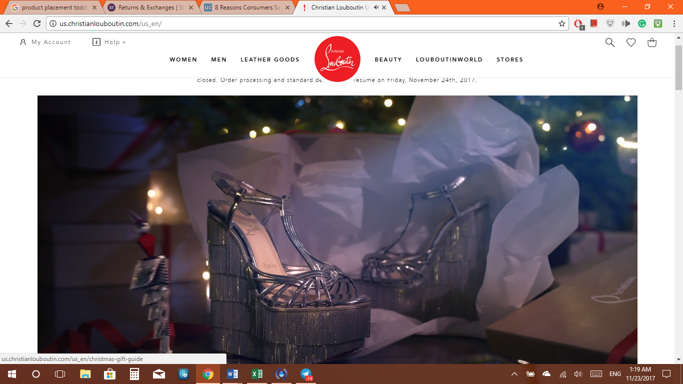
The website, or online boutique, for Louboutin has a sophisticated and elegant look. When you first enter the site, there is a display that takes up the majority of the screen. The display is a short video of a Christmas themed story showcasing the various Louboutin shoes. When the user scrolls down they’ll see a picture of the newest shoes from Louboutin for women and for men. Instead of words for the user to click on, the user can click on the picture of the shoe and it will lead them to a new page with the shoes related to that picture.
There are also tabs on the top of the website with the titles: women, men, leather goods, beauty, Louboutinworld, and stores. If you hover over one of these tabs, more subcategories will appear related to the tab. For instance, the women tab will show “the classics” shoes, and the various stilettos flats, heels for women, and an option to view all women’s shoes. These help the customers navigate to the exact pair of shoes they want. Once the customer clicks the tab most related to the items they are looking for, a page of those products appear with the name of the shoe and the picture.
If you click one of the pictures it will take the user to a new page displaying the picture of the shoe and the ability to zoom in on the picture to view the intricate details. On the right side of the product are the details and description. The user has the ability to select their size and add to their bag. They also can click the “Boutique availability” button to see which stores the shoe is available in. If a shoe is not available the website also tells the customer that sometimes the product availability is not guaranteed because of inventory changes in the boutiques so the customer can contact client services at the given number or email them using an email form. Additionally, there are product information, shipping and returns tabs for users to find out more details. Another detail the website has is the size guide and fit suggestions. These buttons help the user to see if the shoe is true to its size and a conversion table in European and US shoe sizes.
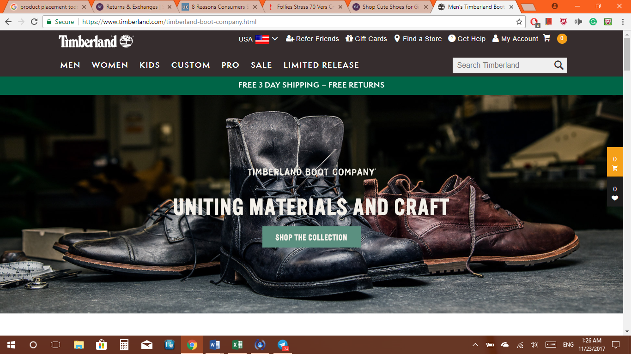The Timberland Company website is also user-friendly and unique. The website has more dark and solid colors in the background; this theme gives a more masculine vibe to the customer. The company has also included a search bar for the user to search for the shoe they are looking for. There is a slide show that display’s the company’s shoes with small headlines.
If you scroll down the website, the customer can see full sized pictures covering most of the screen that displays the featured collections Timberland Company sells. Under these pictures, there are smaller pictures of boots under the collection display with the title of the boot and its price. There are also various places where a customer can find deals and discounts. On the top of the website, there is a moving headline that advertises these discounts on their products or shipping deals.
There are tabs on the top of the screen that categorize the items. A customer can hover over one of these tabs and see the sub categories under these tabs. Once the user clicks the tab it will lead them to a new page with the products under that category. The page include a good sized picture of the product, the title or name, a star rating and the price of the product. On the right side of this page there are various search options the customer can click on. These are Style, width, shoe size, color, features, and price.
4. SURVEY
I conducted a survey of 20 people. 10 were females and 10 were males. The ages of this group ranged from 19 to 45. I handed out these 7 questions on a sheet of paper and asked them to fill the survey out. The questions I gave were the following:
- Have you heard of any of these shoe brands? Circle One.
  - Louboutin Y/N
  - Timberland Company Y/N
  - Stride Rite Y/N
- Which company comes to your mind as a fashionable brand? Circle One.
Louboutin Timberland Company Stride Rite
- Which company is a leader in the footwear market? Circle One.
Louboutin Timberland Company Stride Rite
- Which brand has the best quality in its shoes? Circle One.
Louboutin Timberland Company Stride Rite
- Which brand produces the most safest shoe? Circle One.
Louboutin Timberland Company Stride Rite
- Which brand would you buy from? Circle One.
Louboutin Timberland Company Stride Rite
- How often do you see an advertisement for Stride Rite, Timberland Company, and Louboutin? Circle One.
Louboutin: Very Often Often Not Much Never
Timberland Company: Very Often Often Not Much Never
Stride Rite: Very Often Often Not Much Never
- Which brand costs the least? Circle One.
Louboutin Timberland Company Stride Rite
The results of the survey are provided below:
Question 1:
  - Louboutin 20 Yes, 1 No
  - Timberland Company 11 Yes 9 No
  - Stride Rite 6 Yes 14 No
Question 2:
  - Louboutin 11
  - Timberland Company 9
  - Stride Rite 0
Question 3:
  - Louboutin 15
  - Timberland Company 5
  - Stride Rite 0
Question 4:
  - Louboutin 5
  - Timberland Company 9
  - Stride Rite 6
Question 5:
  - Louboutin 0
  - Timberland Company 12
  - Stride Rite 8
Question 6:
  - Louboutin 8
  - Timberland Company 7
  - Stride Rite 5
Question 7:
Louboutin: 0 Very Often 12 Often 6 Not Much 2 Never
Timberland Company: 0 Very Often 6 Often 7 Not Much 7 Never
Stride Rite: 0 Very Often 3 Often 3 Not Much 14 Never
Question 8:
  - Louboutin 0
  - Timberland Company 9
  - Stride Rite 11
The results of the survey are very interesting. Based on my questions asked from the survey, Louboutin and Timberland seem to be doing the best in the market for footwear and Stride Ride is on the bottom. This is most likely due to the fact that the individuals who I surveyed were mostly not new parents nor were they in need of baby shoes. The results show that Timberland and Stride Rite are the safest and high in quality. This is due to the fact that the market for Louboutin heels are not for comfort or quality in terms of keeping a customer’s feet from pain. Many more people said that they have heard of Louboutin and this confirms the well-known and iconic status of the brand. For the advertisement question, Louboutin also scored higher, most likely because of social media displaying celebrities wearing Louboutins. And, the low price leader seems to be Stride Rite, followed by Louboutin. This is because most people know that Louboutin shoes are very expensive, while they believe that children’s shoes cost way less than adult shoes. If the sample was a little larger, the results may have been a little more accurate for Stride Rite. From these results, we can see that the three companies vary in the market. The quality leader in this group is Timberland, the low price leader is Stride Rite, while the well known and most expensive brand is Louboutin.
5. SWOT ANALYSIS
Internal Factors
The internal factors that these footwear companies deal with are the advantages and disadvantages of their strengths and weaknesses. These companies have strengths in meeting the customer’s needs and continue to make products that adapt to their needs. The companies create quality products that build their brand image and make them famous for their products. The companies are constantly innovating and designing new styles or products that fit the needs, culture and wants of the customers. They also push to connect with the community of their customers by becoming eco-friendly and creating sustainable products that fit the criteria and requirements of the consumers. The weaknesses are derived from such things like markets in the international world, inventory levels and the possibility of losing customers because they stopped purchasing the company’s products. The demand is sometimes hard to forecast and predict because of changing trends; thus, companies need to be careful and accurately predict the demands of customers so that they do not manufacture more than what is needed or less than the demand.
External Factors
The external factors of the footwear industry are the opportunities and threats in the environment. The opportunities that exist can provide great rewards to the company if taken properly. The opportunities to design a product with different materials or connect technology into their products can provide beneficial results. Expanding in other markets, if analyzed and carried out efficiently, can make the company more successful. Threats of competition can cause companies to get lost in the market. Since many products can be substituted with other products that are lesser in quality and pricing, companies need to find ways to educate customers and promote their brand.
SWOT Analysis for Timberland Company
Internal -
Strengths
- Highest and reputable brand/image
- Popular among men
- Uniqueness and high quality
- High customer loyalty
- Modern culture
- Eco Friendly
- Community outreach
- Large market share
Weakness
- Customer loyalty
- Rely on overseas sales
- Inventory level buildup
- Expensive costs and pricing
External -
Opportunities
- Design new products
- Expansion in market in new markets
- International expansion
- diversification
- Build more to brand
Threats
- Economy crisis/Downfall
- Wide range in substitution
- Cheaper Products
- Intense competition
6. SOCIETAL MARKETING CONCEPT

Stride Rite

Stride Rite addresses the societal marketing concept in some ways. Stride Rite uses material for their shoes that are eco-friendly. Most of the lining of their sneakers are made of environment friendly material. The cleaning and stain repellant products made to SAVE the shoe are also eco-friendly. Since 2014, Stride Rite has partnered up with Soles4Souls, a company that campaigns to reduce the number of shoes dumped in landfalls and reduce the waste to help the environment. Stride Rite played a huge role in helping the environment by providing incentives for parents and people to donate their kid’s shoes. The stride Rite company placed donation bins in their stores to allow families to bring back their new or used pair of shoes. The incentives included buy-one-get-one sales on new shoes and discounts on select styles.

Stride Rite also helped children in need with providing fitting and proper footwear for them to continue their education. Customers of Stride Rite were asked to participate in donating up to $50k worth of new and used shoes for back to school season. The company promised to donate one percent of their net profit on shoes to consumers. These efforts helped the community be involved in reducing the amount of waste in landfills and helping the impoverished. Stride Rite also gave customers five percent of new pairs of shoes when they donated their shoes. All these efforts and support from Stride Rite have created a supportive and reputable image and reputation.

Louboutin
Louboutin contributes to the community and environment. The material from corks are organic, water-resistant material used in the shoe’s material. The cork is one of the most ecologically friendly materials because it is natural, recyclable and helps prevent deforestation. Most Louboutin shoes utilize the cork for its waterproof and organic qualities.

A couple of years ago, Louboutin also marketed Eco-fashion. He designed and created a shoe using materials from the trash. The shoe was a 6-inch pump made of trash from Paris, leopard print fabric and snakeskin. This shoe design was to symbolize how trash can be art, and the idea that material can be recycled and used the same way.

Christian Louboutin also participated in charity and fundraising activities. Louboutin worked with Model, Elisa Sednaoui, who has a platform that sells products and experiences, to support people in need. They worked together in supporting educational programs in Egypt, which strived to engage children with art and culture. The foundation helped kids learn about music and other forms of art. They provided an incentive for donations by rewarding a lucky winner of the experience to be flown to Paris to meet Louboutin and Sednaoui to discuss the story behind his shoes and be given a signed pair of shoes. Louboutin also raised money for Senegalese women by designing an African themed handbag and giving 10 percent of the profits to the Senegalese women and children. These efforts made by Louboutin have brought positive attention to their products.

Timberland Company

Compared to Stride Rite and Louboutin, the Timberland Company has addressed and contributed to the societal marketing concept the most. Their website provides information on their efforts to keep their products and mission to benefit the environment and the community. They aim to protect the environment by using recyclable materials like plastic from water bottles in their footwear. They have also planted over 9 million trees worldwide since 2001.
The company has reached up to 60 percent of their apparel products are sourced from organic cotton, 84% made of recycled, organic or renewable material in footwear, 94% of their leather is sourced from gold and silver rated tanneries, and almost 100 percent of all their products are PVC free. They have also made the goal to reduce their use of energy by 10 percent and source 50 % of renewable energy and have a 95% diversion rate for their waste.

Timberland company also aims to give back to their communities. They have at least 42 percent of their employees engaged in community service around the world and have arranged over 450 projects for communities worldwide. The company has helped Haitians plant and regrow cotton for their farmers and have teamed up to make greener parks. These efforts show the company as a passionate, caring and hardworking company that wants to do good for their customers and for the communities the customers are from or also support; it reveals the “human” side of the company and shows that they are not just about manufacturing and selling shoes but are there to impact lives in a positive way.

7. PERSONAL SELLING

The efforts of the B2B buyer and sales associates all contributed to the success of making substantial profits for Timberland Company. The leader of the company found that Timberland was trying to cater to everyone’s need, with no clear brand identity. This caused customers to be confused on what the company represents. Thus, the company repositioned itself and redesigned its marketing techniques. They aimed at focusing on millennials and style. Timberland added more to the style aspect of their shoes to make it so that customers can wear their products in the cities and suburbs. This repositioning moved the company to the higher end products, which allowed for the company to lower their promotion and brand as a high price leader.

The company has set up a B2B business through e-Commerce. Timberland’s customers have access to product images and descriptions, availability, order statuses, customer specific pricing, etc. This has resulted in product inventory being available and updated hourly, ensuring accurate and timely information. The company can also send out emails and customize their website to provide information on new product lines, styles, and promotions. This is controlled by the content manager who can ensure that customer are better connected to the company. Also, products are turning faster because with customers being allowed to place orders any time of the day, and having their orders met.

The company placed all its efforts in managing their supply chains by connecting with each industry and making the goal to provide the best customer satisfaction. They also strived to work with the distributors and wholesalers to improve on delivery time. Timberland also improved the management in stores by bettering the skills in customer relationship management.
8. BLUE COLLAR SUPPLY CHAIN MANAGEMENT
Timberland deals with three activities in the Blue Collar supply chain management process: Sustainability materials, Production and manufacturing, and Assembly line workers.
Activity 1: Timberland Company measures and tracks the sustainability of products in their business. They have set up a system that measure and communicates the critical factors of environmental performance that lets the industry know about the product design and consumer choices. The system communicates the environmental impact associated with the products. The company strives to manage their share of environmental harm and work on reducing their environmental impact.
This is done by aligning product design and environmental strategies to work on climate, chemical use and resource consumption measures. Once measures for these are set up, the company can improve on working with less harmful chemicals and using more organic, recyclable materials. The company is working on improving their footwear by making sustainable materials that are eco-friendly and renewable.
Activity 2: In Timberland’s production and manufacturing activities, there are a lot of factors that contribute to the success of this company. They are engaged with supplier at all times and are committed to make a more organized production of sustainable products. They effectively communicate with the leaders within each section of the manufacturing process to perform at the highest rate possible. In order to facilitate the production efforts, the company conducts engineering reviews. This promotes the use of better, environment-safe products to maintain the quality and integrity of the shoe.
Activity 3: The Timberland Company has about 250k people working to make their products. They ensure that the products are made in safe, fair, and non-discriminatory workplaces that do not harm the community, environment and most importantly, the workers. They have set up a team that continually monitors the factory conditions within the suppliers and workers to improve social management systems. After assessing the problems of the work environment and systems, the team provide the workers with training and assistance to implement the most effective environmental and labor management systems. The company wants their workers and employees making the shoes to feel that they are doing their part in creating safe and eco-friendly products.
9. ANALYSIS OF ADVERTISING EFFORTS
Stride Rite
The advertisements designed and released by Stride Rite are creative, relatable, and cute. Stride Rite uses social media, in store advertisements and print advertisements. The advertisement campaigns connect with mothers through real life experiences. The company focuses on bringing in new customers by providing high quality visuals, authenticity and daily parenting occurrences. Through these ad campaigns, the company is aiming to spread awareness among young millennials and new parents. Each advertisement on social media sites, television and in magazines showcase the "Built for Childhood" slogan. They display the durability and practicality in their shoes that also look fashionable.
The ad campaigns vary in terms of the stages a child goes through. Stride Rite focuses on the "pre-walker" phase, or the crawling stage, the "early walker" phase, when children take their first steps and the running stage when toddlers are walking. The visual pieces that Stride Rite uses are placing aesthetically pleasing and cute babies and toddlers in disorderly situations.
The company also incorporates the struggle and experiences a new parent goes through; this helps parents connect better and favor Stride Rite products. For instance, the advertisement showing a little toddler with stickers all over his body with the caption, "built for rookie walkers" illustrates the exciting moments of a child's first steps that every parent cherishes.
One of my favorite advertisements by Stride Rite displays two kids playing with mud on the ground, covered in mud. The ad shows the slogan and a caption that reads, "Made2Play machine washable shoes outlast even the messiest kids." This ad explains the durability and favorable features in just simple words and visuals. The consumers viewing the ad can connect with the messiness and struggles of having kids; the shoes being advertised can be a solution to their struggles and reduce a parent's stress. The ad is shown below:
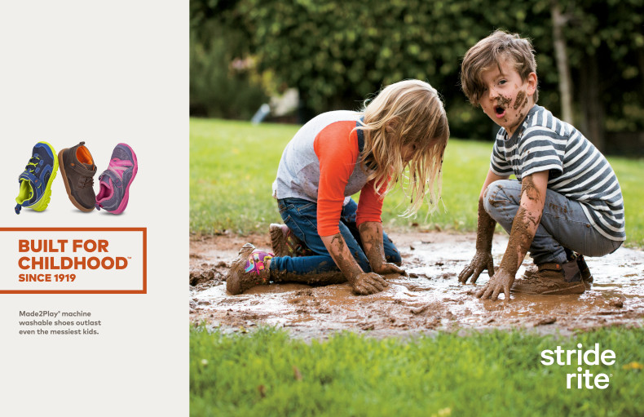
Louboutin
Louboutin ad campaigns are as modern and attractive as their products. The company’s approach in showing off their heels is captured by one of their slogans: “Flirting with your feet.” A phrase that reminds consumers that their products are for confident, sexy woman who evoke art and beauty. Their advertisement for Louboutin shoes and products are through print ads in well known magazines like Vogue, and in social media outlets, like Facebook and Instagram.
In the past, Louboutin would use iconic celebrities like Victoria Beckham and Angelina Jolie, as sponsors of the shoe; these sponsors helped define the luxury and glamour of Louboutins. Now, Louboutin is using a different approach to advertise the shoes. Louboutin’s social media platforms feature consumers in current and past favorites, showing the heels on real customers, who aren’t famous or well known. This was a unique and unconventional approach but it succeeded in connecting customers around the world through Louboutins.
Lastly, the advertisement on their website is a very dynamic and appealing video displaying the latest products. The video starts off with the Christmas tree decorations falling on the floor and coming to life, opening all the shoe boxes with Louboutin products. The decorations are hurriedly decorating the tree with all the shoes in the boxes before the owner comes home. As soon as the owner walks in, who is wearing the Louboutin red sole shoes, she is surprised and delighted by the new decorations on the tree. The story is cute and uses beautiful imagery and tasteful music to captivate the audience.
Timberland Company
The timberland company has improved their ad campaigns to target a significant market, millennials, rather than targeting more types of consumers with more messages. The advertisements released by the company are now focused on promoting styles and versatility. The advertisements are using slogans like, "Made for the Modern Trail" and "Best then. Better Now." These are reinforcing the appeal for timberland shoes for consumers because their shoes can be worn in cities and suburban areas. They advertise for the outdoor lifestyle enthusiast who may not even be outdoors all the time but like the style and the feeling of adventure the shoe gives. Since the shoes are now being worn more at outdoor concerts, instead of hiking trails, Timberland created ads that cater to trendy and outdoorsy millennials.
The timberland company also uses social media and digital production to display lifestyle ads and style campaigns. The company has set up media platforms on social media outlets like Twitter, Instagram and Facebook to reach and advertise to the millennial and young consumers. In the effort to cater to women customers, the company invested in media outlets like Teen Vogue and People Style Watch to show their digital advertisements of their footwear made for women. The focus of these advertisements are not on functional features of the shoes and boots but on the lifestyle and stylish appeal of the shoes. The advertisements portray an image of the brand that fits the styles of the outdoorsy woman and can be worn in the city.
10. HOW TO MAKE CUSTOMERS ORDER MORE?
In the business world, the best strategy for a business to become successful and gain the most profits, they must focus on the best customers. It is much easier and better for a company to make an existing customer a repeat customer than to win new customers each time. There are several ways in which a business can make an existing customer a recent, frequent and high dollar customer.
The company or business needs to understand what a customer goes through when shopping for items. The first stage is predisposition, they first think of the item they need or want. Then the individual goes through various searching methods either online, through people, or advertisements. The individual then decides and picks the best product that fits their criteria and budget. The customer then purchases the item and goes through the experience of the item to see if they enjoy it or does not favor it.
Stride Rite can use this thought process and better their techniques in making their customers order more. After researching different brands, a parent of a baby walks into the store to find what kind of shoes fits their criteria to purchase for their baby. After the parent decides to buy a pair of shoes from a Stride Rite store, the company can try to make this parent a reoccurring customer. The employees can obtain the contact information of the parent to send out emails or texts of deals or sale events, suggest different items, like repellant, or place a small flyer that gives promotional offers for the next time the parent comes into the store. This helps create a connection with the customer and cultivates the relationship the company has with the customer to make the customer a repeat customer. After the seed is planted and the parent comes to buy more shoes for her other kids or comes in every six months because the babies’ feet grew and the parent is satisfied with the quality of the product, the customer can become one of Stride Rite’s best customers. The parent loves buying shoes at the stores and they become part of a rewards program where they can take advantage of sales earlier than other customers and other special treatment. Lastly, Stride Rite can send personal thank you notes either by mail or email to thank the customer for their recent purchases and offer discounts for their next purchases as an incentive to come back. Another way for the customer to come back is for Stride Rite to send “we miss you” emails every 6 months or year to remind customers that they can buy other pairs of shoes for their growing children.
11. FOUR COMPANIES’ ORIENTATIONS
Societal Marketing Orientation
Unilever, a company that includes brands like Dove, Lipton and Ben & Jerry’s, uses societal marketing techniques in their business. This company is eco-conscious and strives to create natural. green and sustainable products. They are heavily focused on eco-production. Unilever has promised its customers to cut their environmental footprint in half and use non-degradable materials in their products by the year 2020. They also are promoting products that contain less salt and fat. The companies under Unilever advocate healthy actions like brushing your teeth and washing your hands.
Unilever’s, Dove company aims at helping young people, especially women, build body confidence and self-esteem. Today, Dove is working with women to embrace their beauty and encourage everyone to raise awareness of positive body image. Dove’s commercials and advertisements portray a more positive, realistic and natural image of women and girls using Dove products. These efforts have created higher purchase intent, a strong position in their brand and differentiation.

Recently, Unilever has pledged to design all of their plastic packaging to be fully reusable, recyclable or compostable by the year 2025. They want to reduce the weight of packaging and increase the use of recycled plastic content. They are in full support of reducing greenhouse gases and lessening the buildup of waste. This image of caring about the environment further entices customers to purchase Unilever products because the products haven proven to be sustainable and high in quality.
Product Orientation
Most companies that work in the furniture industry use product orientation marketing. For example, Jerome’s Furniture company is mostly a production-oriented industry. They make and sell product that their engineers can design with their equipment and strategize to make the best products they can produce. Jerome’s carry the same styles and varieties of furniture that they have been carrying for the many years they have been in business. The company always makes and sells stock sofas, coffee tables, end tables and table lamps for the living room and bedrooms. The master bedrooms always have a queen or king sized bed with a head, two tables on the side of the bed, and two dressers. This set up is always seen in their stores regardless of what the customers are trying to buy. This has worked because the items and furniture they make has always been equal to what the customers expect to buy for their homes.
Sales Orientation
Retail stores use sales orientation marketing to make short term profits. The sales strategies that companies use make consumers to buy their products even though they do not need or want their products. On Banana Republic, a popular retail store, has coupons on their website that offer free shipping on order of $50 or more and promote free returns on all items. This helps customers with worrying about extra costs. With the pressure taken off of returning items, consumers are swayed to make their purchases. The more deals and coupons the company offers the greater the appeal to the customer to purchase more items to get free shipping. The company encourages larger orders for customers to spend more money then they need to receive a “better” deal. Banana republic does not keep this offer for long so that customers do not always rely on discounts. This instills a sense of urgency to purchases items during coupon offers, which capitalizes on customer interests. Coupons and offers offered a few times a month help encourage purchases for repeating and new customers.
Marketing Orientation
Marketing orientation is used by several successful companies. The companies don’t depend on aggressive sales force but depend on customer’s decisions to buy a product. Companies like Tesla obtain information about customers, their competitors, and markets. They strive to deliver customer satisfaction and high quality cars that match customers’ needs. Tesla was recently ranked as the highest for overall customer satisfaction. These reports and rankings help boost sales for Tesla, because it advertises that the company sells the best car in the market. This company aims to meet customers’ needs and adapt to their changing over the past years they have been in business.
12. DOES NOT EXIST ANYMORE
The Video Home System, or VHS, released by Victor Company of Japan (JVC) was a major contributor to the television industry. It’s first release for home use in the United states was in the 1970’s. The VHS allowed for television watchers to record, playback and watch their shows freely the mid 1980’s the VHS had become the dominant product in the market for video watching and recording. As television became more and more popular, customers all around the world were using VHS and loved using the product too meet their hobby’s needs.
However, streaming videos online, DVD’s and blue ray caused for VHS’s and VCR’s to become obsolete. Starting around 2002, the DVD’s and DVD players began to boom in sales, outselling VHS and VCR’s. And in 2006, the United States stopped producing VHS taped films. America was improving and growing in technology, making VHS’s a thing of the past. Today, movies and tv shows either are online to buy, rent and/or watch or come in DVD’s. The VHS lost most of its popularity in consumers and the shift from the experience of putting a VHS tape in a tape machine to record a show to virtual and high-speed experiences.

13. WALMART’S SUSTAINABLE COMPETITIVE ADVANTAGES
One of the best retailers with many sustainable competitive advantages is a well- known and successful company: Walmart. The company strives to provide the best quality products at affordable costs for its consumers. Today, Walmart employs about 2.3 million employees worldwide and 1.5 million in the United States, named as the largest private employer of the world. The total revenue Walmart produced for the fiscal year of 2017 was $485.9 billion, marking the company as the world’s largest company by revenue. The company’s retail sales exceed those of other popular retailers combined. Its main competitors are Target, Costco, Best Buy, Wholefoods, Sam’s Club and Kmart. Walmart’s success is due to the responsiveness of the demand and competition in the market and the management in distribution and in inventories.
Walmart’s core business strategy and philosophy is to follow the slogan: “Everyday Low Prices.” Walmart utilizes this cost leadership tactic to beat their competition. The company cuts out the expenses of their products and materials to make it both cost efficient and to sell the products at lower prices than the ones being sold by competitors. Walmart assess the demand of each product they sell and either chooses to invest in selling more of that product or get rid of the product if the demand is low. Walmart follows customer trends, wants and needs to better their product placement, distribution and inventories; less useless items are being sold and less items are sitting in inventory, while items that bring profit are at the top for Walmart. Also, Walmart’s distribution and purchasing of products are by point-of-sale date methods. This helps with reducing the amount of inventory, lowers stock outs and lessens the amount of markdowns. This competitive advantage is seen through other retailors who devote an average of 25 percent of space in inventory, while Walmart only uses 10 percent.
Walmart also has efficient in-store operation strategies. The company relationship management and delivery is another factor in the success of the company. Walmart has a close coordination with suppliers and distributors through technology and in person collaborations. The managers of companies that Walmart works with are trained and taught the systems and methods Walmart uses before the company’s products are released in Walmart stores. The speedy delivery of Walmart items is because they own their own transportation system that enables the company to ship goods directly from the warehouses to the stores. This results in the company to restock their stores at a faster rate than their competitors.
The value Walmart places in the employee is just as important as the value in the customer. Walmart has created a safe and supportive environment for their employees. Working for Walmart is advantageous because it treats each employee with respect and listens to their needs. The employees are offered bonuses in peak seasons and are allowed to share their opinions to the upper management. The employees are given a say to help improve customer relationship and store management. It is difficult for competitors to replicate the strategies that Walmart uses because of the strong relationship building, quality delivery, and image Walmart possesses.

