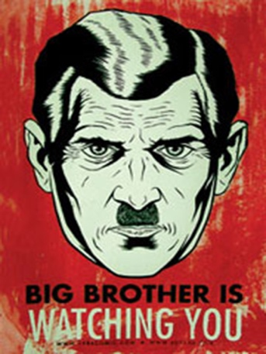
Due Date:

1984 ISU Project Possibilities

Introduction/Directions: As part of Unit 4, you were instructed to being reading 1984 in September in order to get a head start on what is your final unit. You will be doing an ISU (independent study unit). We will be conducting short lessons until the final exams begin and your final project will be due before the final exam. Note that 1984 will only be a small focus on the final exam; primarily in the long answer question. See rubric attached.
Choose one of the projects below to demonstrate your knowledge and understanding of the events, characters, and themes of 1984.

1. “I pledge allegiance…”

Examine the U.S. Pledge of Allegiance word for word. In two paragraphs, analyze and explain what it says about freedom of speech. Think about 1984 then, from either Winston or Julia’s point of view and write a new Pledge of Allegiance based on the rules of the Party and Oceania. Design your Pledge formally and in a creative manner.

2. Edit me, DEAREST!

You are Orwell’s editor and you feel that 1984 would be even more appealing with catchy, meaningful chapter, and part titles. Replace each chapter and part with actual titles/names. For each chapter/part name, explain in a paragraph what in that chapter/part inspired you to name it thus.

3. You should buy this…

Create a dust jacket for 1984 including a photo, major idea, incident, or symbol from the novel. Include also the titles, the author’s name, back cover summary, and why readers should read the book (e.g. critical reviews). The author’s biographical information, other books he has written, and even a picture should also be included.

4. Be warned!

Hate Week is a momentous event for Airstrip One and as a Party member you want to show your support and get your fellow members excited. Create your own posters (3-4 different designs) and t-shirts (3-4 different designs) for Hate Week. Remember: it is a means of propaganda employed by the Inner Party to encourage conformity and public support of Party actions and policies [that you support yourself].

5. Sing me a pretty song

The themes of 1984 are prevalent in all forms of human expression, and many songs cite that 1984 was a direct or indirect influence on why an artist wrote a song and what message a band is trying to communicate. For example, Radiohead’s “2+2=5.” Find two songs that, directly or indirectly, represent the themes of 1984. Print out lyrics and annotate/analyze how this song is influenced by or in conversation with 1984. Analysis should be in paragraph form but you should also show your textual annotations on your lyrics. Make sure you cite the lyrics you’re talking about!

6. Newspeak=plusgood

Create your own Newspeak Dictionary. Include a minimum of 40 words from your daily life that you can convert into Newspeak. Include a definition, part of speech, example sentence, and your rationale for the word(s) you chose and how you abbreviated it. Dictionary should be done in a creative manner. Make Syme proud!

7. “Dear Diary, Mood—Apathetic”

Continue Winston’s diary for him! The beginnings of the diary should repeat what we see/read in 1984, but Winston doesn’t write about his encounters with Julia or O’Brien in his diary. Also, consider what might Winston write about if he had the diary in Mr. Charrington’s room and was reading the Book, if he had his diary in Room 101, after he is released? Write a minimum of seven entries.

8. If Big Brother met Calvin & Hobbes

Political cartoons are used to express criticism of current world events and leaders and cover a variety of topics—the economy, pop culture, education, environmental issues, political speeches and campaigns, etc. If the Brotherhood had a secret publication and included political cartoons aimed at the Party and Big Brother, what might they look like? Create a minimum of five cartoons.

9. “I’m ready for my close-up”

Create a condensed video version of 1984. It can be a summary of the whole novel (think of something like Sparknotes or Cliffnotes would produce) or a new interpretation of it (think about what he did with Macbeth). You can act yourself, graphically design cartoon characters, use puppets, create characters à la South Park style, etc.

10. Do what I say!

Research what the rules and consequences of historical dictators employed in their oppressive/fascist/totalitarian states (e.g. Stalin, Mussolini, Hitler, Nasser, Sadat, Amin, Zedong, etc.) and write a short paper on your findings (2-4 pages, make sure you cite!). Based on these historical examples, 1984, V for Vendetta, and Fahrenheit 451, create your own totalitarian society with rules and consequences. Write another short paper (1-2 pages) on why you want these rules (a minimum of ten rules) for your society and justify your punishments.

